NAME_________________________________________Wildlife Notes 11-26 (Mammals) Mrs. Weimer
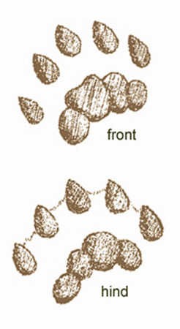
- River Otter
Lutra Canadensis
  - Live in/near clean water
  - Protected in PA since ______________
  - Reintroduced to PA in 1985 (PSU,ESU,PGC)
  - Carnivore, prefers fish
  - Intelligent, playful and “athletic”
  - Good underwater senses
  - Order = Carnivora Family = _____________________
  - Facts:
    - Males are 10-25 lbs, females smaller
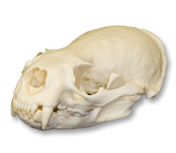
    - _________ layers of fur: short underfur and long guardhair
    - Obtain food from water: fish, mussels, snails, etc
    - Eyesight superb below water;__________________________
    - Most adept land mammal for _______________________
    - Can swim up to _____________ mile without coming up for air
    - Sexually mature at _________ years
    - Females undergo ____________________________ of 9-12 months before eggs attach to uterus
    - Gestation 2 months
    - _____________________________________________
    - Frequently groom themselves to prevent __________________________
    - Lifespan = ___________ years
- Beaver
Castor Canadensis
  - North America’s largest _____________________
  - Large, orange ____________________
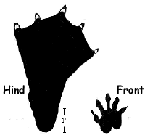
  - Webbed rear feet (w/ split toenail for grooming)
  - Large, flat, leathery tail
  - K-selective (young called _________________)
  - Trapped for fur (hats)
  - Weak vision, good sense of _______
  - Build lodges and dams
  - Excellent swimmers (can submerge for ______ minutes)
  - Alter ecosystems to fit their needs
  - Aspen, birch, maple, beech (store food in winter)
  - Order = ____________ Family = Castoridae
  - Adults weight ______ lbs
  - An extinct giant beaver of the Pleistocene era was as big as a _________________
  - Tail is 8-12inches, with leathery covering
  - Both males and females possess ___________________ to mark territories (used to make ingredients in medicine and perfume) animal uses it to rub on fur as a water repellent
  - Front teeth never stop growing (rodent)
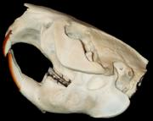
  - Prefer ________________ and will eat them when available
  - Build dams on streams and creeks
  - Backs up a barrier of water to create a ________________
  - Require periodic maintenance
  - Lodges are built for their ______________
  - Beaver lodges can house up to ________ beavers
  - Females are monogamous, but males may breed more than one female
  - Young remain with parents for up to _______ years
  - Little to no predation
  - Can live up to _________ years
  - Can cohabitate with the ___________________ during the winter months

- Mink
Mustela vison
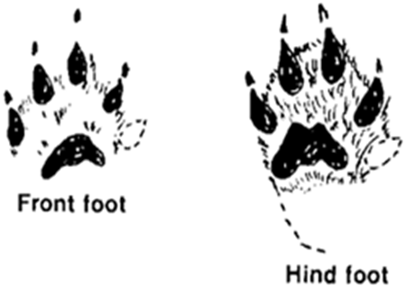
  - Nasty temper
  - Fierce fighters
  - Thick, full, glossy fur
  - #1 predator of ____________________
  - Live in forested areas near water shores
  - Primarily _____________________________
  - Highly trapped, grown on commercial farms
  - Order = Carnivora Family = Mustelidae
  - Facts:
  - Mustelid family (weasel, marten, wolverines,etc.)
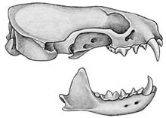
  - Active year round
  - Most active at _____________
  - Opportunistic feeder
  - Carnivorous
  - Live in dens near water
  - Basically solitary until _______________________
  - Also undergo __________________________________
  - 15-50 days until the egg attaches to uterine lining
  - Gestation period of 28-30, but actual time from implantation is ______________ days
  - Live up to 10 years
  - Mink was introduced from Sweden in ____________s
  - Spread throughout country in 35 years

- Muskrat
Ondatra zibethicus
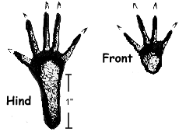
  - Nation’s leading _______________________ (leg-hold, conibear trap)
  - Polygamous
  - “Musk”: smell/glands “rat”: rat-like features
  - __________________
  - 2-4 litters/yr
  - Cat-tails are it’s favorite food
  - Aquatic rodents
  - Can be aggressive and nasty, esp. when on land
  - Order = ___________________
  - Family = Muridae
  - Facts:
  - Musk-strong smell, rat=rodent
  - Resemble ____________________________
  - Have been known to eat mainly plants, but get some animal protein (also some ______________)
  - Build lodges
  - Mink are predators of the _______________
  - Can live 12 months-5 years
- Skunk
Mephitis mephitis
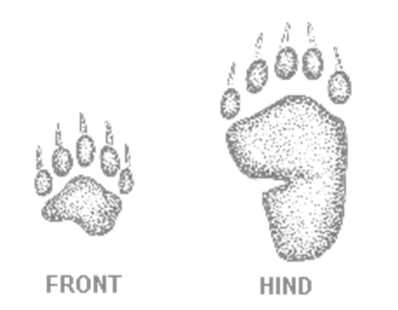
  - Striped, spotted, hooded, hog-nosed
  - Can spray ___________, 6-shooter
  - ___________________ (walk on soles of feet)
  - Opportunistic omnivores
  - _______________
  - nocturnal
  - Preyed upon by _____________________
  - Spray = mercaptan, Sulfuric Acid
    - DOES NOT WORK: Tomato Juice, vinegar
    - Effective mix: 1qt Hydrogen peroxide, ¼ cup Baking soda, 1 tsp liquid detergent
  - Order = Carnivora Family = ________________
  - Facts:
  - Skunks molt in __________________
  - Top speed 10 mph
  - Large scent glands under skin beside ____________
  - Have nozzle ducts that spray out through anus
  - Can shoot up to 12 feet
  - Will eat _____________________________
  - Females have a _________day estrus period
  - ______________ day gestation (bearing 2-10 young)
  - Predator: great horned owl (lacks sense of smell)
- Opossum
Didelphis virginiana
  - North America’s only _____________________
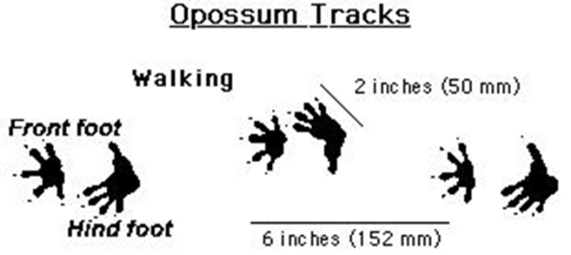
  - Naked, _____________ tail (do not hang from it to sleep)
  - “Thumb” on rear foot
  - 90 million years old
  - “______________” brain
  - Catatonic shock (playing ‘possum)
  - Shortest gestation (_______days)
  - More teeth than any other NA mammal (_____)
  - Order = Didelphimorphia
  - Family = ________________________
  - Facts:
  - Can also __________
  - Opportunistic omnivore
  - Do not dig burrows, but will occupy abandoned burrows
  - Gestation (one of the shortest) ______________ days
  - Young climb upward to mothers pouch
  - Pouch is lined with __________________________
  - Nipple enlarge when young attach to help baby stay attached
  - PA is the ____________________________ and they can sometimes lose tails and ears to frostbite
- Weasels
    - Mustelid family (with skunks, otters, minks, etc.)
    - Long, slim bodies with short legs and 5 clawed toes on each foot
    - Long necks, small heads, low ears
    - Good hunters – like to eat _____________________
    - Fast metabolism – must eat a lot
    - Some change from brown to white in winter
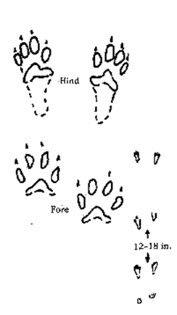
- Long-tailed Weasel
Mustela frenata
- Most common PA weasel
- Long, slender bodies, triangular heads
- May turn _________________ in winter
- Carnivores, bite the back of the neck
- High metabolism, must eat often
- ______________________________________
- _______________________
- Order - Carnivora Family - Mustelidae
- Ermine = _________________________________
  - Adults ______________ inches in length, including a 1.6 to 3.2-inch tail; males are larger and heavier than females.
  - The ermine’s bushy tail is shorter than that of the long-tailed weasel.
  - _________than long tail
  - Prey: small terrestrial mammals, bats, hares, rabbits, birds and their eggs, frogs, snakes, earthworms, insects and carrion; smaller victims are eaten whole
- Least Weasel
  - The least weasel is the world’s ________________________________________
  - Just as aggressive as their larger cousins
  - Only weigh ___________________
  - Must eat _______________ of their body weight/day
  - Solitary
  - Breed and reproduce all year
  - _______day gestation period
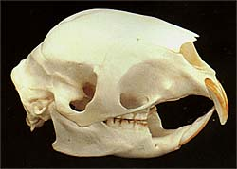
- Porcupine
  - PA’s ____________largest rodent
  - ___________________ quills (shed, barbed, cannot “throw”
  - Seeks salt (Na) to flush out K
  - Slow moving (_________________)
  - Arboreal
  - __________________
  - Herbivore
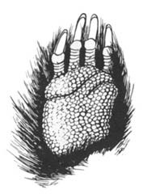
  - Preyed upon by ______________
  - Mating ritual
  - K-selective
  - Order = ___________________
  - Family = Erethizontidae
  - Facts:
  - Young porcupines are called-_______________________________ (Pup)
  - They cannot shoot their quills
  - They have _____________________ teeth
  - Gestation period is _________________________ days
  - Pups nurse for ______ days
  - Make dens
  - Preyed upon by foxes, coyotes, bobcats, dogs, owls
  - Lifespan=______________________ years

