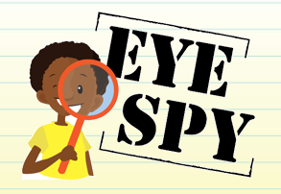
TYPE NAME HERE

____
30

TYPE DATE HERE

Eye Spy
Welding Dangers

Directions: Look at the pictures in the PowerPoint and identify the dangers. The PowerPoint can be found on Mr. Kush’s website.

Picture 1

1.
2.
3.
4.
5.
6.

Picture 2

1.
2.
3.
4.
5.

Picture 3

1.
2.
3.
4.
5.
6.
7.
8.
9.
10.

Picture 4

1.
2.
3.
4.
5.
6.
7.
8.
9.

