NAME__________________________________________________Unit 1C-Amphibians-Envirothon Mrs. Weimer
- CHARACTERISTICS of AMPHIBIANS
  - Amphibians are ______________________, which means their blood temperature rises and falls with that of the surrounding environment
- They use gills, lungs, skin, and mouth cavity in __________________
- They have moist, smooth, thin skin with _________________________.
  - Feet ____________________________ and the toes lack claws.
- Amphibians have many prominent characteristics that are adaptations to a life spent both on land and in water:
  - They change from an aquatic larval stage to a terrestrial adult
form. This transformation is called ____________________
- Amphibians enter a state of dormancy or _________________when conditions are unfavorable.
They often bury themselves in mud or leaves, emerging when conditions are better.
- Such states of inactivity are known as known as:
  - _______________________ when it occurs in the winter
  - _______________________ when it occurs in the summer
- Larvae have _____-chambered hearts; adults have ________-chambered hearts and well-developed circulation.
- Eggs lack multicellular _________________________________. They are usually laid in water or in a moist environment and ________________________________________.
Pa Amphibians
Salamanders
Newts
Frogs
Toads

- Salamanders
  - Mole Salamanders
_____________________________________________________
    - T_____________ mole salamanders are identified by having wide, protruding eyes, prominent costal grooves, thick arms, and rounded tails. Most have vivid patterning on dark backgrounds.
    - Terrestrial adults spend most of their life underground in ________________ either of their own making or abandoned by other animals.
    - Lunged Salamanders
    - Adults spend little time in the water, only returning to the ponds of ____________________.
      - Marbled Salamander
        - Although other salamander species in the mole salamander family breed in water, the marbled salamander __________________________
        - It migrates to a pond ______________________ rains begin. There, the animal begins to court and mate.
        - Each female lays her clutch of ________________ eggs in a dry depression, and the embryos begin to develop.
        - A female usually stays with her eggs until autumn rains begin to fill the pond.
        - When the nest sites become flooded, the _______________ within a few hours or days.
- After four to six months, the larvae have grown enough to ________________________ (or metamorphose), and leave the pond to live on land.
- Adults remain dormant underground during dry conditions, but they feed during opportune times and use much of their energy to grow and build up fat reserves.
- Adults usually reach a length ________________ inches and live an average of four years.
- The bands on female marbled salamanders are more _______than males' bands, which are generally white
- Jefferson Salamander
    - Because of living underground, and being _________________, it is uncommon to see the Jefferson's except in the early spring when it migrates to ponds during the breeding season of March and April.
    - Between ________________ eggs are laid.
    - Once the larva hatch, it takes __________ months to metamorphose into land living adults.
    - The male Jefferson's will breed with another mole salamander, the ______________________
    - Their young are hybrids, known as triploid Jefferson's salamanders, are always ____________________________.

Other Salamanders-
- Eastern Hellbender
    - Hellbenders are extremely large, completely aquatic salamanders native to the eastern United States. The largest hellbender ever recorded was nearly ___________________________
    - These salamanders need cool, clear streams and rivers with ______________________________. They feed almost entirely on crayfish, but will also eat small fish, invertebrates, and other hellbenders.

- Cool, clear streams are important because hellbenders breathe entirely through __________________________! They have lungs, but rely on the thousands of _____________________________ found in the fleshy folds of skin along their body and legs to get oxygen from the water.

- Hellbenders live a long time! The oldest known hellbender in captivity was __________________and individuals in the wild likely live that long or longer. Because they live so long, the removal of adults from the wild can cause populations to dwindle
Mudpuppy
  - They never lose ____________________ during maturation from the tadpole into the adult stage-- beneficial since they will spend their entire lives underwater
  - Mudpuppies prefer shallow water with lots of places to hide, but have been found at depths of up to _________________
  - The mating season is late autumn however eggs are not laid until late spring when ____________ eggs are deposited in a nest cavity under a rock or other object. It takes 1 to 2 months for the eggs to hatch and 4 to 6 years for the young to reach maturity.
  - Mudpuppies may live for up to __________!
- Four Toed Salamander
  - 4 in., rusty brown back, white belly with black spots, and _______________ on the hind feet.
  - Eggs are deposited in April and May in hummocks of sphagnum moss associated with water filled pools.
  - A single female lays about ______________ but several females may lay eggs in ________________ resulting in several 100 eggs per nest.
  - Larvae transform in ___________ weeks.
- Longtail Salamander
- Their tail comprises over __________the total length and has black marks on the sides that form a herringbone pattern.
- They reach ___inches in length.
- Long-tailed salamanders are usually encountered along streams, in seepage areas and springs, and in caves. They may also occur in terrestrial habitats.
- Northern Dusky Salamander
- They are about 2.5-4.5” long.
- They are found in ________________________________.
- About ___________ eggs are deposited from June to July in cavities under rocks, logs, leaves, or mosses close to water.
- Nests are guarded by the ________And eggs hatch in late summer or early autumn.
- Larvae transform into juveniles in about _________________
- Northern Spring Salamander
  - Largest ____________________________________ @ _______________
- They will lay eggs from July to August. The clutch size is from 20-60 and they hatch in about 3 months.
- The adults are _________________ and the aquatic juveniles are more active in the day.
- This species is dormant in the summer
- The females mature at _________________
- Northern Two Lined Salamander
  - They are found in or near small streams with rocky bottoms, seepages, and flood plains. They are frequently found under rocks and logs in forests.
  - In March and April, ________________ eggs are either attached to the undersides of rocks or broadcast among small rocks and sand.

- Northern Red Salamander
  - They have the potential to be quite long-lived, surviving for _________ years as aquatic larvae, and may mature to a ripe 20 years of age!
  - Living in or near cool, clear springs or streams, adults tend to be mostly aquatic in the fall and winter, and become more terrestrial in the warmer months of spring and summer.
  - On land, they stay mostly underground in ___________, or they may seek a variety of shelter including under rocks or logs
- Northern Redback Salamander
  - It is a small, hardy ____________________________
  - Throughout most of its range it is often the _______________________________________
  - The red-backed salamander is found in mostly two color variations: the nominate red variety, as well as a darker phase known as the _______________which lacks most or all of the red pigmentation found in the red phase.
- Slimy Salamander
  - They are 5-7” Woodland Salamanders
  - This amphibian has __________________ that secrete a thick, gluey substance. Its is extremely sticky and very difficult to remove.
  - They mate both in spring and the fall
    - Eggs are laid in the early fall
  - Mostly __________________________

- NEWTS
- Red-Spotted Newt
- Eastern newts have three stages of life: the aquatic ________________________________________________________________
- The larva possesses gills and does not leave the pond environment where it was hatched. Larvae are brown-green in color, and shed their gills when they transform into the terrestrial red eft. The red eft is bright orangish-red in color, with darker red spots outlined in black.
- After ________________, the eft finds a pond and transform into the aquatic adult. The adult's skin is olive green, but retains the eft's characteristic outlined red spots. It has a larger and wider tail and characteristically slimy skin.
- FROGS
Bullfrog*
- They are the ___________________ in N. America.
- It can grow to a length of 6 inches with a weight of up to one pound.
- ____________are typically larger than males.
- They are aptly named since their call is a loud, guttural bellow that carries a long distance, giving the impression that the frog is much larger than it actually is, which is an advantage in keeping _______________________
Eastern Gray Treefrog*
- 1 1/4 - 2 in. green to gray to brown; light spot beneath eye; bright yellow or orange on underside of hind legs; large toe pads; a rough or bumpy skin on its back, usually with darker blotches.
- Habitat: _____________ growing in or near water.
- Breeding: May through mid-July.
- Voice: A short, loud trill lasting up to __________________; slower and more melodic.
Pickerel Frog*
- 1 3/4 - 3 in. brown or tan; rectangular spots, without light borders, in parallel rows down the back; bright yellow or orange on concealed surfaces of hind legs; light stripe on upper lip; ridges along its back which extend to the groin.
- Habitat: Cool, clear waters of spring fed __________________________.
- Breeding: April through mid-June.
- Voice: A steady, _________________________________ with little carrying power; similar to leopard frog
Northern Green Frog*
- 2 1/4 - 3 1/2 in. green to brown; ridges along its back that do not reach groin; green on upper lip.
- Habitat: All types of ______________-Bodies of water.
- Breeding: June through July.
- Voice: Similar to the ________________________________________, usually given as a single note.
Northern Leopard Frog*
- 2 - 3 1/2 in. green or brown; rounded spots with light borders; light stripe on upper lip; ridges on its back which extends to groin.
- Habitat: Lakes, streams, rivers, ponds; often far from standing water.
- It is sometimes called the ____________________
- Breeding: April through mid-June.
- Voice: A deep, rattling snore interspersed with "chuckling" or the sound of a _______________________________; similar to pickerel frog.
Northern Spring Peeper*
- 3/4 - 1 1/4 in. They are tan to brown to gray depending on their surroundings. Peepers have a dark, often imperfect, "x" on the back; a plain belly and large toe pads.
- Habitat: Wooded areas with temporary or semi-permanent ________________________________
- Breeding: March through May.
- Voice: A high ascending "peep," sometimes with a short trill; chorus _________________________________.
- Did you Know. . . that in winter, peepers' bodies freeze--but their cells don't rupture because of the ___________________________ in them. These sugars act as a kind of natural anti-freeze.
- One the first frogs to leave its winter home and prepare for breading.
- Breading season: March- May
  - initialized by the 1st warm rains.
- Tadpoles develop in 6-12 days
- Complete Metamorphosis in ______________________
90-100 days
Upland Chorus Frog
- 3/4-1 1/2 in. greenish-gray to brown; 3 dark stripes down the back; light stripe on upper lip; small, round toe pads.
- Habitat: Forested areas often _________________________
- Breeding: March through May.
- Voice: A _____________________________________________
Wood Frog*
- Adults emerge from hibernation in early spring and migrate to nearby pools.
- Eggs are deposited in masses that float on the surface, often aggregated with those of other females in ____________
- Larvae quickly develop and emerge in early to mid summer.
- Following successful metamorphosis, juveniles travel to neighboring moist woodlands. A small percentage will disperse and breed in other pools, but the _____________________________________ to breed.
- Adult Wood Frogs spend summer months in moist woodlands, forested swamps, and bogs where they forage and maintain body moisture as surrounding environments dry out.
- By late fall most leave forested swamps and travel to neighboring uplands to ______________
- Diurnal: __________________________________________
- Solitary and Natural Camouflaged
- Medium size frog: __________________
- ______________________________ than male
- Capable of jumping farther more than most
- Found throughout PA
- Call: _____________________
- Habitat: Damp Woodlands
- Eats Mostly insects and other
small invertebrates
- TOADS
- American Toad*
- 2 - 4 1/2 in. brown to red to olive; dark, warty skin; _______________________________ found at the ridge behind the eye or connected by a short spur.
- Habitat: Common in a variety of habitats wherever there are insects, moisture, and a variety of shallow waters for breeding.
- Breeding: _________________________________
- Voice: A musical trill lasting up to ________________________, with considerable individual variation in the tone.
- Fowler’s Toad*
- Similar to the American toad, though it is __________________________
- Habitat: flood plains and river bottoms, as well as woodland borders and they dig burrows into the sand in which they hide during the day.
- Females deposit as many _____________________ eggs in long, double-row strings.
- Reproduction: mating call sounds like a __________________________ during the night.
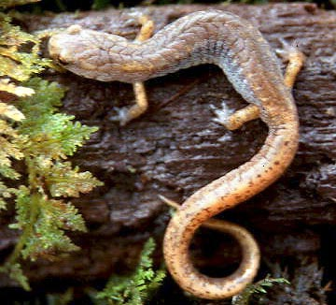
FOUR TOED SALAMANDER
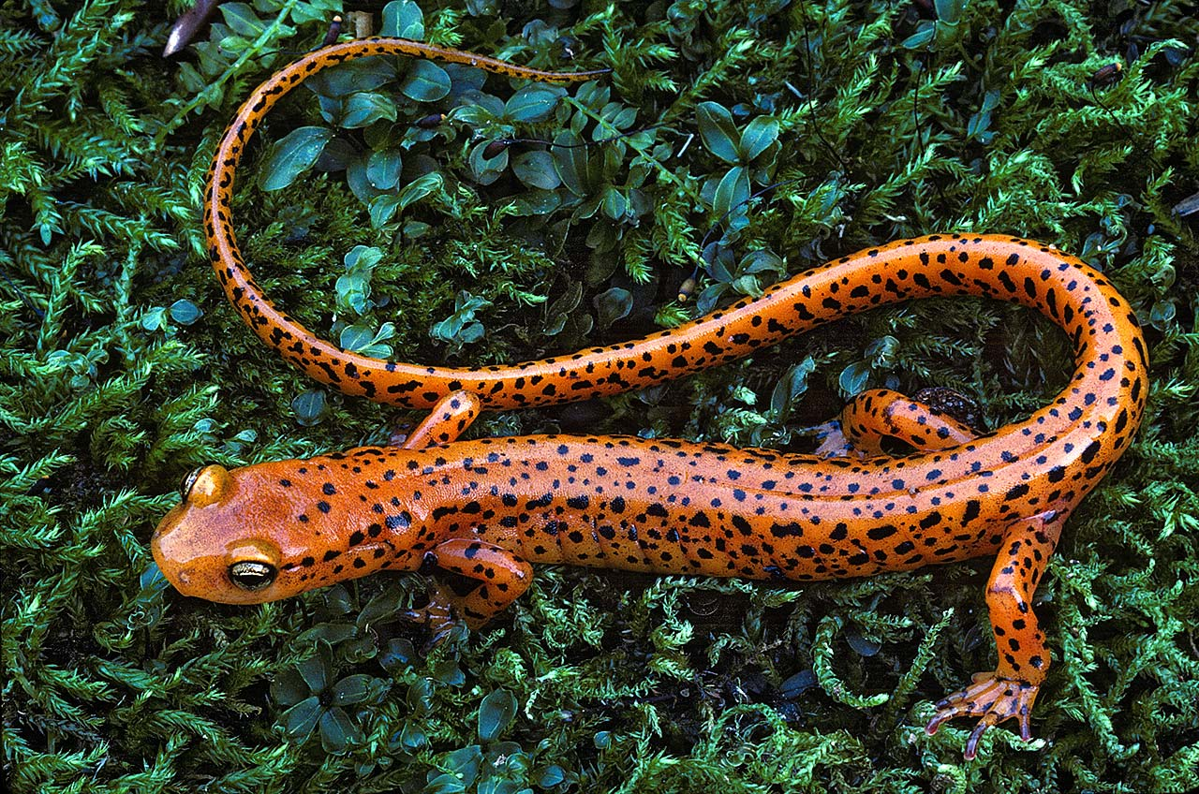
LONG TAIL SALAMANDER
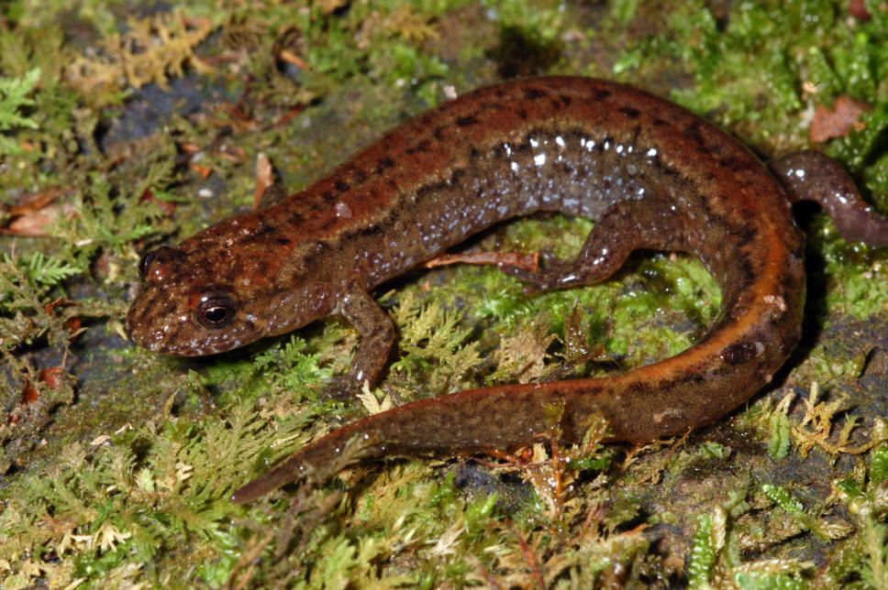
NORTHERN DUSKY SALAMANDER

- Threatened and Endangered Amphibians
- Endangered:

- Threatened:

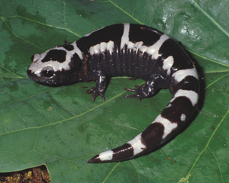
MARBLED SALAMANDER
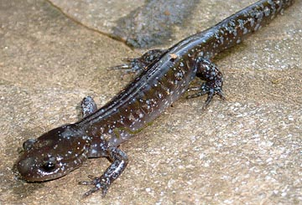
JEFFERSON SALAMANDER
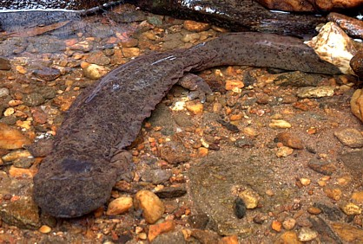
EASTERN HELLBENDER
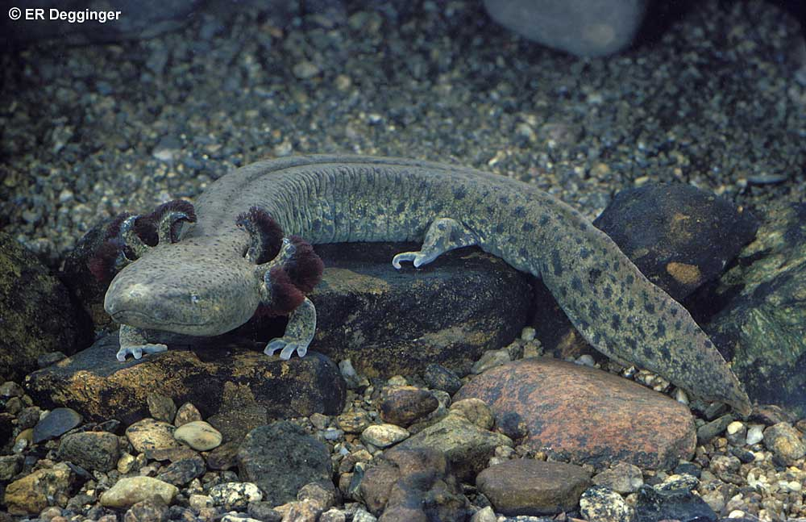
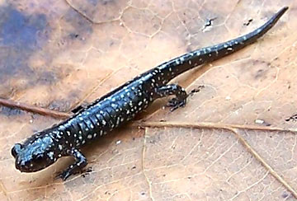
SLIMY SALAMANDER
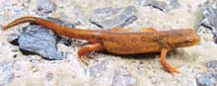
RED SPOTTED NEWT
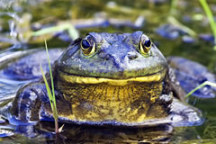
BULLFROG
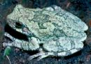
EASTERN TREEFROG
MUDPUPPY
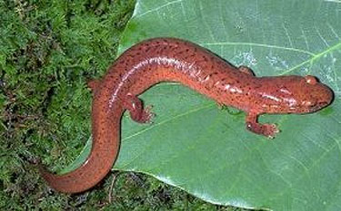
NORTHERN SPRING SALAMANDER
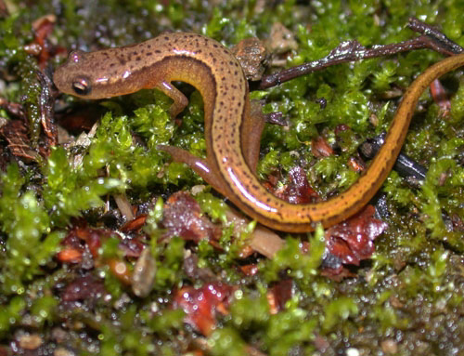
NORTHERN TWO LINED
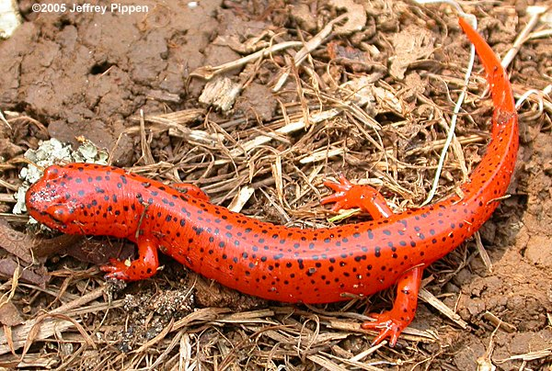
NORTHERN RED SALAMANDER
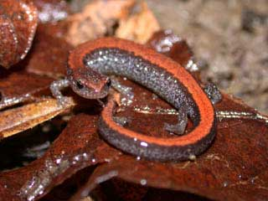
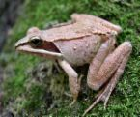
WOOD FROG
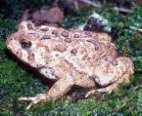
AMERICAN TOAD
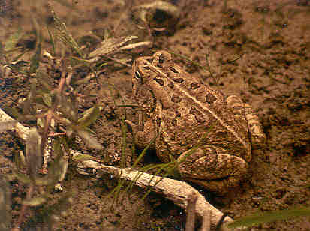
FOWLER’S TOAD
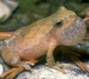Spring peeper
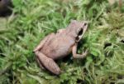Upland Chorus
NORTHERN REDBACK SALAMANDER
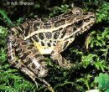
PICKEREL FROG

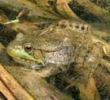
NORTHERN GREEN
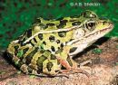
NORTHERN LEOPARD

