NAME__________________________________________Wildlife Notes – Moles, Voles, Mice, Rats-Mrs. Weimer
- Background Information
  - Prolific Breeders
  - At the base of the _____________________
  - __________________ Family
    - Indicated by two pair of constantly growing teeth
  - Hoarders of food stuffs
  - Live in nearly every habitat
  - Most feed at night and remain active year round
  - Gestation Period = ____ Weeks
  - Young are born without fur and eyes are closed
    - Mother nurses them, but within a month they are weaned and can reproduce themselves during their first year
    - Meadow Vole can give birth __________ and an average of ____ babies per year
- MICE & VOLES
  - Small creatures
  - Base of food chain
  - Prefer vegetation, will eat eggs, insects, snails, etc.
  - Feed at night, active ____________________
- Deer Mouse
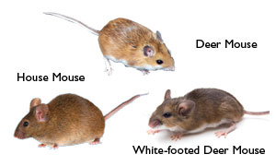
  - 2 forms:
    - ____________deer mouse
    - ____________ Deer Mouse
  - Omnivores
  - Have sharp hearing and eyesight
  - Can ______
  - Run at ___ miles per hour
  - Tail used for steadiness
  - Breed from March to October
  - 3-4 litters per year, ____ young per litter
- White footed mouse
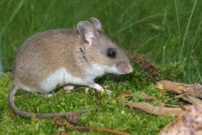
  - Most abundant _____________ in PA
  - Prefers ______________ habitat than deer mouse
  - Eat about ________of their body weight daily
  - Breed March-October
  - Males sometimes help females with young
- Meadow Vole
  - 6-7 inches long, so much bigger than _______________
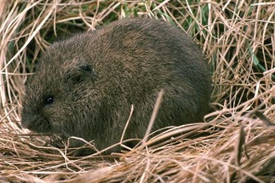
  - Thrive in moist environments and field with sedges
  - do not live in the forest
  - Good swimmers and can run at _____ mph
  - Use a network of ___________________ in the field
  - Eat grass and sedges, tubers, root grains, and can girdle small trees
  - Up to ______ voles can live per acre
  - Average litter is 4-6 with 5-7 litters per year

- Rock Vole
  - Limited to north east PA
  - Inhabits forests
  - __________________nose
  - Considered rare in PA
- Woodland Vole
  - Throughout PA
  - PA’s smallest vole at _______ inches long
  - Woodland bottomlands, forests, old fields
  - Burrows beneath the soil
  - Seldom leaving _________________________
  - _______________________ of food
  - Breed less prolifically than other voles
  - 1-4 litters per year with 1-5 voles per litter
- WOODRAT “pack rat”
  - Lives in remote, rocky habitats
  - Grayish-brown coat above, white below
  - Round ears, long whiskers, bulging eyes
  - Stockpile food & “_______________________” (skulls, feathers, bottle caps, coins, rags, etc.)
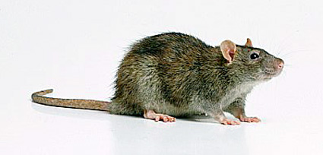
  - Woodland rat is AKA the ________________________
  - __________________ inches long
  - Arrived from Europe aboard ships around 1775
  - Have poor vision, but other sense well developed
  - Mainly nocturnal
  - Can eat_________________
  - They kill poultry, snakes, rats from other colonies, birds
  - _____________throughout the year
  - 6-8 litters per year 6-9 per litter
  - Carry many diseases:
    - 1
    - 2
    - 3
    - 4
- Southern Bog Lemmings
  - Looks like the meadow vole
  - Scattered throughout PA
  - Live beneath ___________________ and create runways above the ground
  - Often share (cohabitate) with moles, voles, mice
- SHREW
  - Food: mainly_________________ (“Insectivore”)
  - Usually less than 5”
  - Light brown or gray coat
  - Look like mice BUT – shrews have ____ toes/foot and mice have ____ toes/foot (front)
  - Sharp, pointed dark stained teeth
  - Beadier eyes and pointier noses than mice
  - One species has _______________________
  - Many species in PA - hard to tell apart
  - Very rapid metabolism (_______________ beats/min.) so starve to death easily

