In an animal, blood is the liquid in the circulatory system. All animals have blood, but its nature varies slightly from one species to another. However, the main components and functions of blood are the same in all animals. Blood, which is vital to the health and survival of all animals, consists of four major components. Blood has five main functions in the body. They are transport of oxygen and carbon dioxide, protection against disease, transport of hormones, transport of nutrients and wastes, and regulation of body temperature.
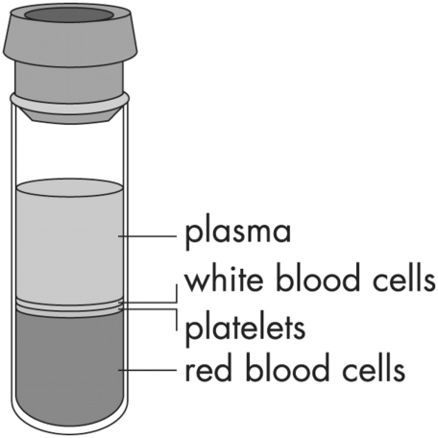
PLASMA
Plasma is the liquid substance in which various solid materials are suspended and moved about. Plasma is 90 percent water. The other 10 percent consists of glucose, hormones, wastes, minerals, vitamins, proteins, and other substances. Plasma makes up 50 to 60 percent of blood by volume. Plasma has a straw color when the solid materials are removed.
RED BLOOD CELLS
Red blood cells, or erythrocytes, are responsible for carrying oxygen from the lungs throughout the circulatory system. The oxygen is carried by a protein part of the blood known as hemoglobin. Red blood cells have flexible membranes that allow them to squeeze through the very smallest blood vessel. Red blood cells do not repair themselves. However, new red blood cells are made in bone marrow. The spleen and the liver remove the dead red blood cells. Scientists have found that one animal may possess a trillion blood cells.
WHITE BLOOD CELLS
White blood cells, or leukocytes, are responsible for fighting disease and removing harmful substances from the body. Four different kinds of white cells are found in blood. Some white blood cells surround and digest infectious bacteria. Other white blood cells produce antibodies. An antibody is a kind of protein that destroys bacteria, viruses, and other substances that invade the body. Animals that are diseased produce increased numbers of white blood cells.
PLATELETS
Platelets, or thrombocytes, are the structures in blood that are responsible for blood clotting. They are not complete cells and have a disk-like shape. In case of a wound, platelets stick to the edge of the skin and to each other to form a scab, or cover, that stops the flow of blood. Without platelets, an animal might bleed to death from a wound.

  - Materials Needed
Karo Syrup, Red Hots, Sprinkles, Granola oats, Unpackaged Smarties, Dixie Cups, Spoons, Clear Plastic Cup, and a Scale that reads in grams

Lab Procedure
Today, you will be asked to make a proportional model of a 50 g sample of blood.
- In your clear cup, measure 25.4 g of Syrup. (be sure to zero the scale after placing the cup and before pouring the syrup in)
- Set the clear cup of syrup to the side.
- Next, using the Dixie cup and a spoon, measure the following ingredients and add them to the syrup. (Remember to zero the scale after placing the Dixie cup and before pouring each ingredient.)
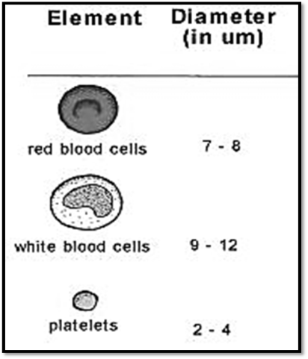
- 2.6 g of sprinkles
- 21.8 g of Red Hots
- 1.1 g of granola oats (you do not have to use whole pieces)
- 1.1 g of Smarties (you do not have to use whole pieces)
- Last, mix thoroughly with your spoon!
Before you consume, answer the questions!
  - Lab Analysis
- Draw what your sample looks like, be sure to use color:

- What did each ingredient represent? Label each component of blood with the appropriate edible material(s) that it represents.

Plasma-
Red Blood Cells-
White Blood Cells-
Platelets-

- Why does blood appear red?

- If animal was anemic (reduced red blood cells), what would blood sample look like? (draw it)

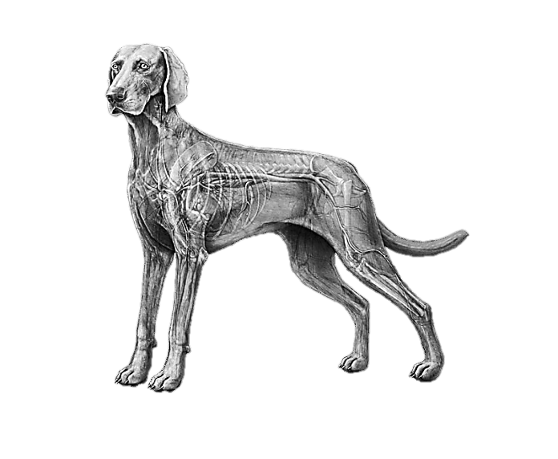
Name: ___________________________________ Date: ________________ Period: _________________

The Circulatory Systems of Animals

What is the Circulatory System?

Three Primary Types of Circulatory Systems:
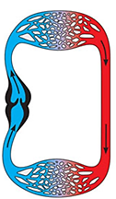 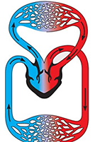 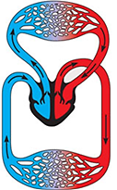
What animals have these types of circulatory systems?

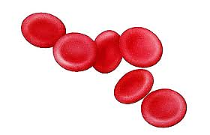
The Parts of the Circulatory System- Blood
- The liquid that _______________ in the blood vessels,
_________________ oxygen, carbon dioxide, waste, etc. around the body.
What is blood made of?

The Parts of the Circulatory System- Blood Vessels:
Veins Arteries Capillaries

The Parts of the Circulatory System- The Heart:
- This is the that is involved in the blood throughout the body.
- What are the parts of the heart?
VENTRICLE CHAMBER(s): ATRIUM CHAMBER(s): VALVES:

- Draw and describe the differences in the parts of 2, 3 and 4 chamber hearts.

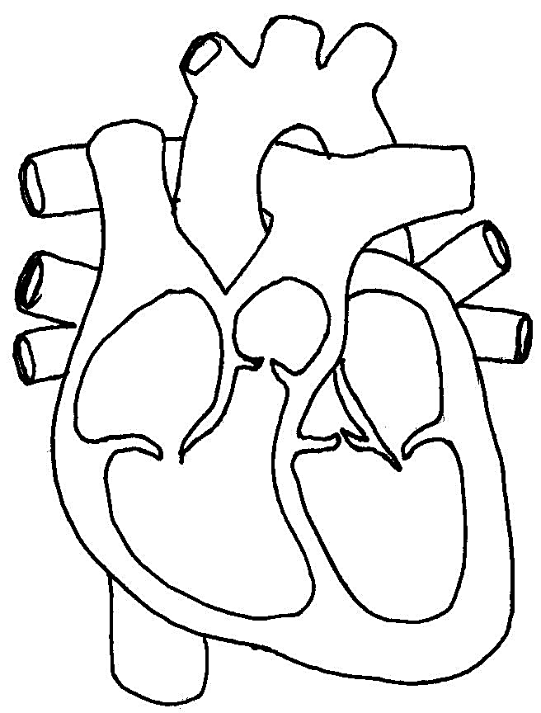
-Label each part of the below 4 chamber heart.
Determine how many chambers each of the following animals’ hearts have:
Horse:
Catfish:
Turkey:
Pig:
Trout:
Bull:

