NAME___________________________________________________Unit 8-Evolution-Mrs. Weimer
- The “Fog-Basking” Beetle
  - The “Fog-Basking” Beetle is a species that only lives in the deserts of southwestern Africa.
  - This beetle has an unusual behavior – it stands on its head.
    - This allows the beetle to collect water from the fog that passes by on its body.
    - The water then runs down into its mouth.
  - This is a behavioral adaptation, ______________________________________________________
  - Most of the beetle’s other characteristics are the same as every other beetle on Earth.
    - ______________
    - ______________
    - ______________
  - How did this new species of beetle evolve?
  - What is its relationship with other beetles?
- Evolution
  - Evolution is the theory that every species that exists on Earth is a _______________ of an ancient ancestor.
    - If you were to trace the history of any two species back far enough, they should eventually intersect.
      - All species have a _____________________________.
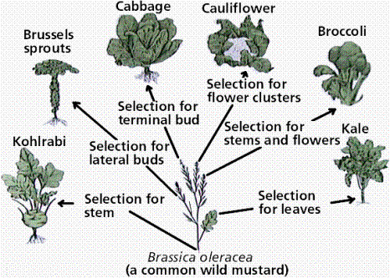
- Vegetable Evolution
  - COMMON ANCESTOR________________
  - Many of the green vegetables we eat came from the same original ancestor, and were bred for different characteristics.
  - This is an example of ____________________, because these breeds were created by human action.
- Evolution and Creationism
  - Before the theory of evolution was proposed, most of the world believed in some form of ___________________, where all species were created by a supernatural being.
  - This belief was held very strongly up through the mid-1800s.
- Fossils, Cuvier, and Catastrophism
  - The study of fossils helped to lay the groundwork for the development of the theory of evolution.
  - Fossils are remains or traces of organisms from the past, usually found in layers of rock.
  - Each layer of rock is called a _______________________
    - The stratum on the surface contains younger fossils.
    - The stratum deep below the surface contains older fossils.
- Cuvier and Paleontology
  - ___________________, the study of fossils, was largely developed by French scientist _______________________________
  - Cuvier made two observations from studying fossils:
    - Younger fossils were much more similar to living species than older fossils.
    - Between each layer of rock, some species disappeared, while other new ones appeared.
  - Cuvier had observed two phenomena:
    - _______________, or the emergence of a new living species.
    - _______________, or the complete disappearance of a species.
    - His theory to explain this, called ________________________, stated that each boundary line between strata represented a natural disaster that wiped out some of the species.
      - Example: ______________________
- Theories of Gradualism
  - Other scientists believed in __________________
    - This is the idea that profound change can take place through the cumulative effect of slow but continuous processes.
  - Geologists Hutton and Lyell theorized that changes in Earth’s surface can result from slow continuous actions still operating today. Aka_________________________
    - For example, valleys can be formed by rivers flowing through them and eroding the soil over time.
  - This view strongly influenced Charles Darwin
  - If slow, continuous changes occur in the Earth, they can also occur with life.
- Lamarck’s Theory
  - Lamarck hypothesized that can evolve new traits based on their actions and lifestyle.
  - According to his theory, the giraffe developed its long neck by _________ it to eat from trees.
    - This is called an ____________ because it developed over a single lifetime.
  - As the 19th century dawned, it was generally believed that species had remained unchanged since their creation
  - However, a few doubts about the permanence of species were beginning to arise
- Darwin’s Research
  - As a boy and into adulthood, Charles Darwin had a consuming interest in nature
  - Darwin’s father sent him to medical school, but he found medicine to be boring and quit.
  - He enrolled at Cambridge University to be become part of the clergy of the church.
    - Most scientists at this time were also clergymen.
  - After graduation, he went on a voyage around the world on a ship called the _____________.
  - The Voyage of the Beagle
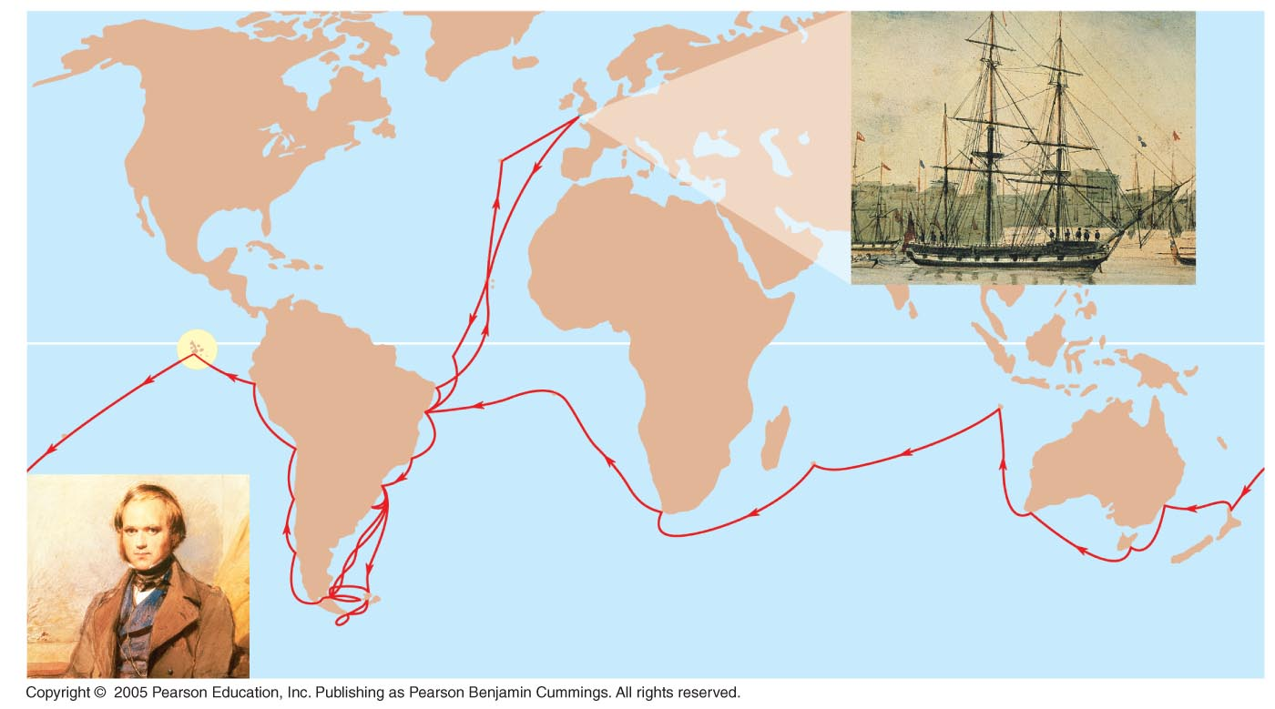
  - During his travels on the Beagle, Darwin was able to observe adaptations of plants and animals from many diverse environments.
    - ________________________
    - _________________________
    - _________________________
  - One of the most important visits he made was to the __________________ west of South America
- The Galapagos Islands
  - Darwin found animals on these islands that weren’t found anywhere else in the entire world.
  - He theorized that the animals had migrated from ______________ and then began developing specific adaptations to their new environment.
  - The Galapagos Islands
  - Darwin also noted that the animals on the Galapagos islands __________________________________.
- Darwin’s Focus on Adaptation
  - Darwin noted many _______________, or characteristics that enhanced the organisms chances of survival.
  - He began to form a theory that as organisms gradually accumulated new adaptations, they would form a new species.
    - One of the best examples of this theory is the different species of________ on the islands.
    - The birds were all very similar except for their ______________
- In ________, Darwin wrote an essay on the origin of species and natural selection but did not introduce his theory publicly, anticipating an uproar.
  - His theory suggested that new species developed over time naturally, not directly from God.
- In June 1858, Darwin received a manuscript from Alfred Russell Wallace, who had developed a theory of natural selection similar to Darwin’s.
  - Darwin quickly finished his book, entitled T______________and published it the next year.
- The Origin of Species
  - The ideas of Origin of Species can be summarized with these two main points:
    - Evolution explains life’s unity and diversity.
    - Natural selection is a cause of evolution.
  - Descent with Modification
  - Darwin did not call his theory “evolution”.
  - He used the phrase _____________________________________________________
    - This means that all organisms are_____________
    - All species came from a common _____________
  - In the Darwinian view, the history of life is like a tree with branches representing each new species.
    - Each new species is simply a “modified” version of its ancestor.
- Natural Selection and Adaptation
  - Charles Darwin’s theory can be broken down into five different observations.
    - Observation #1:__________________________________________________________.
    - Observation #2: _________________________________________________________
    - Observation #3: __________________________________________________________
    - Observation #4: __________________________________________________________
    - Observation #5: __________________________________________________________
    - Conclusion #1: More individuals are produced than the environment can support;
      - Frogs lay thousands of eggs at a time, but only about ____ survive to adulthood.
      - Inference #2: Survival depends in part on ______________________________
        - Individuals with traits that give them an advantage are more likely to reproduce and have offspring.
      - Inference #3: Individuals that reproduce the most will pass favorable characteristics to their offspring.
      - Over generations, these characteristics will _____________________
- Summary of Natural Selection
  - Natural selection is differential success in reproduction from interaction between individuals that vary in heritable traits and their environment
  - Natural selection produces an increase over time in adaptation of organisms to their environment
  - If an environment changes over time, natural selection may result in adaptation to these new conditions
- Modern Application of Darwin’s Theory
  - Darwin’s theory of evolution continues to be tested by how effectively it can account for additional observations and experimental outcomes.
No writing for Chiclids* or HIV Drug Resistance

- Evidence of Evolution
  - Evolution is ____________________
  - As a theory, some aspects of it may be changed as new discoveries are made, but there is a large amount of evidence to support the idea in general.
- Homology
  - According to the theory of evolution, if new species develop from common ancestors, they should share many physical features.
  - ____________ is the similarity between two organisms due to common ancestry.
  - Anatomical Homologies
  - _____________ are specific parts of the anatomy that show small variations on a common design.
    - Example:
      - Human arm: Used for lifting and using tools
      - Cat leg – Used for walking and climbing
      - Whale fin – Used for swimming
      - Bat wing – Used for flying
- ___________________________ is the common characteristics of two organisms in the embryo stage.
  - _________________ are remnants of structures that were important in the organism’s ancestors, but are no longer necessary.
    - In humans, examples of vestigial organs would include:
      - The appendix
      - Tailbone
      - Wisdom teeth
  - Molecular Homologies
  - Homology can also be present at the molecular level.
  - ______________________________________________________________________________ can be compared to see how closely related two organisms may be.
- Convergent Evolution
  - Organisms that are not closely related but live in similar environments may have similar adaptations. This is called _________________________
  - These organisms may ______________________, or adaptations with similar functions, but completely different structure.
- Biogeography
  - __________________, the geographic distribution of species, formed an important part of the theory of evolution.
    - Until about 200 million years ago, all the Earth’s continents were joined together in _________
    - Examples of Biogeography
      - Dinosaurs first evolved about 250 million years ago, before Pangaea broke apart. As a result, dinosaur fossils have been found in every _________________
    - The Fossil Record
      - The fossil record is the most important evidence of evolution.
      - If two species are related, then ________________ of species should exist. These are organisms that have characteristics of the ancient ancestor and the modern organism.
      - For example, if snakes and lizards are related, there should be evidence of snakes gradually losing their limbs.
- Species
  - A ______________ is defined as any two organisms who reproduce and produce fertile, healthy offspring.
  - One of the most important concepts in the theory of evolution is ______________________, or the development of a new species from one that already exists.
- How does Speciation Occur?
  - ________________________ causes a population to be divided into two isolated groups.
    - A large lake can shrink into two smaller lakes. The fish in each lake are no longer able to interbreed.
  - How does Speciation Occur?
  - ___________________________ is when one group within a population begins living in a different part of the habitat.
    - This group will start developing adaptations to match this new part of the habitat.
  - How does Speciation Occur?
    - ____________________ is when females select males on the basis of their appearance, ability to fight and dominate other males, or perform specific mating rituals.
    - A species is defined as a population of organisms that __________________________________________________________________________
    - Once two species are formed, why do they choose to not interbreed, or why can’t they interbreed?
  - Reproductive Isolation
    - Reproductive isolation any barrier that impedes two species from producing fertile, healthy offspring.
    - There are two types of barriers: prezygotic and postzygotic.
      - _______________________ prevent successful mating and fertilization.
      - _______________________ prevent the successful development and mating of the hybrid offspring.
  - __________________ is when a physical barrier separates a population.
  - __________________ is when two species live in the same general area rarely or never physically encounter each other because they occupy different habitats.
    - Two species of flies live in the same ecosystem, one in the soil, the other on the surface of the water.
  - ____________________ is when two species breed at different times of the day, different seasons of the year, or different years.
  - _______________________ is when courtship calls, dances, displays, or other rituals are required before mating will occur.
  - ______________________ is the genitalia of two species are physically incompatible.
  - Examples of unusual and unique genitalia of the animal kingdom..?
  - The Barnacle
    - The barnacle has a penis 50 times its actual body size.
    - This is a necessary adaptation because the barnacle is immobile; thus the length is required to actually reach their mate.
  - Marsupials
    - Most male marsupials have a forked penis with the scrotum and testes on the front.
    - This is a necessary adaptation because the female has a dual vagina and uterus.
  - The Pig
    - The pig has a corkscrew-shaped penis. Female pigs have matching shaped vaginas.
  - Honeybees
    - The genitals of the male honeybee snap off and explode once inside the queen.
    - In honeybee society, the queen lays the eggs while the workers are all female. The males have no other purpose except for mating.
  - Gametic Isolation
  - _______________________ is the inability of the gametes of the male and female to fuse.
  - The female immune system may recognize the male gametes of another species as foreign and attack them.
    - In this case, sperm and ova of the two species are chemically (genetically) incompatible, and will not fuse to form a zygote.
    - example
      - Sea urchins do not mate. They broadcast their gametes into the ocean where sperm and eggs fuse to form zygotes and then develop into larvae. The Giant Red Urchin (Strongylocentrotus franciscanus and Purple Urchin (Strongylocentrotus purpuratus) cohabit the rocky intertidal along the western U.S., but they do not interbreed. Their gametes are genetically/chemically incompatible, maintaining species integrity.
_______________________________________
  - The embryo is not able to survive to birth and is miscarried.
  - The offspring is born, but is not healthy or strong enough to survive to adulthood.
  - The offspring is born healthy but is infertile.

