NAME__________________________________________Unit 1 Earth Resources Rocks and the Rock Cycle
- What is a mineral (REVIEW) ?
  - A mineral is a naturally occurring inorganic solid, with a definite chemical composition, and an ordered atomic arrangement. (_____________)
  - Minerals are _______________________-humans do not make them
  - Minerals are _____________-They have never been alive and are not made up from plants or animals
  - Minerals are ________________-They are not liquids (like water), or gases (like the air around you)
  - Minerals have a definite __________________________-Each one is made of a particular mix of chemical elements
  - Minerals have an ordered atomic arrangement-The chemical elements that make up each mineral are arranged in a particular way - this is why minerals 'grow' as crystals

- Three forms of Rock
  - Igneous
  - Sedimentary
  - Metamorphic

- Igneous
  - Formed from _________________________

- Igneous Rocks-Physical Forms
  - ____________: light colored rocks that are rich in elements such as aluminum, potassium, silicon, and sodium
  - ____________: dark colored rocks that are rich in calcium, iron, and magnesium, poor in silicon
  - ____________: takes longer to cool, giving mineral crystals more time to grow
  - ____________: cools quickly with little to no crystals
- Igneous Rocks

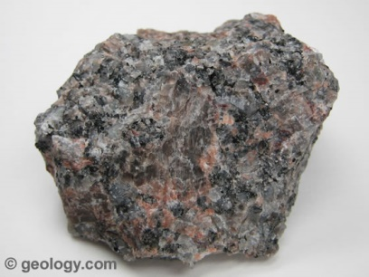
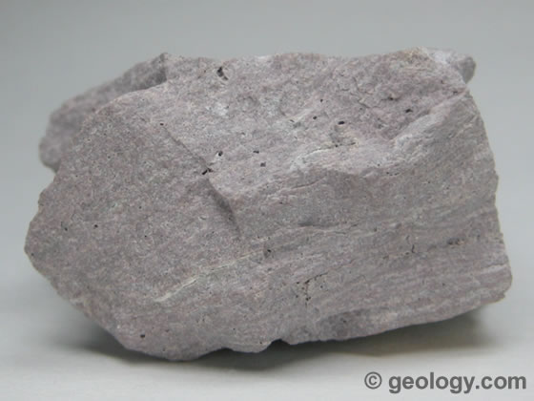

Rhyolite

Granite

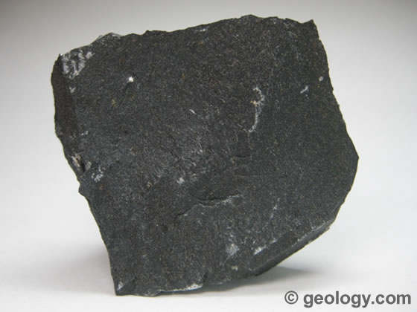
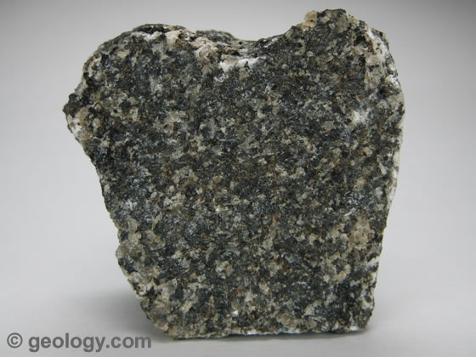

Basalt
Gabbro

- Types of Igneous Rocks
  - PLUTONIC
    - is intrusive igneous rock that is crystallized from magma slowly cooling ________________________ of the Earth.
  - Intrusive
    - Igneous rocks which form by the crystallization of magma at a depth ______________________
  - Extrusive
    - Extrusive refers to the mode of igneous volcanic rock formation in which hot magma from inside the Earth flows out (extrudes) onto the _______________________________________

Examples of Igneous Rocks
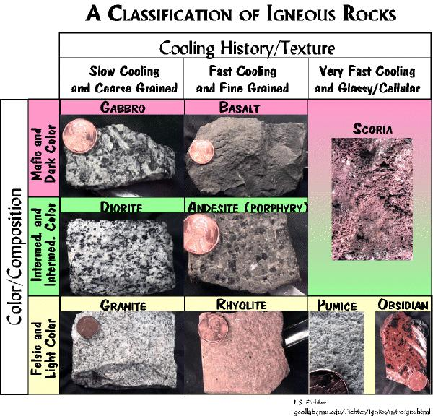

7. SEDIMENTARY ROCKS
a. Formed from igneous, metamorphic, or other sedimentary rocks. When these rocks are exposed at the earth’s surface they begin the long slow but relentless process of becoming sedimentary rock.
8. Cementation-TASK:
-on this paper (individually) in the next 3 minutes summarize how sedimentary rock is formed through cementation:

8. Erosion
a. Breaking down rocks and soil with ______________________________
9. Difference in WEATHERING AND EROSION
a. WEATHERING-No movement is involved in weathering,; it is the ____________________________
b. EROSION-when those weathered items are ________________________________
10. Sedimentary Rocks
- Sedimentary rock is formed by weathering and erosion
- Sediments are moved from one place to another
- Sediments are deposited in layers, with the older ones on the bottom
- The layers become compacted and cemented together-cementation

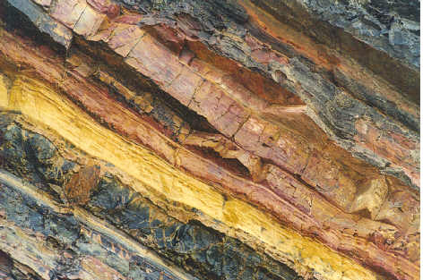
11. Sedimentary Rock
- Sedimentary Rocks are formed at or near the Earth’s surface
- No heat and pressure involved
- Strata – _____________________________________________
- Stratification – the process in which sedimentary rocks are arranged in layers

Sedimentary Rock
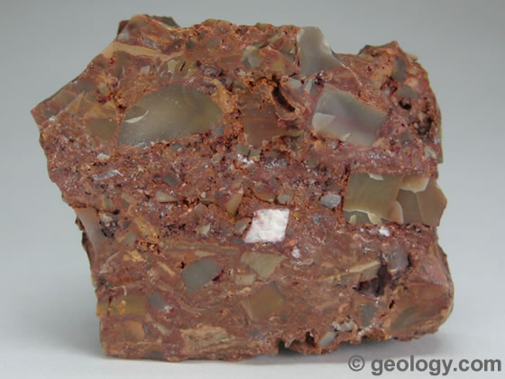
- Clastic – made of fragments of rock cemented together with ___________________________

Sedimentary Rock
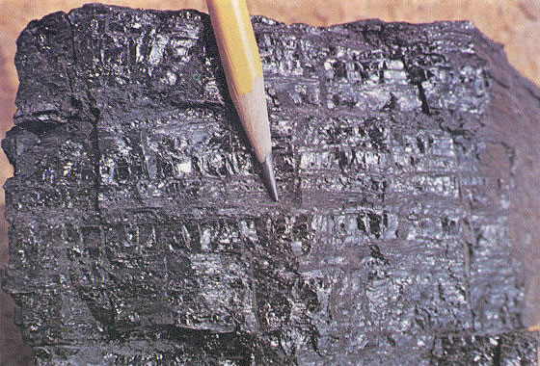
a. Organic sedimentary – remains of ______________________________

Sedimentary Rock
a. Chemical sedimentary – minerals _____________________________________ to become rock
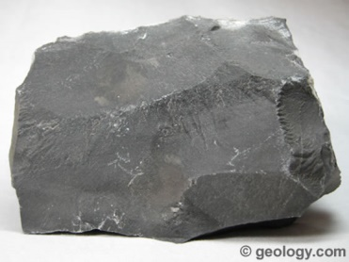

12. FOSSILS
- Fossils are generally found in sedimentary rocks formed by soft ____________________
- The soft sediment preserves the fine details in the bones, teeth, and leaves of plants.
- Sometimes sediments fill an opening in a bone or shell and leave behind a cast of the inside of the living thing.
- Plants are often fossilized in soft sediments which preserve the structure of the veins in the leaves.
13. TASK:

14. METAMORPHIC
a. FORMED FROM
- Heat and pressure
- Chemical Changes
- Foliation
15. Regional vs. Contact
a. Regional metamorphism is the creation of metamorphic rock from large geographically significant processes like ________________________________
b. Contact metamorphism is the creation of metamorphic rock from the proximity of an existing rock to a ____________________ provided by a plutonic intrusion.

16. Metamorphic Rock
a. Foliated - contain aligned grains of ____________________
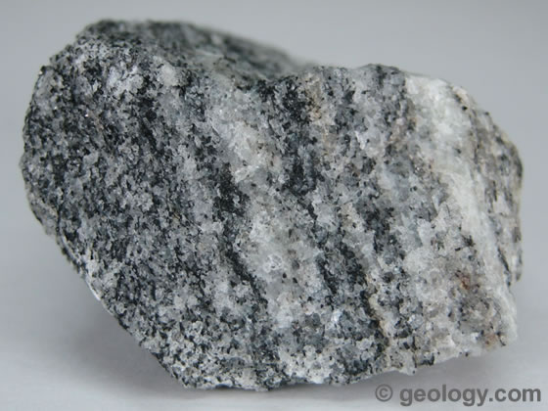

b. Non-Foliated – mineral grains are _____________________ in plains or bands
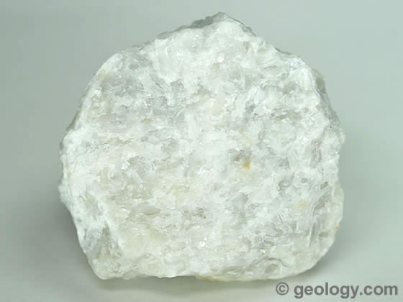

Intro to Rock Cycle
Rock Cycle

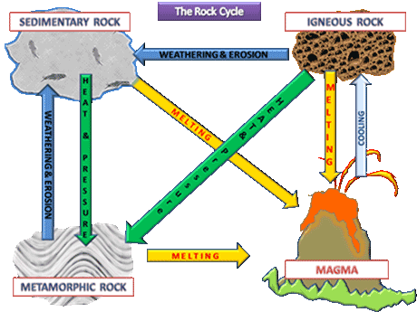

18. How to get rocks and minerals?
- MINING
- Strip Mining-a form of surface mining. The ore is ______________________________ of the land but has one or more layers of rock and dirt on top of it.

- Deep Mining- coal or mineral deposits by underground mining methods. 'Deep' is often interpreted as meaning _________________________________________

