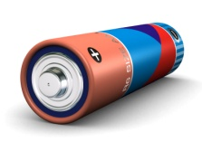
Name __________________
Batteries: All Charged Up

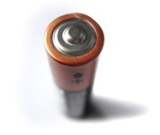
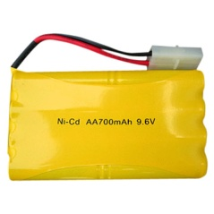
Date __________________

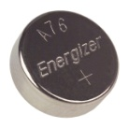
A Class Full of Experts
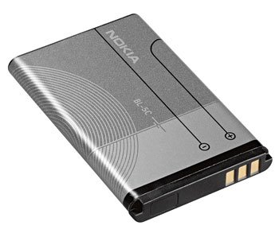
Directions: Because there are so many different battery types, your job is to become a class expert on one specific type of battery. Generally, batteries work from the same principal as we learned from the lemon battery experiment. First, we will delegate the type of battery that you will research. Then you will use the Internet to research information to complete the battery information chart. You need to complete a citation for each website that you reference for information. You may use the site http://citationmachine.net/ and type them on MS Word. The citation machine is located on the far left column of the page. Be sure to use APA citations. After 20 minutes you will present the information that you researched.
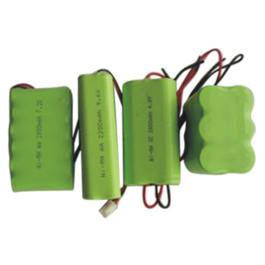
Paper Battery
Lead Sulfuric Acid
Alkaline / Zinc Carbon (non-rechargeable)
Battery Room
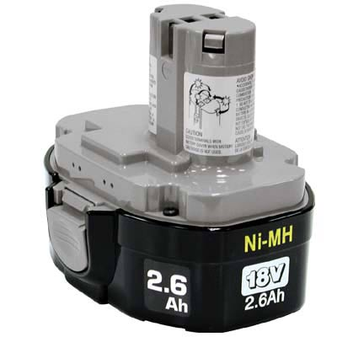
Nickel Cadmium (NiCd)
Penny Battery
Nickel Hydrogen (NIHZ)
Button Cell
Nickel Metal Hydride (NiMH)
Earth Battery
Lithium Ion (Li-ion)
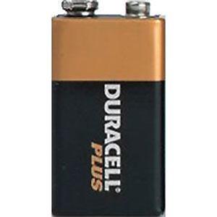
Zinc – Air Battery
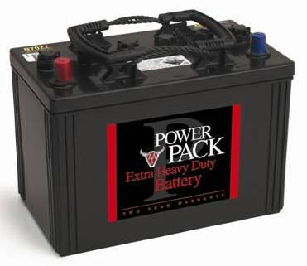
Lithium ion Polymer (Li-ion Polymer)
Frog Battery
Nanowire Battery
Molten Salt Battery

REMEMBER
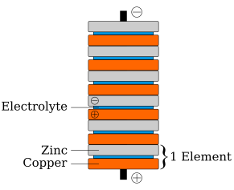
- Research your battery type from various sources
- Complete an APA citation for each website that you use
- Review your information
- As a specialized expert, present your information for the class

Name __________________
Batteries: All Charged Up

Date __________________
Type of Battery: ______________________________

What makes this type of battery function?
__________________________________________________________________________________________________________________________________________________________________________________________________________________________________________________________________________________________________________________________________________________________________________________________________________________________________________________________________________________________________________

What is the battery’s best application?
__________________________________________________________________________________________________
__________________________________________________________________________________________________

What is its life cycle? __________________________________________________________________________________________________
__________________________________________________________________________________________________

What is its average charging time? If you can not find this information, please write and interesting fact about it.
__________________________________________________________________________________________________
__________________________________________________________________________________________________
PRICE – Google It!
_____________________
DISADVANTAGES
ADVANTAGES

You can put this on a separate piece of paper. Please have four for each section.

Does it have a “memory”? __________________
What are its best charging practices?___________________________________________________________________
__________________________________________________________________________________________________
Attach the Works Cited
(LST LLC, 2008)http://citationmachine.net/
(Wikimedia Foundation Inc., 2009)http://www.youtube.com/watch?v=tr5ZB1eFhwc
(Daneboe, 2007)http://www.youtube.com/watch?v=nzgDffMcsUU
(Daneboe, Insane Car Battery Hack, 2007)http://www.youtube.com/watch?v=s_8n2Qgguto
(Biz/Ed, 2006)http://www.bized.co.uk/current/leisure/2006_7/250906.htm
(Boyd, 2008)http://xprizecars.com/2008/04/batteries-power-energy-and-uni.php
(AANT, 2007)http://www.aant.com.au/Membership/BenefitsofMembership/tabid/62/Default.aspx
(GERMES, 2005)http://www.germes-online.com/catalog/87/90/449/page6/269287/rechargable_battery_packs.html
(Mobile Geeks, 2008)http://www.mobile-geeks.com/how-to-save-your-mobile-phones-battery-life-while-you-sleep/153/
(GERMES LLC, 2005)http://www.germes-online.com/catalog/87/90/444/rechargeable_batteries.html
(Northern Tool + Equipment Catalog Co., 2009)http://www2.northerntool.com/power-tools/power-tool-accessories/item-1591773.htm
(Farm 3 Static, 2009)http://farm3.static.flickr.com/2023/2278454056_c63956c9a7.jpg?v=0
(Science Projecsts Resources.com, 2008)http://www.science-projects-resources.com/how-to-make-a-potato-battery.html
(Storage Battery Systems Inc, 2006)http://www.sbsbattery.com/subpage_index.php?_subp_=93
(Wikimedia Foundation Inc., 2009)http://en.wikipedia.org/wiki/Wet_cell
(Second Chance Garage, LLC, 2009)http://www.secondchancegarage.com/public/98.cfm
(Wikimedia Foundation Inc., 2009)http://en.wikipedia.org/wiki/Dry_cell

Works Cited
AANT. (2007). Benefits of Membership. Retrieved Januray 27, 2009, from AANT: http://www.aant.com.au/Membership/BenefitsofMembership/tabid/62/Default.aspx
Biz/Ed. (2006, September 25). Batteries Included. Retrieved January 27, 2009, from Biz/Ed: http://www.bized.co.uk/current/leisure/2006_7/250906.htm
Boyd, E. (2008, April 18). Batteries: Power, Energy, and Units. Retrieved January 27, 2009, from X Prize Cars: http://xprizecars.com/2008/04/batteries-power-energy-and-uni.php
Daneboe. (2007, September 17). 6 Volt Battery Hack. Retrieved January 27, 2009, from YouTube: http://www.youtube.com/watch?v=nzgDffMcsUU
Daneboe. (2007, December 11). Insane Car Battery Hack. Retrieved January 27, 2009, from YouTube: http://www.youtube.com/watch?v=s_8n2Qgguto
Farm 3 Static. (2009). Retrieved January 27, 2009, from Flickr: http://farm3.static.flickr.com/2023/2278454056_c63956c9a7.jpg?v=0
GERMES LLC. (2005). Rechargable Batteries. Retrieved January 27, 2009, from GERMES: http://www.germes-online.com/catalog/87/90/444/rechargeable_batteries.html
GERMES. (2005). Rechargable Battery Packs. Retrieved January 27, 2007, from Germes Online: http://www.germes-online.com/catalog/87/90/449/page6/269287/rechargable_battery_packs.html
LST LLC. (2008). Get Better Battery Life in Five Minutes. Retrieved January 27, 2008, from All Shadow . Com: http://www.allshadow.com/2008/07/21/get-better-battery-life-in-5-minutes/
Mobile Geeks. (2008, November 12). How to Save Your Mobile Phone's Battery Life While You Sleep. Retrieved January 12, 2009, from Mobile Geeks: http://www.mobile-geeks.com/how-to-save-your-mobile-phones-battery-life-while-you-sleep/153/
Northern Tool + Equipment Catalog Co. (2009). Makita Nickel Metal Hydride Rechargeable Battery — 18 Volt . Retrieved January 27, 2009, from Northern Tool + Equipment: http://www2.northerntool.com/power-tools/power-tool-accessories/item-1591773.htm
Science Projecsts Resources.com. (2008). How to Make a Potato Battery. Retrieved January 27, 2009, from Science Project Resources: http://www.science-projects-resources.com/how-to-make-a-potato-battery.html
Second Chance Garage, LLC. (2009). Automotive Electrical Systems - Part 1. Retrieved January 27, 2009, from Second Chance Garage: http://www.secondchancegarage.com/public/98.cfm
Storage Battery Systems Inc. (2006). Flooded Batteries. Retrieved January 27, 2009, from Storage Battery Systems: http://www.sbsbattery.com/subpage_index.php?_subp_=93
Wikimedia Foundation Inc. (2009, January 8). Dry Cell. Retrieved January 27, 2009, from Wikipedia: http://en.wikipedia.org/wiki/Dry_cell
Wikimedia Foundation Inc. (2009, January 24). Rechargable Battery. Retrieved Januray 27, 2009, from Wikipedia: http://en.wikipedia.org/wiki/Rechargable_batteries
Wikimedia Foundation Inc. (2009, January 10). Wet Cell. Retrieved January 27, 2009, from Wikipedia: http://en.wikipedia.org/wiki/Wet_cell

