NAME____________________________________________Wildlife Unit 2 Skull Identification-Mrs. Weimer
Identifying Carnivores, Herbivores, Omnivores, Predators & Prey
Teeth:
Label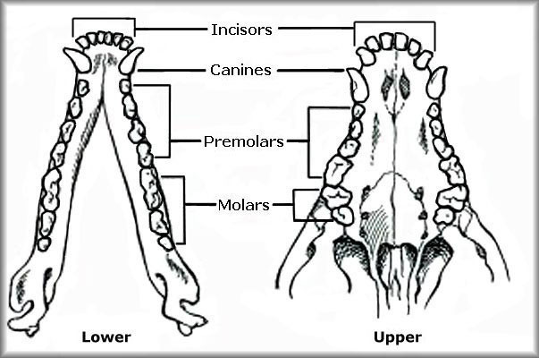
The teeth in an animal skull can tell us whether the animal was a carnivore (meat eater), herbivore (plant eater) or omnivore (meat and plant eater). The different types of teeth are:
- Incisors: middle teeth in the front
- Canine teeth: longer pointed teeth to the sides of the incisors
- Cheek teeth: pre-molars and molars, side and back teeth
Carnivores
Carnivores are predators and tend to bite, tear, and gulp down food without any chewing action. Their teeth tend to be clean and white because they are not stained by __________material. The teeth of carnivores can be identified by:
- Incisors: smaller and less developed
- Canine teeth: large, long, and pointed for ______________________________ prey
- Cheek teeth: sharp and pointed for cutting and tearing flesh, upper cheek teeth overlap the lower teeth, providing __________ shearing action to cut meat, they ____________ have the ability to move their jaws from side to side in a chewing motion
Herbivores
Herbivores are prey animals who need to rapidly ingest food when they have the opportunity so they can avoid being eaten by predators. Many are ________________ who ingest large amounts of plant material, then seek cover after eating to regurgitate and chew their cud while watching for predators.
- Incisors: large, well-developed for cutting plant material
- Canine teeth: resemble the incisors in form and function, flat and non-pointed, many herbivores do not have upper incisors or canines, instead they have a hard, flat upper palate that serves as______________________ for the lower incisors to cut through plant stems
- Cheek teeth: large and wide for grinding and chewing plant material, do not overlap, instead they make surface contact to provide a __________________________
Omnivores
Omnivores have a combination of carnivore and herbivore teeth characteristics. Many omnivores are either predominantly meat eaters or predominantly plant eaters. This can be determined by looking at their cheek teeth to see if they are more sharp and pointed like a carnivore’s, or more large, wide and flat like a herbivore’s.
- Incisors: fairly large and well developed for cutting plant material
- Canine teeth: long and pointed for killing and holding prey
- Cheek teeth: combination of sharp, scissor-like canine teeth for shearing meat and teeth with rounded edges for grinding and crushing plant material, allow some contact between upper and lower molars, but _______________ have lower jaw movement for chewing, instead their cheek teeth perform both __________________________ actions
Predator and Prey
- ______________________ are animals that eat other animals and_________________ are animals that are eaten by other animals. Predators can also become prey. Ex. When a cat eats a mouse, the cat is the predator. When the cat is then eaten by a coyote, the cat is prey.
- Predators are always _______________________, whereas prey can be carnivores, herbivores, or omnivores.
- When examining skulls to determine predators, look for teeth characteristics of a _______________________. If the teeth characteristics are strictly those of a herbivore, the animal must be a prey species.
Eyes
The size of the orbits (eye sockets) in relation to the overall size of the skull is good indicator of the sharpness of an animal’s eyesight. In general, the ______________ the orbits, the better the animal’s eyesight.
- Predators: most predators have eyes located in a forward position on the skull, this provides the animal with ________________vision which means that both eyes focus on a object and the animal has a greater ability to judge distance, an advantage when attacking prey
- Prey: eye orbits are located on the __________________ which limits binocular vision, but provides greater ____________ vision which means they can see an object with only one eye, they have a greater field of view or peripheral vision, almost 180 degrees with each eye so they can almost see in a complete circle around their heads, giving them a greater ability to locate predators
Nasal Passage
The size of the nasal passage on a skull in relation to the overall size of the skull is an indication of the animal’s sense of smell. The thin bony structures inside the nasal passage provide the framework for membranes which sense odor, the greater the size of these structures, the greater the sense of smell. Examining the size of the nasal passage of an animal’s skull can help you identify the type of animal.

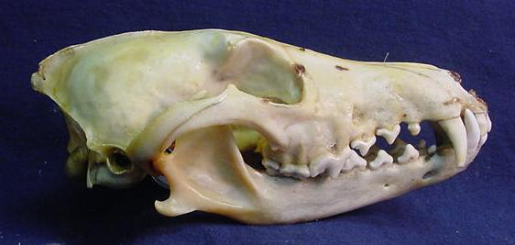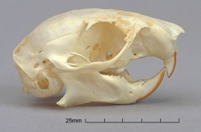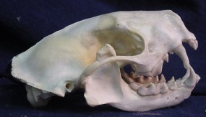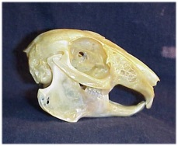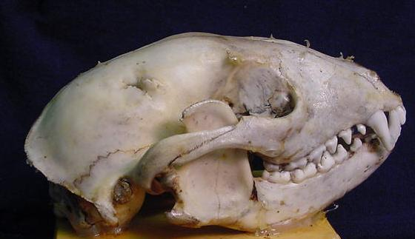

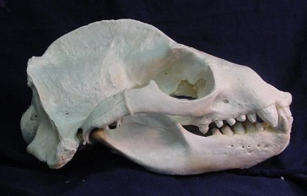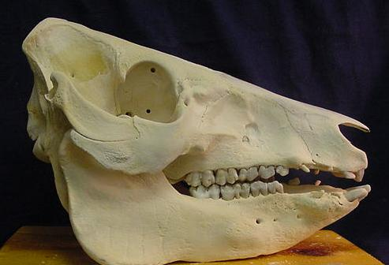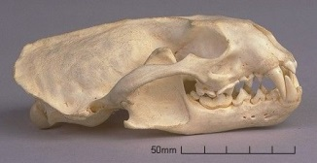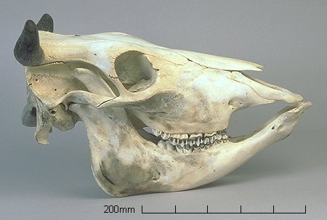

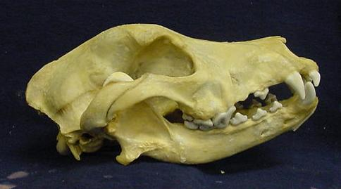

Label them and decide Omnivore, Herbivore, Carnivore

