Name_________________________________________________Wildlife Notes 1-10-Mrs. Weimer
- What is Population Ecology?

- What is R and K Selection?

- Squirrels

- ALL SQUIRRELS
  - See in ______________ only
  - Use their __________ to balance
  - Most active in the morning and early afternoon
  - _________________ species
  - Born blind and completely depend on mother
    - Up to ____ months

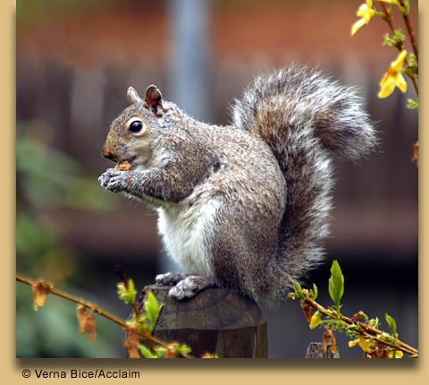
- Five Pennsylvania Species
- Gray Squirrel
Sciurus carolinensis
- most familiar and most common in PA
- ____small game animal
- deciduous (oak/hickory)
- “_____________”
- store nuts singly (lose 75%)
- barks
- dawn & dusk
- Other facts:
  - Albinism is rare, but ________________________(black) common
  - Eat acorns, hickory nuts, walnuts, beechnuts, berries, mushrooms, corn
  - Max life span _______________________________
  - _______ day gestation period, females bear litters of 4-5 in early spring with a second litter in late summer
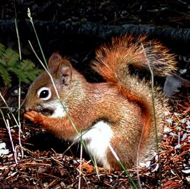
- Red Squirrel
Tamiasciurus hudsondonicus
- “Busy-body”
- Loud, alert
- AKA Chickaree or ground squirrels bc of their ______________________
- ___________-so they do not bury nuts, but keep them in a large hollow log
- Other facts:
  - About ____________ the size of a gray squirrel
  - ____________ day gestation period
  - Have extreme ____________________

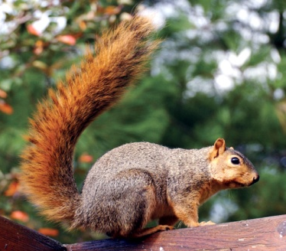
    - Fox Squirrel
    - Sciurus niger
- W/SW PA
- _________ in PA
- Woodland “edges”
- Active at _______________
- Other facts:
  - They never actually hibernate
  - Fox and gray seem to get along
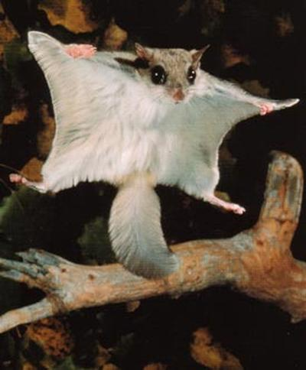
- Flying Squirrels
Glaucomys volans
- Skin flaps
- “Glide”
- __________________________
- large red eyes
- social
- Other facts:
  - Mainly________________, but some forage on the ground
  - Nest in hollow tree cavities
  - Will also eat bugs, beetle, larvae, fungi, small mice, shrews
- FACTS ABOUT SQUIRRELS
- Once grays were so abundant that bounties were paid to kill them (1749)
- _______________________________________ per acre is a good density
- Habitat: oak hickory and beech-birch-maple
- Chipmunk
Tamius striatus
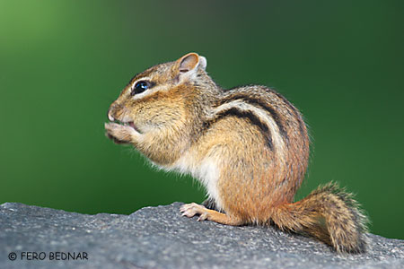
- stripes, cheek pouches
- smallest in PA
- ____________________________________
- Estivation-_____________________________________________________
- Same FAMILY as the squirrel
- “cache”
- Other facts:
  - Also related to the ____________________________
  - Makes a chirping noise
  - Omvivorous-seeds, nuts, eggs, insects, worms
  - Also not a true hibernator
  - Gestation: _________ days
  - Deciduous forest habitat
#3 Bobcats
- Bobcat
Lynx rufus
- PA’s only ________________
- Resembles a _____________
- Retractable claws______, large eyes, raspy tongue
- Carnivore - hunting based on stealth, ambushes prey
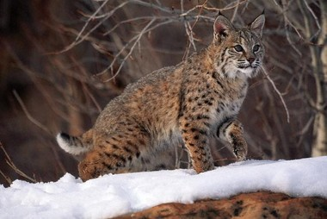
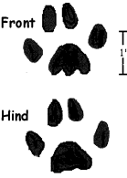
- K-selective
- Facts:
  - AKA: lynx, wildcat, swamp tiger
  - __________________________
  - 15-30 pounds
  - Mainly nocturnal
  - Strong swimmer
  - Gestation: ______________ days
  - Life span: 14 years
  - Current population __________in PA with very limited hunting and trapping
  - Remote areas
  - Age determined ______________________________ (cementum annuli)
  - _________ vertical leap
  - Bounties paid until 1938, protected from 1970-2000
  - Limited trapping begun in 2000-2001
  - Order = Carnivora Family = Felidae

#4 Cottontail Rabbit
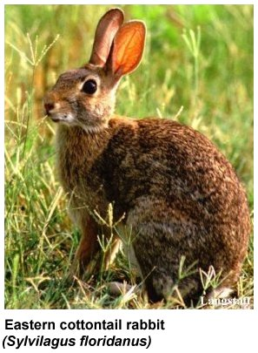
- Eastern Cottontail Rabbit
Sylvilagus floridanus
- PA’s _________________________
- Males- ___________Females- _____________
- Prefer fields, farms, brushy areas
- r-selective, high reproductive potential
- Herbivore (___________________________________________)
- #’s increased with ___________________________
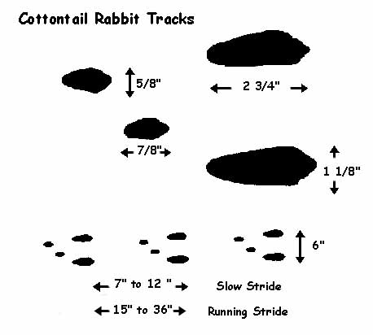
- Life-span = < 1 year in the wild
- Order = Lagomorphia Family = Leporidae
- Other facts:
  - _________________________________
  - Run in a _________ pattern
  - _________take no part in raising young
  - Prefer grasses and clover
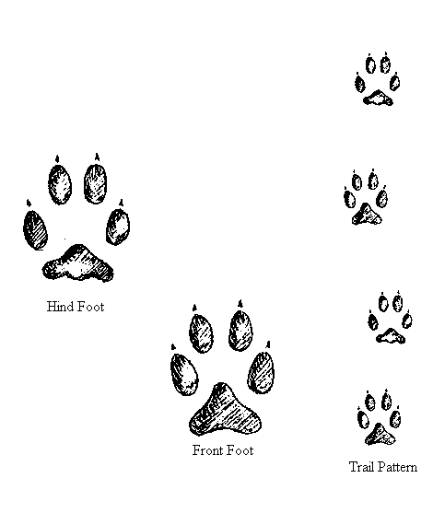
#5 Gray Fox
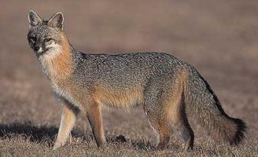
- Gray Fox
Urocyon cinereoargenteus
- Opportunistic omnivore
- K-selective
- Can _____________________
- Slightly ____________________ than red
- Hunted and trapped
- ___________________
- ♂- __________, ♀- _________, Young- ___________
- Order = Carnivora
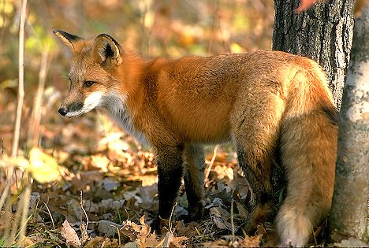
- Family = Canidae
#6 Red Fox
- Red Fox
Vulpes vulpes
- Opportunistic Omnivore
- K-selective
- Slightly________ than gray
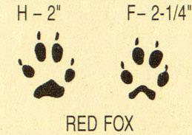
- Imported from Europe for hunting
- Reputation for being “sly” & “cunning”
- Hunted & trapped (red light, calls)
- Black ears & “socks”, White-tipped tail
_________________= dogs,_______________= vixen, young = pups/kits
- Order = Carnivora Family = Canidae

  - Facts:
    - __________________ seem to be pushing foxes out of their habitats
    - Red and gray can coexist without a problem
    - Density of one per ______________ acres is appropriate
    - Can eat whatever is obtained-fruit grasses, rodents, insects, cats, chickens, etc
    - ___________________is a problem
#6 Woodchuck
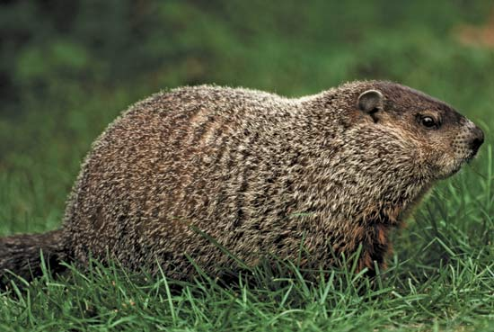
- Woodchuck
Marmota monax
- Senses located on top of the head
- Large, white incisors
- May suffer from _______________ - abnormal growth of incisors
- Prefer farms, fields, and orchards
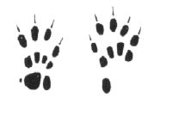
- #’s _______ with human settlement
- Extensive underground tunnel system
- Herbivores
- K-selective
- True _____________________
- “Groundhog’s Day”
Feb. 2nd, “Punxsutawney Phil”
- Can _______________________
- Order = Rodentia
- Family = Sciuridae
- Other facts:
  - Weigh from 5-15 pounds
  - Keen sense of sight, hearing, smell – all located at the ___________________________
  - Can fight very well and will take on coyotes, etc
  - A population that can absorb heavy hunting and still produce offspring at a high rate

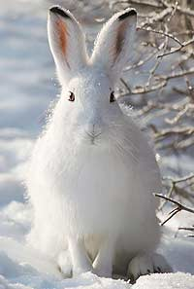
#7 Snowshoe hare
- Snowshoe/Varying Hare
Lepus americanus
- _________- hair falls out and is replaced Summer / Winter
- Responds to changing periods of light (__________________________)
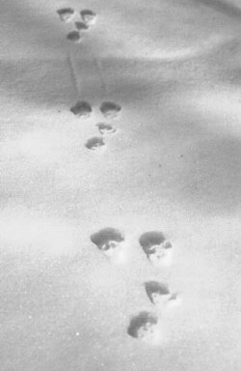
- K-selective (vs cottontail)
- Large, 6” rear feet
- Northern climates, remote spruce forests
- Limited hunting (3-5 days)
- Population decreased with human settlement
- Males- ________________________
- Females- _______________________
- Young- l________________
- Order = Lagomorpha Family = Leporidae

#9 Raccoon
- Raccoon
Procyon lotor
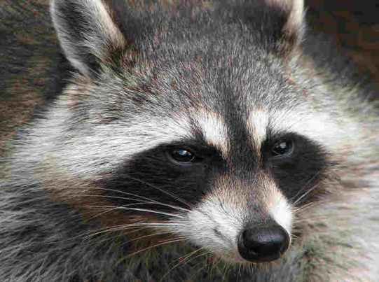
- “Masked bandit”, ringed tail
- Acute sense of touch, dexterous forepaws
- Opportunistic _________________
- “dunks” food
- Adaptable to many habitats, great _____________________
- Trapped and hunted
- Can be vicious if cornered
- Communication system
- Victim of __________________________
- Order = Carnivora Family = Procyonidae
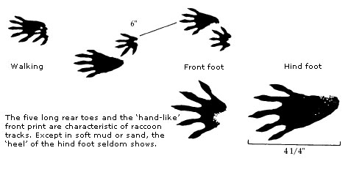
- Facts:
  - ____________________________
  - Excellent sense of hearing, touch, sight, smell
  - Nocturnal
  - Life span – ________________ years
  - Adaptable habitat
    - Favoring hardwood and coniferous trees

