NAME ________________________

DATE _________________________
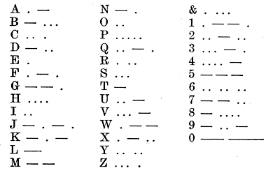
Hello Operator!
STEP 1:
Now that you know how to wire your door bell system, the next step is to try to communicate with it. With your partner, remove the two different sections of wire with alligator clips that connect to the door bell and replace them with the two 15’ of red and black wire. Connect them in the same places as the wires that you removed.

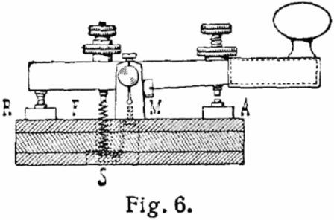

STEP 2
- Get your Engineering Journal and take it with you
- Decide who is going to send and who is going to receive the message
- Carefully stretch the red and black wire so that you and your partner are now approximately 15’ apart
- The sender (person who will turn the switch on and off) needs to write a very brief message in their Engineering Journal that they want to send. Use 5 words or less.
- Use the Morse Code chart above and write the code beside your message (see below)
T C . . . I . . A .
H . . . . L S . . . W .
I . . A . E .
S . . . S . . . S . . .
S . . . O . .
M
E .

- Transmit the message that you wrote. Make sure to leave obvious pauses between words.
- Don’t tell the receiver the message! If they could not decode your message, try it again.
- Switch sides and let the other group member send a new secret message that they wrote in the Engineering Journal.
- Now share your message with each other. If time permits, you may try to resend the message if it was not understood the first time.
STEP 3
DIRECTIONS: Answer the following questions and complete the chart information.
- Explain how changing the amount of tension on the wires affects the communication of the message.
_______________________________________________________________________________________________
_______________________________________________________________________________________________
_______________________________________________________________________________________________

- Explain what would happen if you touched the wires during the transmission of the message (think in comparison to the string & cup phones).
_______________________________________________________________________________________________
_______________________________________________________________________________________________
_______________________________________________________________________________________________

- What would happen if you tried to send a message around a corner?
_______________________________________________________________________________________________
_______________________________________________________________________________________________
_______________________________________________________________________________________________

- In your opinion, do you think that changing the lengths of wire would change the ability to send the message?
_______________________________________________________________________________________________
_______________________________________________________________________________________________
_______________________________________________________________________________________________

5. – 15. Complete the PROS & CONS for using the doorbell system as a Morse code device to send messages. This section is worth 10 points so pack as much as you can into each side!
CONS
PROS

16. – 17. Why do you think that the S.O.S message that people use was kept as simple as possible? Can you think of a situation other than sinking ships that would use the message to communicate the need for help?
_______________________________________________________________________________________________
_______________________________________________________________________________________________
_______________________________________________________________________________________________
_______________________________________________________________________________________________
STEP 3
Using extra wire leads, arrange the system so that an “operator” group in the center of the room can direct connections between students. Transmitters may tell the operators aloud to whom they want to send a message to. Try sending a simple message again.

STEP 4

Dissassemble and return all materials back to the yellow bins. Put the black caps back on the 9 volt batteries.

18. How would the addition of an “operator” change the Pro/Con chart for the Buzzer Telegraph system?
_______________________________________________________________________________________________
_______________________________________________________________________________________________
_______________________________________________________________________________________________
_______________________________________________________________________________________________
19. What additional features does this communication system need to make it “useful” for home use?
_______________________________________________________________________________________________
_______________________________________________________________________________________________
_______________________________________________________________________________________________
21. – 23. Identify at least three subsystems used in this model.
A. ___________________________________________________________________________________________
B. ___________________________________________________________________________________________
C. ___________________________________________________________________________________________

- What subsystems would need to be “substituted” to turn this into a modern telephone system?
_______________________________________________________________________________________________
_______________________________________________________________________________________________
_______________________________________________________________________________________________
25.–30. On the back of this paper draw a universal systems model for the original doorbell telegraph design from STEP 1.
30.- 40. On another piece of paper, draw a wiring diagram for the system from STEP 1. Don’t forget to add the positive + and the negative – labels on the wires. Label: Doorbell, Electromagnet, Battery, Switch

