Island Watershed Activity
Background
In order to understand many of the important water-related issues that society faces, students need to understand the existence and dynamics of watersheds (a.k.a. drainage basins). This will help them realize how an abandoned mine can cause the presence of dissolved metals in a stream many miles from the mine site, and how farming practices in the Midwest and the Northeast can contribute to a "dead zones" in the Gulf of Mexico and the Chesapeake Bay. This activity will help students learn about the watersheds, giving them the foundation needed to understand these issues.
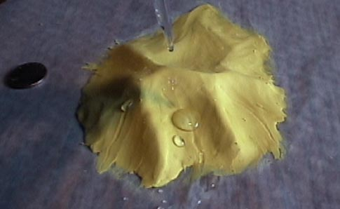
Materials
Modeling clay (60-75 cubic cm), Eye dropper with water, Wax paper ~35 x 35 cm, Metric ruler, Graph paper (.5 cm x.5 cm squares or similar), Blue thread (~30 cm), Scissors, Red thread (~50 cm), Colored pencils
Learner Outcomes
1. Understand the relationship between topography and drainage.
2. Recognize that runoff from a certain area as the primary source for water in a stream.
3. Apply principles and terms associated with surface water systems, including watershed, drainage basin, upper, lower, divide and tributary.

Procedures:
1. Lay the wax paper on your table and then use the clay to build an island. Design the island so that the maximum height is less than 3 cm. The island should have at least 4 distinct drainage basins. The shape and/or size of at least one of these basins should be much different than the others. Its best toavoid creating lakes, craters, cone-shaped peaks, and unrealistic landforms.
2. Use an eyedropper containing water to determine the approximate location of 4 (or more) of the island’s largest rivers. Do this by gently dropping water from 3-6 cm above different locations on the island. Watch the path of the drops as they run off the island. If a drop gets "stuck", simply add more water to the drop. Eventually it should flow off the island. You may reshape the island to get the rivers where you want them to be.
3. Once you are satisfied with the drainage of the island, use pieces of blue thread to mark the location of the island’s 4 (or more) major rivers. Press the thread gently into the clay to keep it in place. You will need scissors to cut the thread.
4. Next, use red thread to mark the boundaries of the watersheds of each river that you have identified (at least 4).
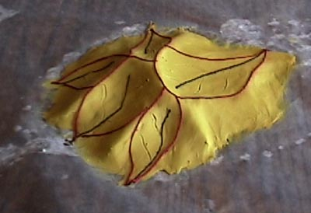

Here are some common mistakes:
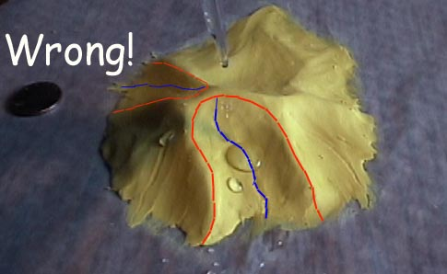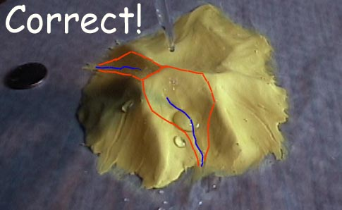
Above: The image on the left shows three common mistakes. For one, rivers do not typically originate at the highest point in a watershed. Usually, the headwaters are some distance below that point as shown on the right. Secondly, the divides are drawn incorrectly. They include more land (near the coast) than they should. The image on the right shows more realistic watershed boundaries. Finally, in the image on the right, there is a gap between boundaries of the two basins. In reality, water at the top of that ridge will drain into one basin or the other, so a single line (divide) like that shown on the right would be correct.

5. Lightly scratch the clay with the tip of a pen or pencil to show the possible locations of 2-5 tributaries for each stream that you have identified with blue thread.

6. Next, make a map of your island. First, cut the island away from the wax paper. Place the model onto a piece of graph paper, and then trace the edge of the island onto the paper. Set the model aside and then draw each of the following onto the map: major rivers (blue), tributaries (blue), boundaries of drainage basins (red).
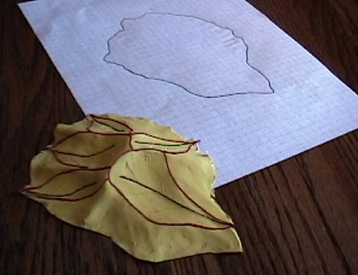

8. Do each of the following to your map:
a. Identify which direction will be "north".
b. Give your island a name . . . place it at the top of the map.
c. Put arrows on all of the rivers (including tributaries) to show flow direction.
d. Name each of the major rivers (blue thread). Write these names along rivers.
e. Put a green X in the upper part of each drainage basin.
f. Put a green Z in the lower part of each basin. g. Include a scale on your map (should show both kilometers and miles).
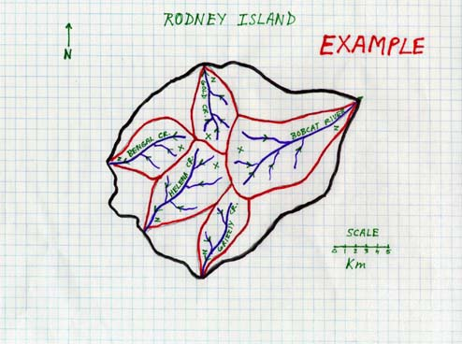
9. Determine the length of the longest channel on the map.

10. Determine the area of the largest watershed on the map.

11. Choose one of the following two options:
A. Imagine that there is a city near the mouth of the river that has the largest watershed that depends on this water for its people. Create a problem in the upper part of this basin that threatens this water supply. On a separate sheet of paper, write a newspaper article (complete with title) describing the problem and explaining how it will impact the water supply for the city. (3-5 good paragraphs should do)

B. Obtain a piece of 12" x 18" construction paper. Draw and color a scene that shows a portion of one of the watersheds on your island. The scene should include the river and vegetation, as well as whatever else you envision present in the area.

