Name __________________________

Why Do Airplanes Fly?
VOCABULARY

Date ___________________________

Four forces keep an airplane in the sky. They are lift, weight, thrust, and drag.

Use the link from Mr. Kush’s website to define the following vocabulary words

lift - ______________________________________________________

__________________________________________________________

__________________________________________________________

__________________________________________________________

weight - ___________________________________________________

__________________________________________________________

__________________________________________________________

thrust - ___________________________________________________

__________________________________________________________

__________________________________________________________

__________________________________________________________

drag - _____________________________________________________

__________________________________________________________

__________________________________________________________

__________________________________________________________

Directions: Label the following in the diagram below

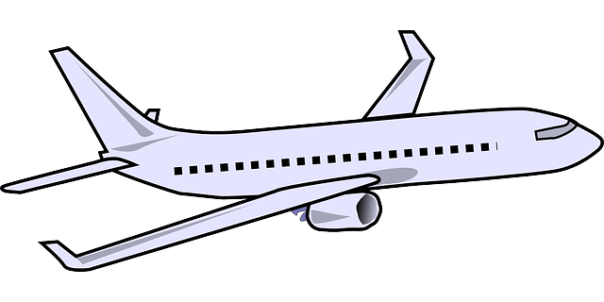
lift weight thrust drag

