Unit Resource Sheet-GRADE 7-Rocks and Minerals Mrs. Weimer
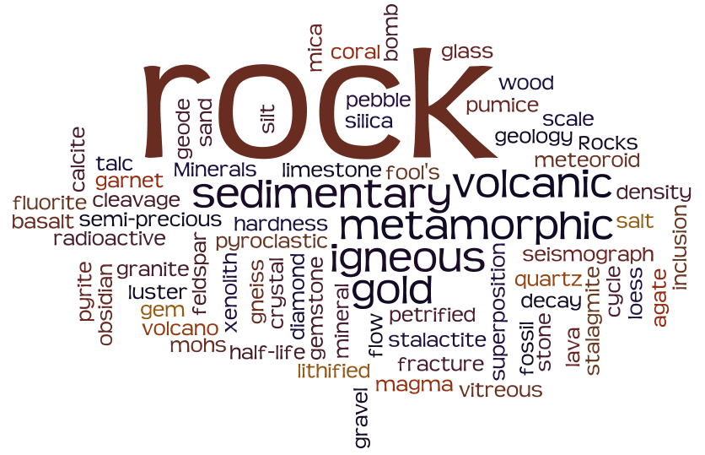
Mrs. Weimer Website:
http://www.rockwoodschools.org –Ms. Weimer (Science)
lweimer@rockwoodschools.org
phone extension 204

RESOURCES:
- Textbook
  - RED Integrated Science UNIT 2
- Mineral Self-Assessment
  - http://www.phschool.com/webcodes10/index.cfm?fuseaction=home.gotoWebCode&wcprefix=cja&wcsuffix=1030
- Rocks Self-Assessment
  - http://www.phschool.com/webcodes10/index.cfm?fuseaction=home.gotoWebCode&wcprefix=cfa&wcsuffix=1050
- Quizlet:
  - http://quizlet.com/_kknpv
- Applets:
  - http://www.classzone.com/books/earth_science/terc/content/investigations/es0602/es0602page02.cfm

Unit Resource Sheet-GRADE 7-Rocks and Minerals Mrs. Weimer
Mrs. Weimer Website:
http://www.rockwoodschools.org –Ms. Weimer (Science)
lweimer@rockwoodschools.org
phone extension 204

RESOURCES:
- Textbook
  - RED Integrated Science UNIT 2
- Mineral Self-Assessment
  - http://www.phschool.com/webcodes10/index.cfm?fuseaction=home.gotoWebCode&wcprefix=cja&wcsuffix=1030
- Rocks Self-Assessment
  - http://www.phschool.com/webcodes10/index.cfm?fuseaction=home.gotoWebCode&wcprefix=cfa&wcsuffix=1050
- Quizlet:
  - http://quizlet.com/_kknpv
- Applets:
  - http://www.classzone.com/books/earth_science/terc/content/investigations/es0602/es0602page02.cfm

