Unit Resource Sheet-Biomes and Ecosystems 7th grade Science-Mrs. Weimer
lweimer@rockwoodschools.org 814-925-4688 ext 2204
Websites and Internet Resources:
- Biomes of our Earth Video: http://www.youtube.com/watch?v=v7cZ3b6PH2s
- Bill Nye Biodiversity: http://www.youtube.com/watch?v=iFeRFmqFChQ
- Biomes of the World:
http://www.ucmp.berkeley.edu/glossary/gloss5/biome/
- Great Salt Lake Interactive Food Web: http://learn.genetics.utah.edu/content/gsl/
- Decomposer applet: http://kids.discovery.com/tell-me/animals/bug-world/worm-world
- Self-Assessments for each chapter are located at: http://www.phschool.com/webcodes10/index.cfm?fuseaction=home.gotoWebCode&wcprefix=chk&wcsuffix=1000

Vocabulary:
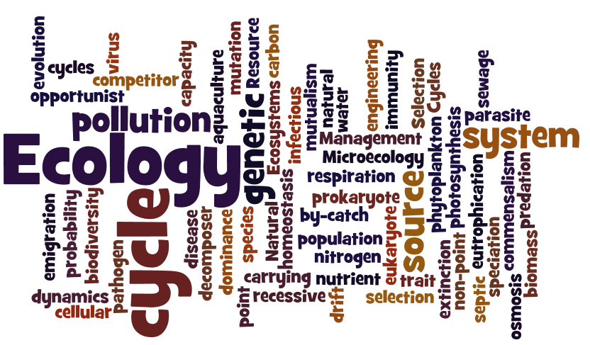

Textbook: Chapters 12 and 13

Unit Resource Sheet-Biomes and Ecosystems 7th grade Science-Mrs. Weimer
lweimer@rockwoodschools.org 814-925-4688 ext 2204
Websites and Internet Resources:
- Biomes of our Earth Video: http://www.youtube.com/watch?v=v7cZ3b6PH2s
- Bill Nye Biodiversity: http://www.youtube.com/watch?v=iFeRFmqFChQ
- Biomes of the World:
http://www.ucmp.berkeley.edu/glossary/gloss5/biome/
- Great Salt Lake Interactive Food Web: http://learn.genetics.utah.edu/content/gsl/
- Decomposer applet: http://kids.discovery.com/tell-me/animals/bug-world/worm-world
- Self-Assessments for each chapter are located at: http://www.phschool.com/webcodes10/index.cfm?fuseaction=home.gotoWebCode&wcprefix=chk&wcsuffix=1000

Vocabulary:

Textbook: Chapters 12 and 13

