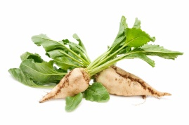
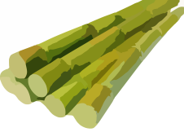
Unit 1 Plant Science Name: ________________________
Topic- Sugar Crops

Lab- Sugar Sampling
Materials
- Sample of pure cane sugar (domino)
- Sample of corn sugar (syrup)
- Sample of brown sugar
- Sample of Sucralose (Splenda) (yellow)
- Sample of sugar substitute (Stevia-green)
- Sample of Saccharin (pink)
- Sample of Aspartame (blue)

Directions

1. Look at each of the samples and record your findings in the data table below. (Example: color, crystal size, etc.)

2. Touch each of the samples by rubbing a small amount between your thumb and forefinger. Describe their texture in the data table. Example: Course, Smooth, Slippery, etc.

3. Smell each of the samples and record you findings in the data table. * Note: If no odor is detected, write ‘no odor’. * Note- you may compare it to a food that it reminds you of if it makes the task a bit easier.

4. Taste a small amount of each of the samples and record the flavor detected in the data table.
You may use a rating system to compare sweetness between sugars
(Ex: * = faintly sweet ** sweet *** very sweet **** = extremely sweet)

 | Look | Feel | Smell | Taste
Cane Sugar
Corn Sugar
Brown Sugar
Sucralose (Splenda)
Sugar Substitute-Stevia
Saccharin
Aspartame

Sugar Sampling Conclusion Questions
1. Which sugar was your favorite and WHY? Which sugar was your least favorite and WHY?

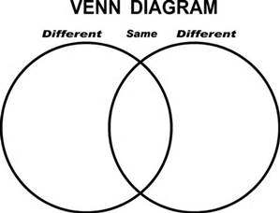
_______________ _______________
2. Which plants provided the sugars you sampled today? Write their names on the lines above.
Complete the Venn Diagram by filling in as many similarities and differences between the two plants that you can think of. (Minimum of TWO for each category)
3. RESEARCH QUESTION: How is Brown Sugar produced?

4. SPLENDA® Brand Sweetener, also known as sucralose, is made through a patented process that starts with sugar and converts it to a no-calorie, non-carbohydrate sweetener. Why do you think some people prefer to use a sugar substitute such as Splenda instead of a natural sugar?

Culminating Question:
You and your marketing partner will now research the differences between cane sugar, beet sugar, maple sugar, and one other sugar of your pick.
1. How the sugar tastes (try to convince us of the flavor)?
2. How the sugar is made (from farm to table including how it is processed).
3. The amount of sugar that is consumed by Americans eat year.
4. The cost to farm and process the crop
5. By-products of the crop
Crop | Taste | How it’s made | Amount of sugar consumed by Americans each year | Cost to produce Crop | By-Products of crop
Cane
Beet
Maple
___________

