Physical Exams Notesheet
Name: Date:
- Define physical exam:
- Physical exams should follow a consistent – in most cases, every
examination should follow .
- If you find a suspicious symptom, should you stop the exam? Explain:
- What is the first step of any physical exam?
- What are the 8 questions that should be asked during any physical exam of cattle?
1
2
3
4
5
6
7
8
- What should you do after you ask these 8 questions:
- What are the 7 things you should assess in the head and neck of a cow?
1
2
3
4
5
6
7
- How can a cow’s ears be used to assess its health?
- How can a cow’s eyes be used to assess its health?
- How can a cow’s nose be used to assess its health?
- How can a cow’s mouth be used to assess its health?
- What is a capillary?
- What is the capillary refill time test?
- How do you perform and measure the CRT test?
- How can a cow’s jaw be used to assess its health?
- How can a cow’s neck be used to assess its health?
- What are the lymph nodes?
- How do you perform the pinch test to check for dehydration?
  - How would you know if a cow is dehydrated?
- State what the following symptoms mean:
  - Cold ears
  - Sunken eyes
  - Swollen jaw (bottle jaw)
  - Swollen lymph nodes
  - Nasal discharge
  - Chewing her cud
- What two things do you examine on the left hand side?
- How do you check the heart on a cow?
- What should be the heart rate of a cow?
- What do you check for when you assess the quality of a heart rate?
- What is a heart murmur?
- How do you check respiration on a cow?
- What should be the respiration rate of a cow?
- What do you check for when you assess the quality of a respiration?
- What is a dyspnea?
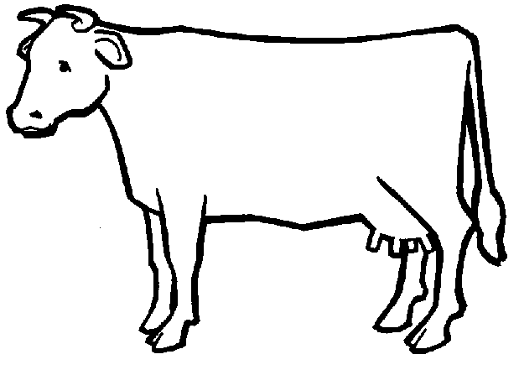
- On the cow below, show where the heart and lungs would be and draw a line from the word to where it exists:
Heart
Lungs
- Explain what the following symptoms mean:
High heart rate:
Heart Murmurs:
Raspy breathing:
- What two things do you check on the left abdomen?
- What is the rumen?
- How do you measure rumen contractions?
How many should occur per minute?
- What do rumen contractions sound like?
- What is the abomasum?
- Why do we need to check the abomasum (what can happen to it)?
- How can you detect if a cow has a displaced abomasum?
- What will a twisted stomach sound like through a stethoscope?
- In the picture below, draw where we would find the rumen and the abomasum. Then draw lines from the word to that structure:
RUMEN ABOMASUM
- What are three things you check in the udder?
1
2
3
- What is mastitis?
- Why is mastitis a major concern?
- What are five symptoms of mastitis?
- If you suspect mastitis, what should you do?
- What do you check for in the rear of the cow?
- To take an animal’s temperature, you need a
- Before inserting the rectal thermometer, what do you need to do?
- How do you insert the thermometer?
- What should the temp be? At what temp does a fever begin?
- What are ketones?
- What must occur for ketone levels to rise?
- What is ketosis?
- What problem can be caused by ketosis?
- How do you test for ketosis?
- How do you stimulate urination?
- What four things should you check for when examining the rear feet and legs?
1
2
3
4
- Manure is one of the most of an animal.
- List AND explain the four things you should look for when examining manure?
1
2
3
4
- Explain what the following 8 symptoms would mean:
Brown, frosting like manure
Runny manure
Watery manure
Sour-smelling manure
Slimy manure
Too little manure
Black/red streaks in manure
Too stiff of manure
- What three things do we check/perform on the right side of a cow?
- How do you check for a right displaced abomasum on a cow?
- A Right DA is much more
- How do you check a digestive obstruction on the right side of a cow?
- If you hear a ping around the hip bone, what does that indicate?
- If you hear a ping on the right side of the hip, this indicates a…
- What are the withers?
- How do you perform a withers pinch?
- How do you know if a cow has a problem after performing a withers pinch?
- What is a dorsiflex?
- On the cow below, state what you would check on each of the following:
Head
1
2
3
4
5
6
7
Left Chest
1
2
3
4
Left Abdomen:
1
2
Udder
1
Rear
1
2
3
4
Right Side
1
2
3
A cow has a severe case of mastitis. Describe how the symptoms of each of the following areas would change?
Head:
Chest:
Abdomen:
Udder:
Rear:
Right Side:

