NAME_________________________________________________Unit 7-MEIOSIS and GENETICS-MRS. WEIMER
MEIOSIS
Organisms that reproduce __________________________ are made up of two different types of cells.
_____________________ are “body” cells and contain the normal number of chromosomes ….called the “Diploid” number (the symbol is 2n). Examples would be … skin cells, brain cells, etc.
_____________________ are the “sex” cells and contain only ½ the normal number of chromosomes…. called the “Haploid” number (the symbol is n)….. Sperm cells and ova are gametes.

Gametes
The Male Gamete is the _____________ and is produced in the male gonad the _______________
The Female Gamete is the ___________ (ova = pl.) and is produced in the female gonad the _______________.

During__________________ the ovum is released from the ovary and transported to an area where ____________________, the joining of the sperm and ovum, can occur…… fertilization, in Humans, occurs in the Fallopian tube. Fertilization results in the formation of the ____________________(fertilized egg)
Fertilization
The fusion of a sperm and egg to form a zygote.
A zygote is a fertilized egg
DRAW THE PICTURE WITH THE CHROMOSOME NUMBERS:

Chromosomes
If an organism has the ________________________ (2n) it has two matching homologues per set. One of the homologues comes from the mother (and has the mother’s DNA).… the other homologue comes from the father (and has the father’s DNA).
Most organisms are diploid. Humans have 23 sets of chromosomes… therefore humans have 46 total chromosomes….. The diploid number for humans is ______ (46 chromosomes per cell).
Homologous Chromosomes
Pair of ______________________ (maternal and paternal) that are similar in shape and size.
Homologous pairs (tetrads) carry genes controlling the same inherited traits.
Each l______________ (position of a gene) is in the same position on homologues.
Humans have 23 pairs of homologous chromosomes.

22 pairs of autosomes
1 pair of sex chromosomes

Homologous Chromosomes(because a homologous pair consists of 4 chromatids it is called a “Tetrad”)
Humans have 23 Sets of Homologous Chromosomes
Each Homologous set is made up of 2 Homologues.
Autosomes
(The Autosomes code for most of the offspring’s traits)
Sex Chromosomes
The Sex Chromosomes code for the sex of the offspring.
** If the offspring has two “X” chromosomes it will be a ______________
** If the offspring has one “X” chromosome and one “Y” chromosome it will be a ________________
Sex Chromosomes
Meiosis is the process by which ”gametes” (sex cells) , with half the number of chromosomes, are produced.
During Meiosis diploid cells are reduced to haploid cells

Diploid (2n)  Haploid (n)
If Meiosis did not occur the chromosome number in each new generation would double…. The ______________________________________

Meiosis
Meiosis is Two cell divisions (called meiosis I and meiosis II)with only one duplication of chromosomes.
Meiosis in males is called ___________________ and produces sperm.
Meiosis in females is called __________________and produces ova.

Interphase I
Similar to mitosis interphase.
Chromosomes replicate (S phase).
Each duplicated chromosome consist of two identical sister chromatids attached at their centromeres.
Centriole pairs also replicate.
Nucleus and nucleolus visible.

Meiosis I (four phases)
Cell division that reduces the chromosome number by one-half.
four phases:
a. prophase I
b. metaphase I
c. anaphase I
d. telophase I

Prophase I
Longest and most complex phase.
90% of the meiotic process is spent in Prophase I
Chromosomes condense.
____________ occurs: homologous chromosomes come together to form a tetrad.
Tetrad is two chromosomes or four chromatids (sister and nonsister chromatids).
During Prophase I “________________________________” occurs.

During Crossing over segments of nonsister chromatids break and reattach to the other chromatid. The Chiasmata (chiasma) are the sites of crossing over.
Crossing Over creates __________________________________ in the offspring’s traits.

Metaphase I
Shortest phase
Tetrads align on the metaphase plate.
INDEPENDENT ASSORTMENT OCCURS:
1. Orientation of homologous pair to poles is random.
2. Variation
3. Formula: 2n
Example: 2n = 4
then n = 2
thus 22 = 4 combinations
Anaphase I
Homologous chromosomes separate and move towards the poles.
Sister chromatids remain attached at their centromeres.

Telophase I
Each pole now has haploid set of chromosomes.

Cytokinesis occurs and two haploid daughter cells are formed.

Meiosis II
No __________________________________
(or very short - no more DNA replication)

Remember: Meiosis II is similar to mitosis
Prophase II
same as prophase in mitosis
Metaphase II
same as metaphase in mitosis
Anaphase II
same as anaphase in mitosis
sister chromatids___________________________________
Telophase II
Same as telophase in mitosis.
Nuclei form.
Cytokinesis occurs.
Remember: four haploid daughter cells produced.
gametes = sperm or egg
Telophase II

Non-disjunction
Non-disjunction is the failure of homologous chromosomes, or sister chromatids, to _______________ during meiosis.
- Non-disjunction results with the production of zygotes with abnormal chromosome numbers…… remember…. An abnormal chromosome number (abnormal amount of DNA) is damaging to the offspring.
- Non-disjunctions usually occur in one of two fashions.
  - The first is called _______________, the second is called _______________. If an organism has Trisomy 18 it has three chromosomes in the 18th set, Trisomy 21…. Three chromosomes in the 21st set. If an organism has Monosomy 23 it has only one chromosome in the 23rd set.
Common Non-disjunction Disorders
Down’s Syndrome – _____________
Turner’s Syndrome – ____________________
Kleinfelter’s Syndrome – ______________________
Edward’s Syndrome – _______________________
Amniocentesis
An Amniocentesis is a procedure a pregnant woman can have in order to detect some genetics disorders…..such as non-disjunction.
Karyotype (picture of an individual’s chromosomes)
One of the ways to analyze the amniocentesis is to make a Karyotype
What genetic disorder does this karyotype show?

Genetics and Heredity
History
Genetics is the study of genes.
Inheritance is how traits, or characteristics, are passed on from generation to generation.
________________________s are made up of genes, which are made up of DNA.
Genetic material (genes,chromosomes, DNA) is found __________________________ of a cell.
Gregor Mendel is considered “The Father of Genetics"

Gregor Mendel
Austrian Monk.
Experimented with “pea plants”.
Used pea plants because:
They were available
They reproduced quickly
They showed obvious differences in the traits
Understood that there was something that carried traits from one generation to the next- “FACTOR”.

Mendelian Genetics
______________________ traits- traits that are expressed.
______________________ traits- traits that are covered up.
______________________- the different forms of a characteristic.
______________________- show how crosses are made.
______________________- the chances/ percentages that something will occur.
Genotype- the types of genes (Alleles) present.
Phenotype- what it looks like.
Homozygous- two of the same alleles.
Heterozygous- two different alleles.

What is TRUE BREEDING:___________________________________________________________________________
Typical Breeding:
P generation _______________________________ generation)
F1 generation (first filial generation, the word filial from the Latin word for "______") are the hybrid offspring.
Allowing these F1 hybrids to self-pollinate produces:
F2 generation (second filial generation).

It is the analysis of this that lead to an understanding of genetic crosses.
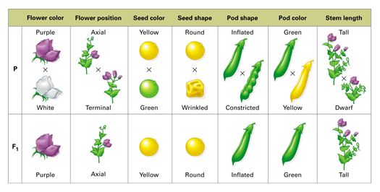
Mendel’s 7 Characteristics of a Garden Pea

Statistics of Mendel’s Experiments
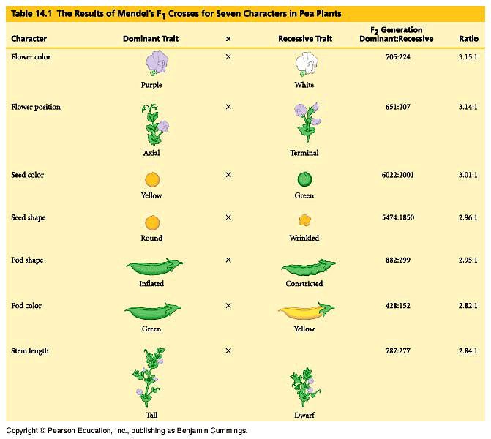

How is it possible to maintain such genetic continuity?
Chromosomes
Homologous chromosome: one of a matching pair of chromosomes, one inherited from each parent.
DRAW THEM HERE:

What genetic principles account for the transmission of such traits from parents to offspring?
The Blending Hypothesis of Inheritance
In the early 1800’s the blending hypothesis was proposed. Genetic material contributed by the two parents mixes in a manner analogous to the way blue and yellow paints blend to make green.
What would happen if this was the case?________________________________________________
Law of Dominance
In the monohybrid cross (mating of two organisms that differ in only one character), one version disappeared.
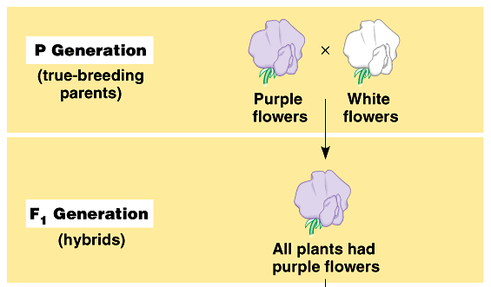
What happens when the F1 Generations are crossed?
__________________________________

Draw the F2 Generation here:

Alleles: alternative versions of a gene.
The gene for a particular inherited character resides at a specific locus (position) on homologous chromosome. Draw them here:

Dominant - a term applied to the trait (allele) that is expressed irregardless of the second allele.
Recessive - a term applied to a trait that is only expressed when the second allele is the same (e.g. short plants are homozygous for the recessive allele).
Punnett square: diagram showing the probabilities of the possible outcomes of a genetic cross
Genotype vs. Phenotype
How does a genotype ratio differ from the phenotype ratio?
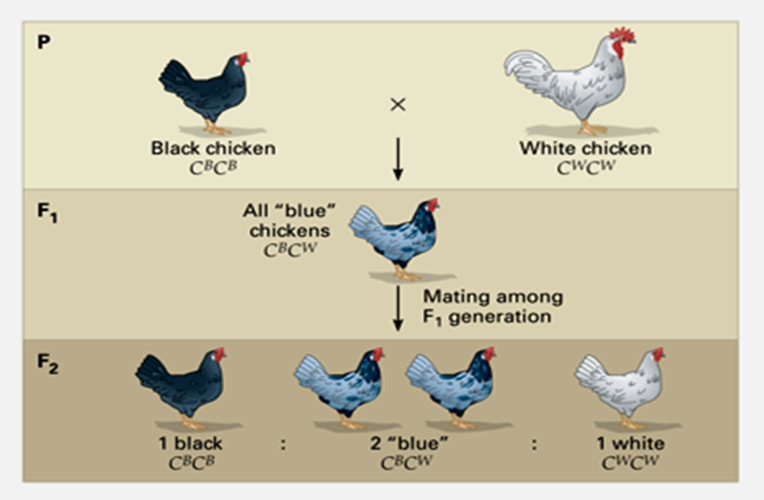

Intermediate Inheritance (blending): inheritance in which heterozygotes have a phenotype intermediate between the phenotypes of the two homozygotes

The Importance of the Environment
The environmental influences the expression of the genotype so the phenotype is altered.
Hydrangea flowers of the same genetic variety range in color from blue-violet to pink, depending on the acidity of the soil.
Multifactorial; many factors, both genetic and environmental, collectively influence phenotype in examples such as skin tanning

