NAME_______________________________________________Expected Progeny Differences and Livestock Evaluation
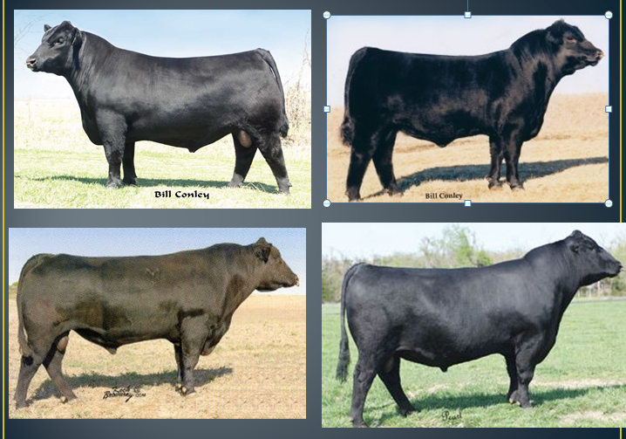
Place in order after your visual appraisal and state WHY.

- What are the MOST important traits to look for in a bull?

- What are EPDs?
  - Expected Progeny Difference
    - Predict differences in performance between future offspring of individuals of the same breed when each is mated to animals of the same average genetic merit
    - The purpose is to compare the ________________________ of an animal as a parent
- Traits used for EPD
  - Birth weight (BW)
  - Weaning weight (WW)
  - Yearling weight (YW)
  - Milking ability (MA)
  - Total maternal traits
  - Carcass cutability
  - Carcass quality
  - Gestation length
  - Scrotal circumference
  - Pelvic area (PA)
    - *The traits in bold are the most commonly referenced traits with regard to beef cattle.*
- Selecting Cattle with EPDs
  - It is important to understand and use EPDs when they are provided.
  - However, EPDs should be combined with visual appraisal to improve decision making accuracy.
- Birth Weight (BW)
  - Major contributing factor associated with calving difficulties
  - The ______________ the BW, the greater chance of _____________________________
- Birth Weight Scenario
  - If these bulls were to be mated to first calf heifers, which bull would you chose to breed to the heifers?
    - Bull _____
      - He has the lowest BW; meaning his calves will average ____ pounds lighter than bull B’s & 10 pounds lighter than bull A’s
- Weaning(WW) & Yearling Weight (YW)
  - Commonly referred to as _______________________
  - Important because cattle are sold by ______________
  - A positive growth rate means a profitable investment
  - WW and YW have positive economic impact on selection
  - WW and YW Scenario
    - Which bull is most desirable if offspring are sold at WW?
      - Bull _____
      - His offspring average 6 lbs heavier than bull B
    - Which is most desirable if they are marked as finished cattle?
      - Bull _____
      - He has the highest YW
- Milking Ability (MA)
  - Measuring the additional pounds of weaning weight from daughters due to genes __________________________________.
- Milking Ability Scenario
  - The difference in MA EPD is 10 lbs
    - This does not mean daughters from bull A produce 10 lbs more milk, but that bull A daughters would wean calves that are on average 10 lbs ____________ than bull B
  - Milking Ability Scenario
    - Which bull has a more desirable MA EPD?
      - It depends on the _____________. If higher milking ability is desired, _______ would be chosen. If the scenario says forage is low quality then bull B would be chosen because the daughters of bull A would need higher quality grasses to reach expected values.
- Selection Scenario
  - This is the situation or environment that cattle are going to be placed into upon completion of the selection process.
    - ALWAYS READ THE SCENARIO OR SITUATION FIRST!
    - It determines what traits to emphasize when evaluating the EPDs.
- Example Statements
  - The ranch labor is limited
    - This means no one is there to pull calves, so you should select a low birth weight.
  - All offspring are sold at weaning.
    - This indicates that the weaning weight should be emphasized heavily
  - The producer is retaining ownership through the feedlot.
    - This indicates that the producer won’t sell the calves until they are fed in the feedlot and go to harvest. Yearling weight is the most important.
- Other Important Information
  - Each beef breed has different breed averages for all EPDs.
  - EPDs should prepare you to understand genetic performance profiles.

- Bull Data Statistics
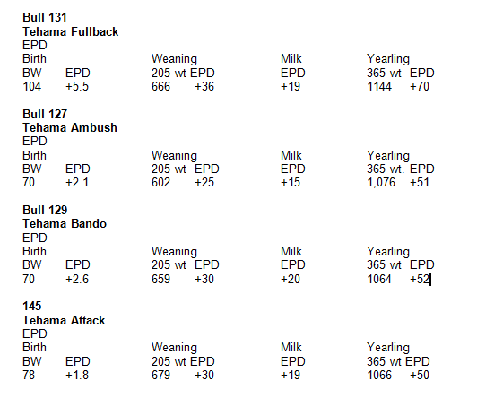
Know which bull would be the best option for your herd of first class heifers and why?

4

- On the Arrowhead ranch, how do they use EPD’s?

Part 2-Livestock Evaluation
1. Rank the shoes of your classmates from 1 through 4 with a positive and a negative reason of why they were placed that way.
P-
N-
P-
N-
P-
N-
P-
N-

