Activities:
- Notes
- Gravity Lab
- Seasons Lab
- Astronomy Lab Stations (students must complete 5 of the 10 stations)
- Exam
- Astronomy Quiz Bowl
- Exam
- Student assignments are subject to change based on the needs of the students

Activities:
- Notes
- Gravity Lab
- Seasons Lab
- Astronomy Lab Stations (students must complete 5 of the 10 stations)
- Exam
- Astronomy Quiz Bowl
- Exam
- Student assignments are subject to change based on the needs of the students

UNIT RESOURCE SHEET-ASTRONOMY Grade 8 Mrs. Weimer

Big bang
VOCABULARY
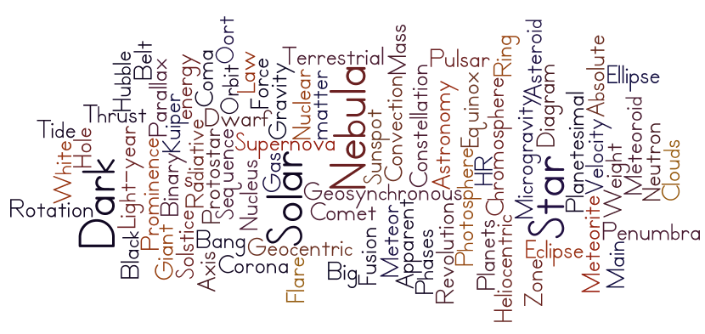
Internet Resources:
- Moon Phases: http://www.cascaeducation.ca/CSA/CSA_Astro9/files/multimedia/unit3/phases_moon/phases_moon.html
- Seasons: http://people.cas.sc.edu/carbone/modules/mods4car/earthsun/earthsun.html
- Interactive TEXTBOOK: http://www.phschool.com/webcodes10/index.cfm?fuseaction=home.gotoWebCode&wcprefix=cjk&wcsuffix=1000
TEXT BOOK: Science Explorer Earth Science Unit 5
Contact Information: lweimer@turkeyfoot.k12.pa.us
Website: http:// turkeyfootscience.webnode.com

UNIT RESOURCE SHEET-ASTRONOMY Grade 8 Mrs. Weimer

Big bang
VOCABULARY
Internet Resources:
- Moon Phases: http://www.cascaeducation.ca/CSA/CSA_Astro9/files/multimedia/unit3/phases_moon/phases_moon.html
- Seasons: http://people.cas.sc.edu/carbone/modules/mods4car/earthsun/earthsun.html
- Interactive TEXTBOOK: http://www.phschool.com/webcodes10/index.cfm?fuseaction=home.gotoWebCode&wcprefix=cjk&wcsuffix=1000
TEXT BOOK: Science Explorer Earth Science Unit 5
Contact Information: lweimer@turkeyfoot.k12.pa.us
Website: http:// turkeyfootscience.webnode.com

