NAME________________________________________________WILDLIFE NOTES 29-40 Mammals – Mrs. Weimer
Black Bear
- Morphology:
  - 60-65” (4” tail)
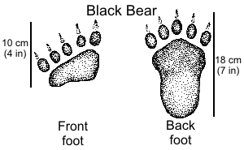
  - 200-400lbs (males ave. 500lb- larger than national ave.)
  - Black (brown, cinnamon, blonde)
  - __________________
  - Excellent smell, good vision and hearing
  - Climb trees at all ages
  - Male = ___________
  - Females = ___________
  - Young = _____________
- Habitat
- Range over long areas; movement affected by food availability
- Mixed forests, swamps and thickets(adaptable)
- Feeding Behavior
- Omnivores (PA’s largest__________________)
- Active in _______________________
- Why? Spring - lose 30% of body weight during “hibernation”
- Fall - Build up ______ fat
- (blueberries, insect larvae juneberries, beechnuts, acorn, skunk cabbage)
- Bears find food by ____________________________
- Reproductive Strategies/Population Dynamics/Life History:
  - Breed in June and July [female in heat for 2-3 weeks]
  - Delayed implantation - ________. gestation but young develop for ~ only _____weeks
  - Cubs - most born in January (in the den)
  - - can’t see, hear, or smell: “_________________________”
  - - age determined by ____________________________
  - Breed once every _____years
  - 1-3 cubs (k- selective)
- Other Notes and Distinguishing Features:
  - Regulated hunting season (3 days / extended in some areas)
  - Check stations (hunters harvest 3000-4500/year statewide)
  - “Mark” trees, wallows
  - Can run _________________________
  - ______________ +/- in Pa (~ 20,000 carrying capacity)
  - Aged by “________” in teeth. (1st upper premolar)
ELK

- MORPHOLOGY:
- Second largest member of deer family in N.A.
- 50-60 inches at shoulder
- Male = bull; ____________________ lbs.
- (annually grow antlers)
- female = ________; 500-600 lbs
- young = calves; 30 lbs.
- Brown, brownish gray – white rump
- HABITAT:
  - In PA (Elk and Cameron County) (150-200 sq.mi.)
  - Similar to deer
  - Expanded range includes Clinton, Centre, Clearfield Co.
- FEEDING BEHAVIOR:
  - __________________________ (browser in winter, grazers in summer)
  - Game officials establish food plots to keep the elk off of private agricultural land
  - ____________________________
- REPRODUCTIVE STRATEGIES/POPULATION DYNAMICS/LIFE HISTORY:
- Mate in fall, calves born in spring
- _____month gestation
- Live approx. ____ yrs.
- K-selective
- Rut – bugling, fighting, harem
- OTHER NOTES AND DISTINGUISHING FEATURES:
  - Reintroduced from Rocky Mtns. (Yellowstone) from __________________
  - “Wapiti” – Indian word meaning “white deer”
  - Communication system – ________________
  - Victim of disease and poaching
  - ____________________ – parasitic nematode
  - Closely monitored – radiocollars
  - Current estimated population = _______
BATS
- All Pennsylvania bats belong to family _____________, and are also known as evening bats or common bats
- Most bats mate in late summer or early fall, although some breed in winter.
- The male’s sperm is stored in the female’s reproductive system until _______ when fertilization occurs.
- Bats are the only mammals that ______
- Order: Chiroptera “hand-winged”
- Eleven species in PA (9 all year and 2 just visitors)
- Insectivores - use _________________ to locate prey
- Nocturnal
- Low reproductive potential
- True Hibernators
- _________________________________
  - Indiana Bat
    - resembles the little brown bat, but has a pink cast to fur
    - on the fringe of the species range
    - Also bear a ____________________
    - ____________of bats who hibernate in the caves in Missouri, Indiana, Kentucky, Illinois
  - Big Brown Bat
    - Second in size to hoary bat
    - Use the___________________ feeding range every night
    - Eat _________________________
    - 2 per litter
  - Hoary Bat
    - largest bat in the Eastern forest
    - Fur dark brown
    - Species range across the state, but they are uncommon
    - Roost in ______________
    - Prefer to eat ___________________
    - Females have two _____________________________
  - Little Brown Bat
    - PA’s most common bat found statewide
    - Females__________________________ than males
    - Eat lots of lying insects
    - Singleton for young per year
    - Can live more than _________________
  - Pipistrelle
    - AKA the _______________________
    - Eat flies, grain moths
  - What is White Nose disease?

COYOTE
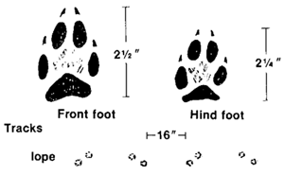
- Largest canine __________________ in PA
- 40-50 lbs
- Opportunistic, will eat deer esp. when they “yard-up”
- Tail held _______________ when running
- Travel long distances ___________________________
- #’s increasing in PA (alter reproductive potential to meet carrying capacity)
- Communication system
- Hunted and trapped
- Poisoned / Killed
- Order = _____________
- Family = _________________
- What is compound 1080?

- What is an M44?

- Describe the COYOWOLF- (Lifecycle, Predators, Description, Characteristics, Habitat, Food)

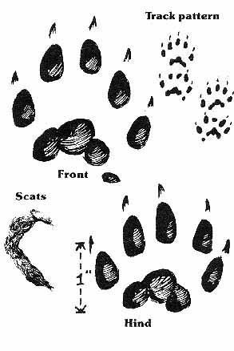
FISHER
- Dark brown, size of a _____________________
- Arboreal
- Porcupine predator
- Large home range, solitary animal
- Remote, unbroken forests
- Reintroduced in 1994-1995 (PSU,PGC) currently protected
- _________________________________
- Populations declined due to over-trapping and habitat loss
- Order = __________ Family = _________________
- What do we know about the mustelidae family?

- How are fishers and wolverines similiar? Different?

