OFFICIAL TICKET  Destination: Center of the Earth  Time to Depart: 10/6/2015  TOUR GUIDE: Mrs. Weimer/Mrs. Langley  Ticket is non-refundable and can only be used on 10/6/15. This is risky business so be prepared-enter at your own risk. | OFFICIAL TICKET  Destination: Center of the Earth  Time to Depart: 10/6/2015  TOUR GUIDE: Mrs. Weimer/Mrs. Langley  Ticket is non-refundable and can only be used on 10/6/15. This is risky business so be prepared-enter at your own risk. | OFFICIAL TICKET  Destination: Center of the Earth  Time to Depart: 10/6/2015  TOUR GUIDE: Mrs. Weimer/Mrs. Langley  Ticket is non-refundable and can only be used on 10/6/15. This is risky business so be prepared-enter at your own risk.
OFFICIAL TICKET  Destination: Center of the Earth  Time to Depart: 10/6/2015  TOUR GUIDE: Mrs. Weimer/Mrs. Langley  Ticket is non-refundable and can only be used on 10/6/15. This is risky business so be prepared-enter at your own risk. | OFFICIAL TICKET  Destination: Center of the Earth  Time to Depart: 10/6/2015  TOUR GUIDE: Mrs. Weimer/Mrs. Langley  Ticket is non-refundable and can only be used on 10/6/15. This is risky business so be prepared-enter at your own risk. | OFFICIAL TICKET  Destination: Center of the Earth  Time to Depart: 10/6/2015  TOUR GUIDE: Mrs. Weimer/Mrs. Langley  Ticket is non-refundable and can only be used on 10/6/15. This is risky business so be prepared-enter at your own risk.
OFFICIAL TICKET  Destination: Center of the Earth  Time to Depart: 10/6/2015  TOUR GUIDE: Mrs. Weimer/Mrs. Langley  Ticket is non-refundable and can only be used on 10/6/15. This is risky business so be prepared-enter at your own risk. | OFFICIAL TICKET  Destination: Center of the Earth  Time to Depart: 10/6/2015  TOUR GUIDE: Mrs. Weimer/Mrs. Langley  Ticket is non-refundable and can only be used on 10/6/15. This is risky business so be prepared-enter at your own risk. | OFFICIAL TICKET  Destination: Center of the Earth  Time to Depart: 10/6/2015  TOUR GUIDE: Mrs. Weimer/Mrs. Langley  Ticket is non-refundable and can only be used on 10/6/15. This is risky business so be prepared-enter at your own risk.

JOURNEY TO THE CENTER OF THE EARTH
DEPARTS: TODAY
ROOM 204

NAME__________________________________________Journey to the Center of the Earth Data Sheet-Mrs. Weimer
Lithosphere | Asthenosphere | Mesosphere | Outer Core | Inner Core

NAME__________________________________________Journey to the Center of the Earth Data Sheet-Mrs. Weimer
Lithosphere | Asthenosphere | Mesosphere | Outer Core | Inner Core

NAME________________________________________Journey to the Center of the Earth Evaluation-Mrs. Weimer
Procedure: You will write a postcard to a family member, friend, teacher, etc. on your journey to the center of the Earth. You must have the following items on your postcard to receive full credit:
1. A picture of all of the layers on the front (like a postcard scene)
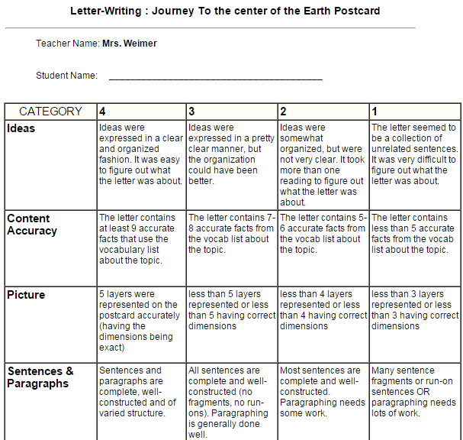
2. On the back, you are writing a letter and you must include (and use correctly) the following terms in a descriptive manner:
a. lithosphere
b. asthenosphere
c. mesosphere
d. outer core
e. inner core
f. density
g. crust
h. mantle
i. core

NAME________________________________________Journey to the Center of the Earth Evaluation-Mrs. Weimer
Procedure: You will write a postcard to a family member, friend, teacher, etc. on your journey to the center of the Earth. You must have the following items on your postcard to receive full credit:
1. A picture of all of the layers on the front (like a postcard scene)
2. On the back, you are writing a letter and you must include (and use correctly) the following terms in a descriptive manner:
a. lithosphere
b. asthenosphere
c. mesosphere
d. outer core
e. inner core
f. density
g. crust
h. mantle
i. core

