Grade 7-Restless Earth Unit Resource Sheet -Mrs. Weimer
Feel free to contact me anytime at lweimer@rockwoodschools.org
Please check Powerschool for links and assignments

Resources:
QUIZLET: http://quizlet.com/_gh1i8
CLASSTOOLS: http://www.classtools.net/mob/quiz_22/Grade_8_Earth_Features_and_Processes_7pwmJ.htm
Rocks and Minerals: http://www.brainpop.com/science/theearthsystem/mineralidentification/
Plate Tectonics: http://www.ucmp.berkeley.edu/geology/tectonics.html
Volcanoes and Earthquakes: http://www.pbs.org/wnet/savageearth/animations/
CHAPTERS COVERED: Chapter 14, 15, 16

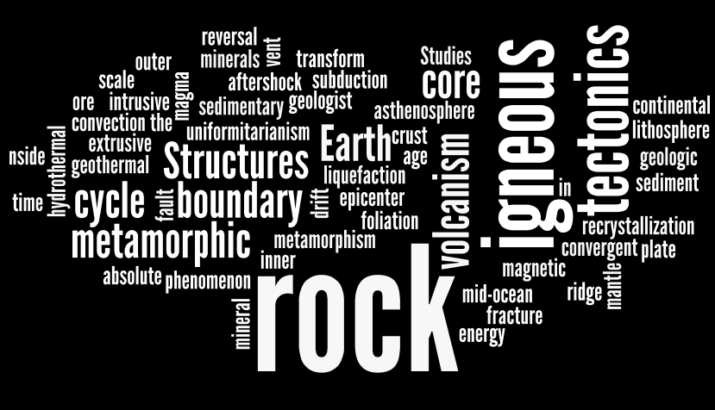

Grade 7-Restless Earth Unit Resource Sheet -Mrs. Weimer
Feel free to contact me anytime at lweimer@rockwoodschools.org
Please check Powerschool for links and assignments

Resources:
QUIZLET: http://quizlet.com/_gh1i8
CLASSTOOLS: http://www.classtools.net/mob/quiz_22/Grade_8_Earth_Features_and_Processes_7pwmJ.htm
Rocks and Minerals: http://www.brainpop.com/science/theearthsystem/mineralidentification/
Plate Tectonics: http://www.ucmp.berkeley.edu/geology/tectonics.html
Volcanoes and Earthquakes: http://www.pbs.org/wnet/savageearth/animations/
CHAPTERS COVERED: Chapter 14, 15, 16

