NAME______________________________________________________Weather and Climate-Unit 4-Mrs. Weimer

Weather VS. Climate - Day 1 Part 1

Weather | Climate

- ATMOSPHERE AND CLIMATE
  - _______________ - A description of short-term physical conditions of the atmosphere.
  - _______________ - A description of the long-term weather pattern in a particular area.
    - Temperature
    - Humidity
    - Wind
    - Rainfall
- The Atmosphere
  - The atmosphere is a thin layer of _____________ surrounding the Earth.
    - If the Earth were the size of an apple, the atmosphere would be the skin.
- Weather
  - ________________ – The condition of the atmosphere at a certain time & place. Strongly affected by the amount of water vapor in the air.
  - What affects the weather????
    - ________________________________________________
- Clouds
Cloud - A collection of tiny water droplets or ice crystals.
__________ – A cloud that forms or descends close to the surface of the Earth.
Cloud Types:
Cumulus – puffy, cottony appearing clouds. Forecasts _________ weather conditions.
Stratus – Layered or sheet like clouds covering a large area. Forecasts _______________________ conditions.
Cirrus – Thin, feathery, high altitude clouds. Forecasts __________________weather conditions.
Nimbus-low, gray rain clouds
CLOUDS: also based on altitude__________________________________________________________
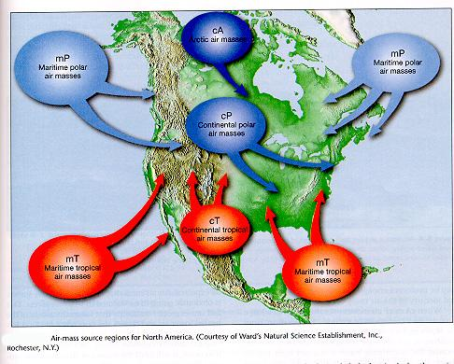
- Precipitation
Forms of Precipitation:
______ – Liquid form that is the most common.
_________ – Rain that freezes as it falls from altitude.
________ – Water vapor that changes into a solid, crystalline form.
_________ – A layered, solid, ball of ice.
- Air Masses
Air Mass – A large volume of air with similar temperature and humidity.
_______________ – Forms over water; moist.
_______________ – Forms over land; dry.
_______________ – Forms over polar regions; cold.
________________ – Forms over the tropics; warm.

- Fronts
Fronts – The boundary between air masses. Weather changes when these air masses move and meet.
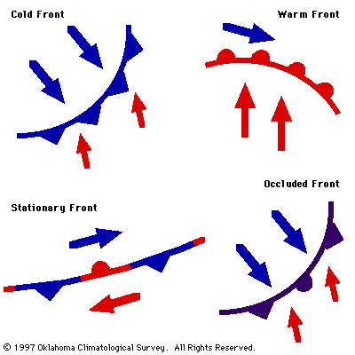
1. ________________ – Occurs when cold air moves in under a warm air mass. Strong winds, heavy precipitation, fast moving.
2. ________________ – Occurs when warm air moves in over a denser, cold air mass and replaces it. Slower, has precipitation with warmer temperatures to follow.
3.__________________ – Occurs when a warm air mass is caught between two colder air masses.
-Very slow moving and can have cool temperatures with large amounts of precipitation.
4.__________________ – Occurs when weak warm and cold air masses and there is not enough wind to move them. -Produces many days of cloudy, rainy weather.

- Weather and Air Pressure
Air Pressure & Weather:
1.___________________________ – Areas of low pressure with rising air spinning counter-clockwise. The rising air cools, condenses forming clouds and precipitation.
2.___________________________– Areas of high pressure where sinking air spins clockwise. Causes dry, clear weather.

_______________________– Small, intense weather systems that produce strong winds, heavy precipitation, lightning and thunder. -Forms along cold fronts associated with very low pressure systems.
-T-Storms form the highest and most dangerous cloud type, the ___________________
________________ – The sound resulting from the rapid expansion of air caused by a lightning bolt.
________________ – Small, intense, spinning funnel of air caused by extremely low pressure cells.
-This occurs in roughly ____ of all thunderstorms.
-_____ of all world tornadoes occurs in the United States.
-These happen most frequently in the late spring/early summer when cold, dry Canadian air meets warm, humid, southern air.
-The average tornado travels about four miles with a path of 30 – 200 feet wide and wind speeds of up to 300 miles per hour.
___________________ – A very large tropical storm of very low pressure and they are the most destructive type of storm. Also known as cyclones or typhoons, they have wind speeds ranging from 80 – 180 miles per hour. These storms form during the late summer in the tropics after the water has warmed up and can cause a destructive path as wide as 900 miles producing high winds and very heavy precipitation.
- Forecasting
_____________________________– A prediction of the weather for the next three to five days. A meteorologist is a scientist who collects weather data and makes predictions about the weather. A three day forecast is about the most accurate and requires satellites and Doppler radar.
- Tools
____________________ – Instrument that measures the temperature.
____________________– Instrument that measures air pressure.
___________________ – Instrument that measures wind speed.
_____________________ – Instrument that measures wind direction.
- Heating the atmosphere
- The earth receives energy from the sun by __________________________________
  - This is the transfer of energy as electromagnetic waves
  - The radiation absorbed by the land, water and atmosphere is changed into ______________________
- ________________________ is the transfer of thermal energy from one material through direct contact
  - Thus, the radiation from the sun is absorbed by black pavement and you walk on it with your bare feet and it burns them (b/c of conduction)
  - Thermal energy ALWAYS moves from __________________________
- _______________________ is the transfer of thermal energy by the circulation or movement of a liquid or gas
  - So, the solar energy is in the form of radiation, conduction is what occurs through direct contact and convection is the mvmt of that heat in a circular pattern
  - When air becomes heated, it becomes less dense and rises, the cooler and is more dense and sinks, then gets warm again, and rises
- The greenhouse effect
  - The greenhouse effect is the earth’s heating process in which gases in the atmosphere trap the thermal energy and heat up the earth.
    - Radiating the heat back towards earth (acting like a blanket)
  - The gases in the atmosphere that cause this are ____________________________
- Pressure and Winds
  - Wind- _________________________
  - Why does air move?
    - Differences in air pressure-the greater the pressure differences, the faster the wind moves
    - Difference in air pressure is caused by the __________________________ of the earth
      - Air at the equator is warmer and less dense and it rises, this creates an area of low pressure
      - Air at the poles is colder and more dense, so it is heavier and sinks, this creates an area of high pressure
- _______________________-almost like convection currents
  - Made of circular patterns caused by the rising and sinking of air and is called ______________________
- _______________________- curving of the moving objects, such as wind, by the earth’s rotation
  - Because of this effect winds in the northern hemisphere curve to the right and those in the southern hemisphere curve to the left
  - (Coriolis effect is also seen in the river system with rivers in the northern hemisphere eroding their banks on the right and in the southern eroding their banks on the left – equal erosion for rivers N-S)
- Types of Winds
  - 2 main types of winds: local and global
    - Both are caused by uneven heating of the earth and pressure differences
    - _____________________-can blow in any direction and are short in distance
    - _____________________- are part of a pattern of air circulation that moves across the earth, and travel in a specific direction
- Wind Types
- _________________- blow from 30 degrees to the equator on both sides of the hemispheres
  - Used to transport ships from Europe to America
- ________________- low pressure area around the equator
  - Very little wind because of the low pressure area
  - Doldrum means foolish in old english because people who got their ships stuck there were foolish
- _______________- area of high pressure at 30 degrees N and 30 degrees S latitude
  - Winds are weak
  - Given the name because ships who got stuck there and the horses were thrown overboard to save the drinking water for the sailors
- _______________- wind belts found in both hemispheres between 30 and 60 degrees Lat
  - Are in the opposite direction as the trade winds
- ______________- wind belts from the poles to 60 degrees Lat in both hemispheres
- __________- narrow belt of high speed winds that blow in the upper troposhere and lower stratosphere
  - Can have a max speed of 500 km/h
  - Does not follow a regular path around the earth
  - Controls the movements of storms
  - By flying in the direction of the jet stream, pilots can save time and fuel
- _______________- influenced by geography of the area
  - During the day, land heats up faster than water and the land heats the air above it
  - At night, land cools faster than water and cools the air above the land
  - Valley and mountain breezes are also local winds
- Climate
  - Solar Radiation
    - _______________ is energy waves that we can see as color.
      - These pass through the atmosphere.
    - _______________ is energy waves that we cannot see but can cause sun burns and cancer.
      - These are absorbed by ozone in the stratosphere.
    - _________________ is the energy of the sun that we feel as heat.
      - This is absorbed by carbon dioxide and water in the troposphere.
- Energy and the Greenhouse Effect
- Solar Radiation
  - Of solar energy reaching outer atmosphere:
    - 25% _________________
    - 25%_________________
    - 50% reaches earth’s surface
  - Of the solar energy that reaches the surface, much is reflected:
    - Fresh clean snow 90%
    - Dark soil 3%
    - Net average of earth 30%
- ____________________________________
  - Infrared energy that reflects off the Earth’s surface is trapped by greenhouse gases such __________________________ in the atmosphere.
    - This is a normal process that keeps our temperature levels in a certain range.
    - Currently, these gases are at unusually high levels due to human activities.
    - How will this affect the Earth’s climate?
- Greenhouse Gases
  - _________________________- Fossil-fuel burning.
      - Atmospheric levels increasing steadily.
  - _________________________ - Cattle, Coal-mines
      - Absorbs more infrared than CO₂.
  - ________________________ – Formed from evaporation.
  - ________________________) – Refrigerants and aerosols. (No longer used)
  - _______________________ - Burning organic material
- How Does Global Temperature Affect Rain?
  - The amount of heat in the atmosphere directly affects the ______________________________.
  - Warm air containing evaporated water rises higher into the atmosphere.
    - Warm air is less dense than cool air.
  - As warm air rises, heat is released into the atmosphere and the water vapor condenses.
    - The condensed water then falls as rain or snow.
- CLIMATE CHANGE IS A NATURAL PROCESS
  - Changes in climate have been observed throughout history.
    - There have been at least ____ major ice ages.
    - The sun undergoes cycles where it releases different amounts of energy.
    - The Earth’s orbit can shift and tilt.
      - Example: Magnitude 8.8 earthquake in Chile shorted the Earth’s day by 1.26 millionths of a second.
- All temperature data prior to the 19th century is retrieved as a result of “proxies”
  - ___________________________
  - ___________________________
    - Water naturally occurs in two isotopes:
    - H₂¹⁶O and H₂¹⁸O
    - Higher amounts of the H₂¹⁸O are found in colder temperatures.
      - Older Climate Data?
- Global Warming Effects on Glaciers
  - Only about 1% of the world’s sheet ice is located in temperate (non-polar) regions, but these are close in proximity to human populations.
  - Himalayan glaciers are the sources of Asia’s biggest rivers
  - Biggest single source of water for the entirety of southern Asia.

