NAMES________________________________________Unit 2 Project-Anatomical Terminology-Vet Science Unit 2
Objective:
- Recognize the three different anatomical planes
- Demonstrate the use of the three anatomical planes
- Define directional terms
- Create and label an animal model using directional terms
- Evaluate which directional terms are associated with which anatomical planes
- Describe anatomical actions of joints
- Demonstrate the anatomical actions using legs and arms

Procedure:
- You and a partner will construct a paper mache model (skeleton first and then paper mache over it) of an animal (native to the US or domesticated) and then you will paint and label the model. Please refer to rubric to ensure you are receiving all points.
Rubric
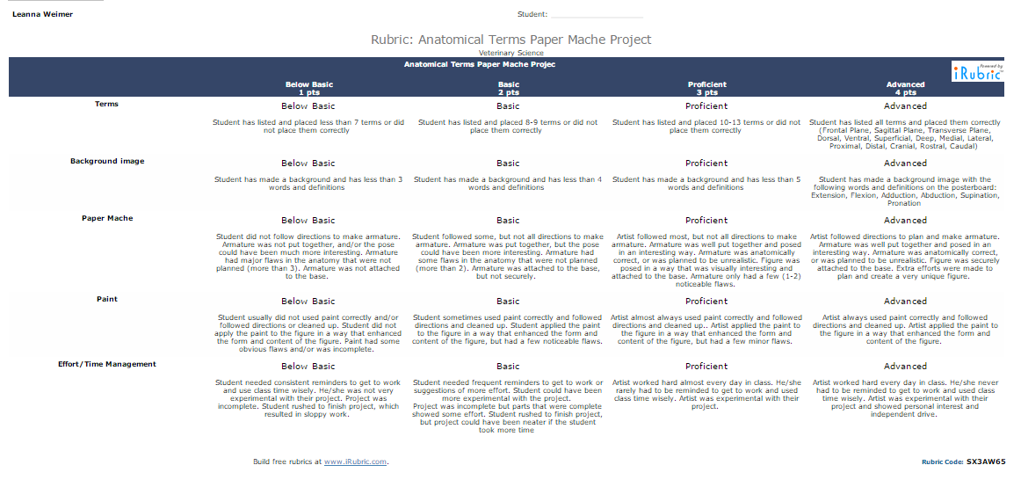
Total Points______/20*5=_____/100 (in Powerschool this will be a 100 point assignment)
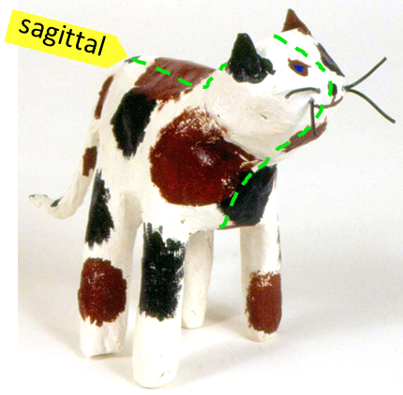

Example Project: You MUST attach this to a posterboard with the other terms listed on background image and define them, you are free to be creative!

