Bovine Reproductive Anatomy
Name:

- What are the four functions of the bovine reproductive system?
1.
2.
3.
4.
- Fill in the names for the structures below:
- The vulva is the of the female reproductive tract
- The vulva is the only part
- During estrus, the vulva
- The vagina is a flattened and serves as a passages between the
- What is the intended purpose of the vagina, biologically speaking?
- How does the vagina affect artificial insemination?
- Why is the vagina a common site of infection?
- The cervix is a muscular or between the uterus and the vagina.
- What is the cervix made out of and how does this reduce infection?
- When is the cervix open? And
- What is the role of the uterus?
- What are the uterine horns?
- What is another name for the oviduct?
- What is the function of the oviduct?
- When are the oviducts open? And
- How are eggs moved down the oviduct?
- What role do the oviducts play in fertilization and conception?
- What is the infundibulum?
- How big are the ovaries?
- How do eggs differ from sperm in terms of production rates?
- What are the two functions of the ovaries?
1
2
- What 5 roles do the hormones released by the ovaries play?
1
2
3
4
5
- What is a follicle?
- What is the corpus luteum
- How are the follicle and corpus luteum alike and different?
- How do the eggs produced by the ovaries differ from the rest of the cells in the body?
- How do the following structures change during estrus?
  - Vulva
  - Vagina
  - Cervix
  - Oviducts
  - Ovaries
- Describe 8 disorders of the bovine reproductive tract:
1
2
3
4
5
6
7
8

Male Reproductive Anatomy of Cattle
Name: Hour Date:
- What are the two main parts of the male reproductive tract and their components?
1
2
- What are the two functions of the testicles?
1
2
- What are the seminiferous tubules?
- What is the main purpose of the Sertoli cells?
- Fill in the blanks in the image below:

- What is the function of the Blood Testis Barrier?
- Why would the body try to destroy sperm cells?
- What is the function of the Leydig cells?
- What are the three functions of the male hormones?
1
2
3

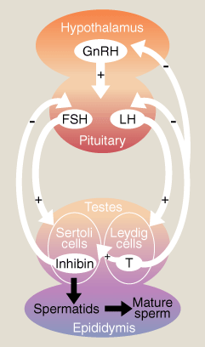
- Fill in the blanks
1. 4.
2. 5.
3.
1
2
3
4
5
- What would happen to sperm production if a bull received
artificial injections of testosterone?
- What is the function of the cremaster?
  - Why is this function necessary?
- What is cryptorchidism?
- What are three other causes of sterility besides this?
- How soon would you know if the damage from these occurrences was temporary or permanent?
- Write the path of sperm from Sertoli cell to ejaculation:
- What role does the epididymis play in semen formation?
- What role does the vas deferens play in ejaculation?
- What activity occurs in the Ampullae of Henle?
- Semen is the mix of
- In one or a couple words, describe the primary contribution of each of the following glands:
Seminal Vesicles:
Prostate:
Cowper’s
- What might yellowed, cloudy semen indicate?
- What are endocrine disrupting chemicals?
- Name five causes of injury to sperm cells:
- Which is better for a bull – infrequent ejaculation, or multiple ejaculations per day?
  - Why?
- How long may it take for the symptoms of infertility to show?
- How long does it take to mature a sperm cell?
- How long does it take sperm to travel through the epididymis?
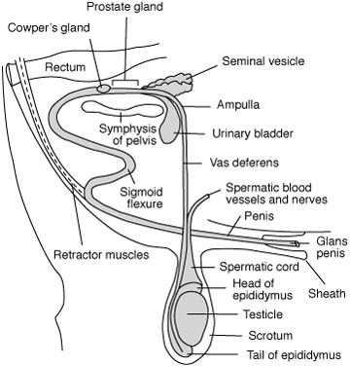
- How many sperm per week should a bull produce?
1
- Fill in the blanks
1.
2.
3.
4.
5.
6.
7.
7
6
5
4
2
3

