NAME__________________________________________________Minerals Notes
Standards:
3.3.8.A2: Describe renewable and nonrenewable energy resources
3.3.8.A3: Explain how matter on earth is conserved throughout the geological processes over time.
3.3.8.A1: Distinguish between physical and chemical weathering. Compare and contrast the types of energy that drive Earth’s systems.

Minerals: How to identify them…
YOU AND A PARTNER will come up with 3 ways you can think of to identify a mineral
1.______________________________________
2.______________________________________
3.______________________________________

A MINERAL’S APPEARANCE HELPS IDENTIFY IT
- In order to identify a mineral you need to observe it properties-the things that identify it.
- There are 5 main properties that we use to identify.
There are many minor properties that can also help id a mineral.

Mineral Property #1
Color and Streak
The first thing we notice about a mineral is color
Many people collect minerals based on appearance and color
Color __________________ a good indicator of the type of mineral
Many minerals have different colors
Color will send you along the right path to identify minerals, though
Since color isn’t a reliable source, geologists ________________
Streak is the color of the ___________________ of a mineral.
To test a mineral’s streak (powder color), you rub or drag a mineral over a tile of unglazed porcelain (white or black).
Hematite's streak is _________________
Galena's streak is ___________________
Pyrite (Fool’s Gold) is always _____________________ when found in crystal form, but when powdered produces a black streak
Gold’s streak is ____________________
WHAT IS YOUR MINERAL’S COLOR:________________________________
WHAT IS YOUR MINERAL’S STREAK:_______________________________

Mineral Property #2-Luster
Luster is the way in which _________________________ from the surface
The two types of luster are:
- ______________________________ 2. __________________________________
WHAT IS YOUR MINERAL’S LUSTER:________________________________

Quick Check-With your partner on a white marker board..
What is the first thing someone notices about a mineral?___________ ___________________________________
What do we call the color of the powdered mineral?____________________________________
Which is more reliable: streak or color?__________________________
What are the two types of luster?______________________________

Mineral Property #3-How a mineral breaks
When a mineral breaks it does so either by fracturing or by cleaving.
Cleavage-the tendency of a mineral to ____________________________________________
Crystal cleavage is a smooth break producing what appears to be a flat face
Fracture is the tendency of a mineral to break into _______________________
HOW DOES YOUR MINERAL BREAK:________________________________

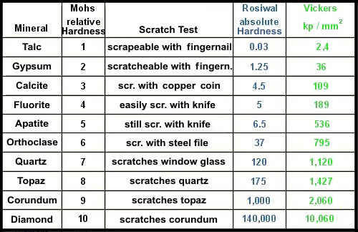
Mineral Property #4-Hardness
A mineral’s hardness is its ___________________ to being scratched.
A scale known as the Moh’s scale is often used.
WHAT IS YOUR MINERAL’S HARDNESS:________________________________

Mineral Property #5-Density
Each mineral has a _______________________________________
Density is the mass of a given space or in. Scientific terms mass per unit of volume
Geologists go even more in depth. They measure___________________________________
The specific gravity of a mineral is it's mass divided
by the mass of an equal volume of water.
Geologists measure density by the following:
First they use a balance to determine the mass of a sample
Second, they place the mineral in water to see how
much water it displaces.
The volume of displace water = the volume of the sample
Third they use the following formula:
_________________________________________________
Some Minerals Have Specific Properties
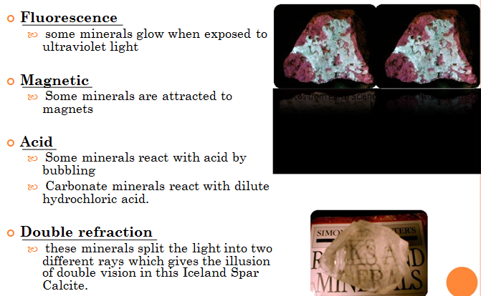
Answer these questions…
Bob found this mineral. He wants to know what it is and if it is valuable.
What properties can Bob use to
determine what this mineral is?_____________________________________

SLCDFH
SOME LLAMAS CLIMB DOWN FUNNY HILLS
Streak-Powdered color
Luster-How Shiny?
Cleavage-Breaks in sheets or blocks
Density-How much mass in a given volume
Fracture-Just crumbles or breaks
Hardness-Can be scratched by

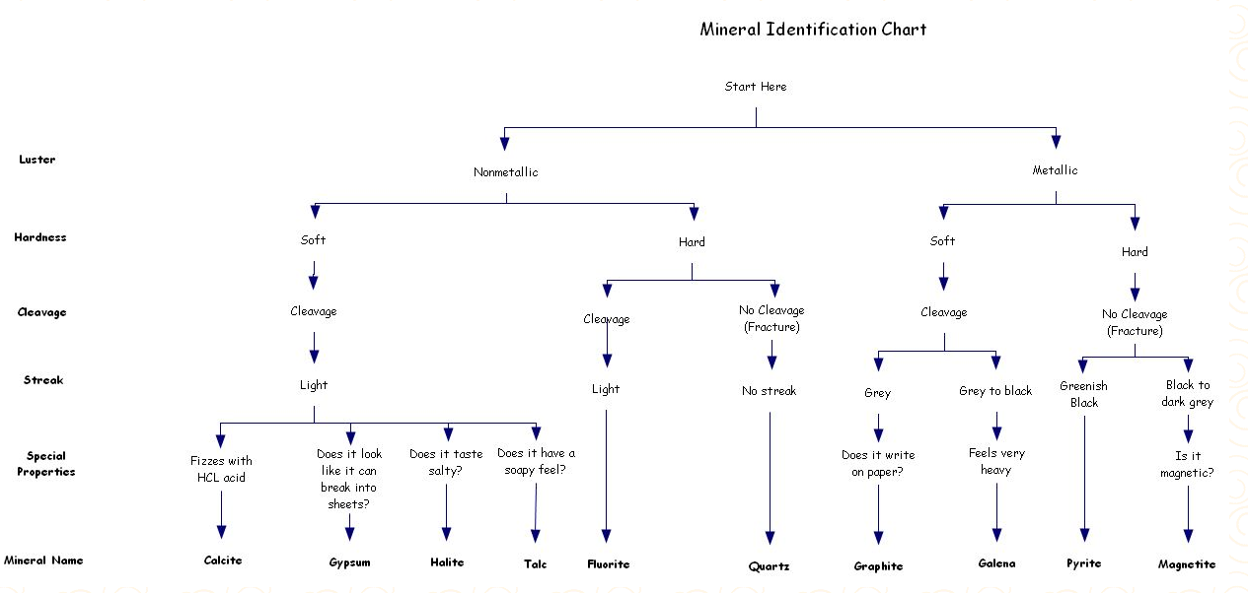
CONCLUSION:
- Explain why certain minerals seemed to be easy to identify. ______________________________________________________________________________________________________________________________________________________________________________________
- Determine two properties that distinguish clear, transparent quartz from clear, transparent calcite. Explain your choice of properties. _____________________________________________________________________________________________________________________________________________________________________________________
- Which physical properties would be the easiest to determine if you found the mineral specimen in the field?
______________________________________________________________________________________________________________________________________________________________________________________

