NAME_________________________________________Envirothon Unit 1A-Abiotic Influences of Water-Mrs. Weimer
Water statistics
- Covers 75% of Earth’s surface
  - _______ oceans
  - _______ freshwater
    - 2% (of Total) in ice caps and glaciers
    - 1% in lakes, underground, or in atmosphere (usable by humans)
- Makes up 70% of the human body
  - 92% of blood plasma
  - 80% of muscle tissues
  - 60% of red blood cells
- Physical properties
  - Is clear, colorless, odorless, and tasteless
  - * Colors, tastes and odors are caused by substances dissolved in the water.
  - Boils at _____________
  - Freezes at __________
  - Density = _____g/mL (at 4°C)
  - Water is a _______ Molecule
- Draw the structure of the water molecule and label it:

- Forms this kind of bond_________________________
- POLAR MOLECULE
  - A molecule that __________________________________ areas.
  - Also called a polar substance or polar compound.
- NON-POLAR SUBSTANCES
  - Non-polar substances do not have charged ends
- Draw water as a polar molecule:

- POLAR MOLECULE
  - THE PROPERTIES OF:
    - Cohesion, adhesion, specific heat, universal solvent, capillary action, surface tension
    - ALL HAPPEN BECAUSE WATER IS A POLAR SUBSTANCE!
  - CAPILLARY ACTION
    - The combined force of attraction among water molecules and with the molecules of the surrounding material.
    - Cohesion + Adhesion
      - Capillary Action (draw it)

  - SURFACE TENSION
    - The tightness across the surface of water that is caused by the polar molecules pulling on one another.
    - Makes the surface act like a solid
    - Surface Tension (draw it)

  - UNIVERSAL SOLVENT
    - This is a nickname given to water.
    - Water dissolves LOTS of things.
    - Remember:
      - ___________ = the thing doing the dissolving
      - ___________ = the thing that dissolves away
      - Other polar molecules can be dissolved by water.
  - NON-POLAR SUBSTANCES
    - Non-polar substances ___________ dissolve in water.
    - Can you think of some examples of non-polar substances?
  - Universal Solvent
    - Why is water so good at dissolving things?
      - Because water is a polar molecule and is shaped like a _________, it is able to break up substances into smaller pieces (dissolve).
  - COHESION
    - Because water is a polar molecule, it is __________________________________________.
    - Cohesion – is the attractive force between water molecules.
    - Draw Cohesion

  - ADHESION
    - Because water is a polar molecule, it is attracted to ____________________________
    - Adhesion – occurs when molecules of water are attracted to other substances.
    - Draw Cohesion

  - SPECIFIC HEAT
    - Specific Heat = the amount of energy needed to increase the temperature of something 1 degree C.
    - Water has a ____________________________ specific heat
    - That means it takes a lot of ______________ for water to increase its temperature.
    - This is because of the _____________________________ between water molecules.
    - It’s POLAR!
  - Freezing
    - Density of ice (at 0°C) is _________________, so ice floats in water.
    - Most liquids become more dense as you cool them. However, when water freezes, a large expansion occurs.
Pennsylvania Watershed (Unit 1 Part 2)
- A watershed is the land area from which ____________________________________ drains into a stream, lake, reservoir or other body of water.
- A basin is the large land area that is made up of many _________________that are drained by a river system.
- Pennsylvania Watersheds:
SODPEG S= Susquehanna O= Ohio D= Delaware P= Potomac E= Lake Erie G= Genesee
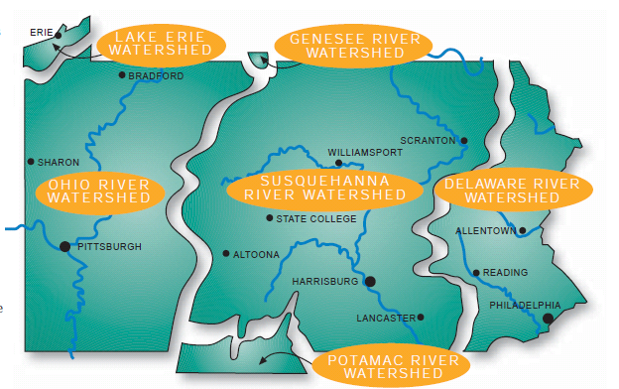
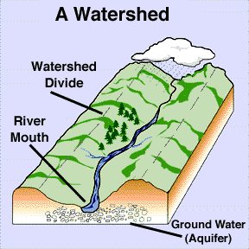
- Watersheds are surrounded by topographic highs called __________________
- Within all watersheds, small streams
  - (1) join together to form _________________
  - (2) and larger streams join together to form _____________________
  - (3). Rivers eventually empty into ___________________
  - (4) where the water may stay for some time or evaporate and form precipitation. Some of this precipitation falls on the land and the process repeats itself endlessly.
- Draw how water moves through one of our watersheds:

- Pennsylvania has more miles of ___________________ than any other state, excluding Alaska!
- If you floated a boat down the Youghiogheny River it could end up in the _________________________________!
- All the stream water in PA eventually ends up in the ____________________________
- Forest watersheds supply over _________of our drinking water!
- If you floated a toy boat down the Laurel Hill it could end up in the Gulf of Mexico
- If you went to an area on the other side of the continental divide (on the way to Frostburg) a toy would float to _______________________________________
- Pennsylvania State Water Plan organizes the state’s freshwater systems into __________watersheds
- Characteristics
  - All contain water
  - Have a divide
  - Contain land
  - Drains to a body of water
  - Water eventually drains to an ocean

- ABIOTIC FACTORS
  - DISSOLVED OXYGEN
      - Organisms that live in water require oxygen to survive, just like land organisms do.
      - The amount of dissolved oxygen in water determines what kind of fish and other organisms live in the water.
      - In estuaries like the __________________________, the amount of dissolved oxygen in the water varies with the _______________________
      - Must be greater than ___________ mg/1 for fish and aquatic organisms to survive
  - WATER TEMPERATURE
    - The temperature of water can change greatly in a watershed over thecourse of a year depending on the seasons.
    - Water temperature affects the types of organisms that can live and reproduce in areas of the watershed.
    - For example, fish that need cooler water temperatures may _______________________ to cooler waters in summer months.
    - Toleerance levels range from ____________ degrees
  - pH
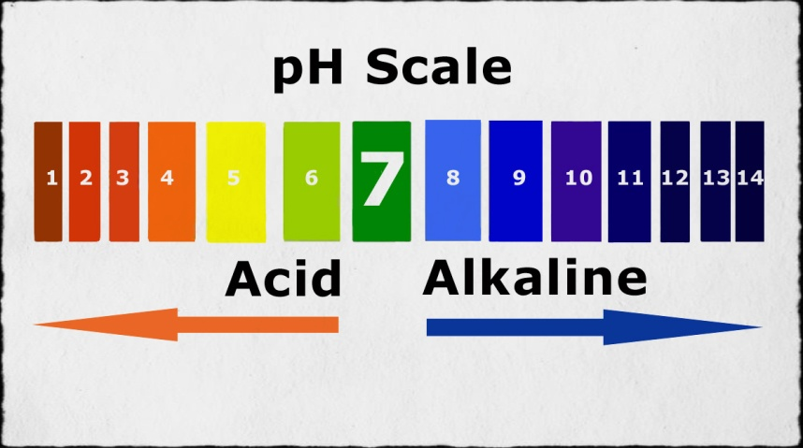
    - pH is a measurement of the acidity or alkalinity (base) of a solution.
    - When substances dissolve in water they produce charged molecules called ____________
    - Acidic water contains extra hydrogen ions (H+) and basic water contains extra hydroxyl (OH-) ions.
    - pH is measured on a scale of _____________________
    - Neutral water has a pH of ____.
    - Acidic water has pH values less than 7, with 0 being the most acidic.
    - Likewise, basic water has values greater than 7, with 14 being the most basic.
  - Acid Rain
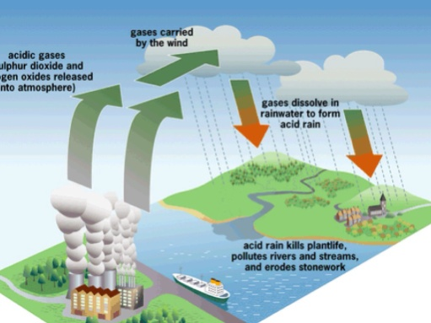
    - Acid rain is anything below 7 on the pH scale
    - Three ways it can harm fish
      - Eggs
      - Gills
      - Body Chemistry
    - AVERAGE pH rainfall in PA is __________
    - Some of the most acid in the country
    - Most aquatic animals and plants have adapted to life in water with a specific pH and may suffer from even a slight change.
    - Even moderately acidic water (low pH) may reduce the ________________________ of fish eggs, irritate fish and aquatic insect ______, and ______________________________________.
    - Water with extremely high or low pH is deadly.
    - A pH below 4 or above 10 will kill most fish and very few animals can tolerate waters with a pH below ___or above ___.
    - Amphibians are particularly vulnerable to low pH, likely because their skin is so sensitive to pollutants.
    - Some scientists believe the recent drop in amphibian numbers around the world is due to low pH levels caused by acid rain.
    - Aquatic invertebrates
      - Have external skeletons
      - Shells made from _________________
      - Extra sensitive to pH change
    - Acid Rain
      - Derived from
      - Power stations, factories and cars all burn fuels and therefore they all produce polluting gases.
      - Some of these gases (___________________________________________________) react with the tiny droplets of water in clouds to form sulphuric and nitric acids.
      - The rain from these clouds then falls as very weak acid - which is why it is known as "acid rain".
    - Clean Air Act
      - 1990
      - Congress passed an ammendment to reduce ______________ emissions
  - Water Pollution
    - 1/5 of PA streams and ½ of PA lakes are impaired or polluted
    - Come from 2 sources
      - Agriculture runoff
      - Abandoned mine drainage
    - Agriculture runoff
      - When runoff from rain or snow carries soil, pesticides and fertilizers from fields to water
      - Soil=can be suspended in the river
        - Makes ________
        - Can damage _________________
        - Can absorb more sunlight and make temps ___________
        - Silt that settles into sediment make it difficult for fish to find food on the bottom
        - Can kill invertebrates by ______________________________
      - Fertilizer on the field makes plants grow and does the same for aquatic plants
        - Make aquatic plants a nuisance
        - Decomposing plants comsume _____________________________________
        - This leads to :
          - Brook trout, mayflies, caddisfly and stone flies=die
          - Small mouth bass, rock bass, and catfish=more tolerant and will stay
    - Abandoned Mine Drainage
      - Pollutes almost 1/2 of PA waters
      - Lowers the ___
      - Below ___algae and plants die
      - can make the stream waters and bottom appear yellow (_______), white (______________), and black (_________________)

