Group Names___________________________________________Soil Erosion Lab – Plant and Soil Science Mrs. Weimer
Objectives: Students will make predictions and record observations about soil erosion and water quality. Students will make connections between the water cycle and watersheds under healthy and unhealthy forest conditions. Students will demonstrate an understanding of how vegetation plays a role in preventing soil erosion and promote water quality. Students will appropriately organize information gathered through observation. ‐Students will use complete sentences to summarize observations and conclusions. Students will understand agricultural impacts on the soil.

Materials:
‐ 4 two liter plastic soda bottles (or other large water bottles) * At least one bottle lid*
‐ Yarn or small rope
‐ glue and/or duct tape
‐ wooden board or piece of cardboard large enough to glue or tape 2 bottles to
‐ enough soil and debris (leaves, twigs, bark, roots, sand, ashes from something burned if possible) to fill 2 of the liter bottles
‐ fast growing seeds (alfalfa sprout seeds, wheat and other grass seeds, watercress seeds, or chia seeds)
that germinate and sprout within a few days
‐ A place near a classroom window if possible

Procedure:
1) Lay 3 bottles down on their sides.
2) Secure them with tape or glue to a piece of wood or cardboard so that the mouths are hanging over the edge.
3) Cut out a rectangle out of each the so that their will be an opening, but don’t cut off the mouth and lid! 4) Place same amount of ground soil in each bottle and press hard to pack as much as possible. The soil must be just below the level of the opening of the mouth bottle.
5) Add grass seed to 90% of the soil in bottle 1
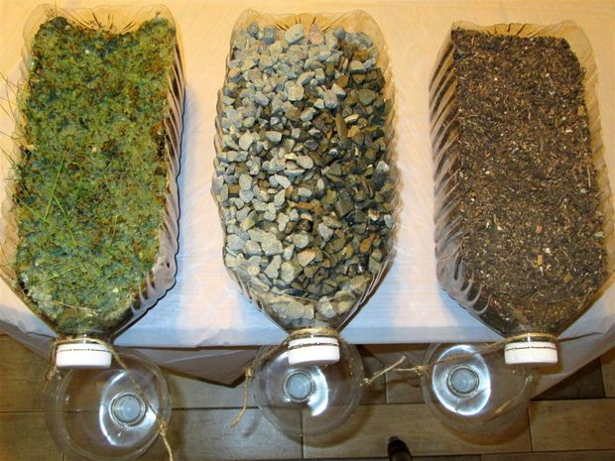
6) Add grass seed to 10% of the soil in bottle 2
7) Add nothing to bottle 3, just the soil
8) Reattach the top to the bottles to allow for the water cycle
9) Allow grass to grow

Hypothesis:
1. Which of the bottles will exhibit the most consistent water precipitation?

2. Why?

3. Which bottle will exhibit the highest rate of erosion?

3. Why?

Observations (recorded on Tues and Thurs of every week)
Date | Observation

Conclusion-analyze your results and provide a conclusion as to what happened, why it happened, what impact erosion has on American Farmers, how to slow down erosion and what farmers can do to slow that process.

Questions:
1. Describe what you learned and how you will utilize this knowledge in your life as an adult humanoid.

