NAME________________________________________________Wildlife Exam #3-Mrs. Weimer
Identity | Herbivore, Omnivore, Carnivore
1
2
3
4
5
6
7
8

Identify the following:
1
2
3
4
5
6
7
8
9
10
11
12

Identify the following:
1
2
3
4
5
6

Matching:
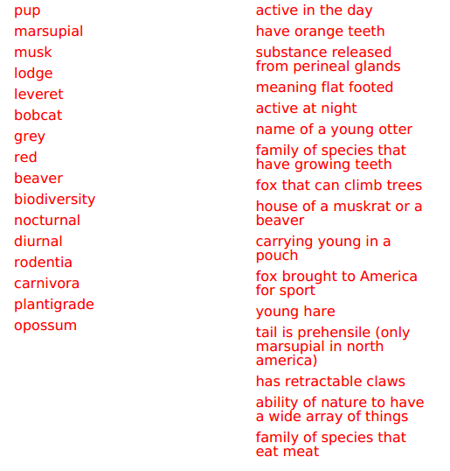
A
B

C

D
E
F
G
H
I
J

K
L
M

N
O

P

Short Answer:
- Describe some of the characteristics of the mustelidae family.

- What is meant by the term “delayed implantation?”

- Why do opossums only have a 13 day gestation period?

