Wounds & Hemostasis Notesheet
Name: Hour Date:
- To have normal blood flow, blood must be kept at an exact (or )
- If blood was too thin, what would happen?
- If blood was too thick, what would happen?
- What keeps blood thin and flowing under normal circumstances?
- List and describe the four kinds of open wounds below:
- The series of chemical reactions needed to stop bleeding is called
- List and describe the three steps of hemostasis below:
- What is vasoconstriction?
- At the site of injury, will help to stick to the site of the injury
- Collagen is sort of like t hat the platelets can grab onto as they pass in the bloodstream
- ________________ are formed in the and live in your body’s circulatory system
for roughly a
- Why are platelets not like other cells?
- Why is it that platelets stick to injured tissue?
- Why don’t platelets stick to other tissue?
- What are contractile proteins?
- About minutes after a blood clot has formed, the platelets within the clot
- Like muscle cells, platelet cells can shrink due to and contractile proteins
- The blood clot is – at the same time of contraction, the tissue surrounding the
damaged site begin to divide and repair via .

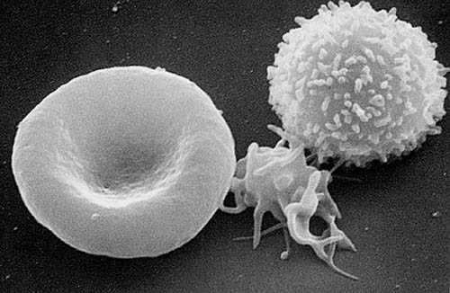
- Draw an arrow to the following: White Blood Cell Red Blood Cell Platelet

- Why do platelets release granules? What do these granules do?
- What kind of mechanism is this?
- The platelet plug will become reinforced with a
- What is a “scab” made out of?
- Describe the role played by each of the ingredients of a scab:
  - Fibrin
  - Red blood cells
  - White blood cells
- Once bleeding is controlled, the blood vessels that were constricted now
(open up) to bring rushing to the scene.
- The process in which the wound swells and becomes inflamed is called .
- Explain why a wound as swelling, redness, tenderness, and heat when healing:
- What is Fibrinolysis?
- What is Warfarin?
- What does Warfarin do?
- What is Warfarin named for?

