ENERGY & POWER SYSTEMS

What, where, when, why, and how are energy and power systems?
Presentation Activity

- Hydroelectric

- Wind

- Nuclear

- Solar

- Fuel Cell

- Biofuels

- Mechanical Energy-Kinetic & Potential

- Fossil Fuels

- First Law of Thermodynamics & Second Law of Thermodynamics

- Thermal / Gravitational / Sound / Elastic / Electromagnetic Energy

- Geothermal / Hydrothermal

- Tidal

- Nuclear

- Cold Fusion

- Cogeneration

- Water Powered Car/Hydrolysis

- Exhaustible/Inexhaustible/ Renewable

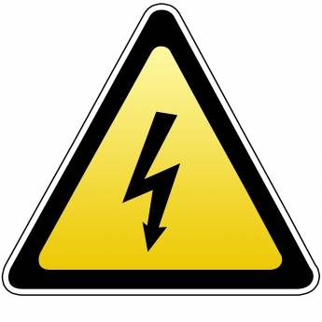
DIRECTIONS: Create a PowerPoint presentation based on your selected power source. Use the checklist below as you develop the presentation.
- Explain: What your system is
What your system does
How does the system do it
- Be sure to cover all answer the what, where, why, how questions
- Comment on what technological developments or future improvements that will impact your power source

- Use appropriate graphics and images
- Use video if possible and appropriate
- Be sure to have and explain a diagram of the system
- Create a handout to supplement the presentation. This should contain the nuts and bolts about what students needs to know about the system

- The presentation must have a sources page (MLA) use this link to help you with the citations: www.knightcite.com
- Be knowledgeable and present the information to the class on your assigned day.

