The Importance of Soil Unit 1-A

Name: Period: Date:

**Slide 2**

Please answer the following Questions:

* 1. Why is soil important to you?
  2. What do we use soil for?
  3. Why do we need soil?

**Slide 3**

After this unit you will be able to:

*Summarize ecological functions of soil*

*Describe 4 ways plants use soil*

*List and explain uses of soil*

**Slide 4**

* Past: The importance of soil dates back thousands of years but is still a current problem today.
  + in 340 B.C.E. observations of soil were taken by green historian Herodotus
  + in the 1930’s the Dust Bowl caused drought because of soil misuse.
* Present
  + North and South America and Europe receive dust blown from Africa. As soils of Africa degrade the movement of dust has been increasing.
* Future:
  + The Earth’s population has reached about 7 billion people
  + The worlds growers will need to provide 70 percent more food by 2050

**Slide 5**

1. Is soil a renewable or a non-renewable resource? ________________________________________________________

__________________________________________________________________________________________________

2. Minerals in Rocks and Fossifuels are (circle one): Renewable or non-renewable. Why? __________________________

__________________________________________________________________________________________________

**Slide 6 and 7: Soil is a life supporting layer of material**

3. The atmosphere interacts to provide plants and animals with what? ________________________________________

4. Temperature: Plant roots grow best in ____________ _______________ ranges 40 – 50 degrees

5. Gases: Plant roots and other soil organisms need _________________ and give off ____________________

6. Water: Soil _______________ water as it moves through; ________________ it.

7. Carbon: Soils act as a ________________ ___________ keeping c02 out of the atmosphere

**Slide 8 Agricultural Uses of Soil**

8. Human societies depend on soil to grow the following:

A. Food

B. _________

C. Timber

D. _______________ plants

E. Biofuels

**Slide 9: Ag uses of soil: Cropland**

9. Please define cropland: _____________________________________________________________________________

__________________________________________________________________________________________________

10. Worldwide the greatest acreage of cropland is devoted to which type of crop? ______________________________

**Slide 10: Agricultural Uses of Soil: Grazing Land**

11. Please define Forage: _____________________________________________________________________________

12. The environmental consequences of grazing depends upon what? _______________________________________

13. Overstock land suffers damage to which two things? ______________________________ and _________________

**Slide 11: Agricultural Uses of Soil: Forests**

14. Foresters disturb soil: (circle one) The most or the least

**Slide 12: Agricultural Uses of Soil: Landscape Horticulture**

15. Landscape horticulture can be defined as the practice we use to: _________________________________________

_________________________________________________________________________________________________

16. These type of landscapers install and maintain plants in soils that have been heavily modified by what?

_________________________________

**Slide 13: Agricultural Uses of Soil: Urban Agriculture**

17. Urban agriculture seeks to provide what to poorer people? ______________________________________________

18. Urban farmers occupy small pieces of land some examples are: ___________________________________________

**Slide 14: Use of soil in the United States**

19. Please fill in the following uses of soil in the united states that are missing.



**Slide 15: Soil and Climate**

20. Climate affects how we use the soil but Soil also affects the _____________________________________.

21. Please define greenhouse gases: ___________________________________________________________________

__________________________________________________________________________________________________

22. Soils is one of the planets largest reservoirs of what? Which form does it take on? ____________________________

_________________________________________________________________________________________________

**Slide 16: Please answer the following:**

* **Now that you know more about the importance of soil …**
  1. What things would you NOT have if we did not have soil? ______________________________________

_____________________________________________________________________________________

_____________________________________________________________________________________

* 1. Do foresters disturb the soil the most or the least? ___________________________________________

_____________________________________________________________________________________

_____________________________________________________________________________________

* 1. What is Urban Agriculture? ______________________________________________________________

_____________________________________________________________________________________

_____________________________________________________________________________________

Soil Science Notes Sheet Unit 1-B

Name: Period: Date:

**Slide 2**

After this unit you will be able to:

*Identify* and *describe* soil

*Describe* the importance of soil

*Describe* and *Draw* a soil profile

**Slide 4: Soil Origin and Development**

1. Please define pedology: __________________________________________________________________________________________________

2. Who published the Factors of Soil Formation in 1941? ______________________________________________________

**Slide 5: Soils Perform Several Vital Functions:**

3. Soils:

A. ___________________ plant and animal life below and above the surface

B. Regulating and partitioning ____________________ and solute flow

C. Filtering, Buffering, Degrading, immobilizing and detoxifying

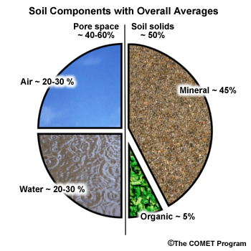 D. Storing and Cycling ________________________________

E. Providing ___________________ to structures

**What is Soil?**

**Slide 7: Soil Components**

4. Please label each for the pieces of the pie chart:

**Slide 8: Soil Body**

5. What is soil a collection of? ________________________________________

___________________________________________________________________________

6. Soil contains living matter that is able to support what?   
  
________________________________________________________________________

7. Define a **Pedon**: _____________________________________________________________________________________________________________

____________________________________________________________________________________________________________________________________

**Slide 9: Soil VS. Dirt**

8.

|  |  |
| --- | --- |
| Soil | Dirt |
| Material which ______________________________ and  _____________________________ growing plants | Soil out of ___________________ |
| Compilation of minerals, ______________, water, animals,  and other ______________________ matter | Unable to serve its original ___________________ |
| Contains an equal amount of _________________,  _________________ and _____________________ | Cannot support plant life |

**Slide 10: Parent Material**

9. Define **Soil Genesis:** ____________________________________________________________________________________________________________________________________

____________________________________________________________________________________________________________________________________

10. Where do soils form directly from? ______________________________________________________________________________________

11. Transported soils are developed from weathered materials and are transported from their place of origin. How are they transported?

A. _____________________________________________________

B. _____________________________________________________

C. _____________________________________________________

D. _____________________________________________________

**Physical Properties of Soil: Slides 12 – 25**

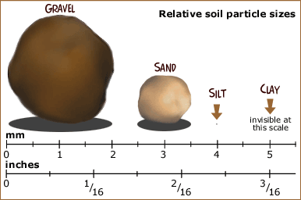**Slide 13: Soil Components and Texture**

12. Soil Texture describes what?

13. What are the three particles that compose soil texture?

1. ___________________________________
2. ____________________________________
3. ____________________________________

**Slide 14: Texture Classes**

|  |  |
| --- | --- |
| Soil Textures |  |
| Sand | Loamy sand |
| Sandy Loam | Sandy Clay Loam |
| Loam | Silt Loam |
| Silt | Silty Clay Loam |
| Clay | Clay Loam |
| Sandy Clay | Silty Clay |

14. How many soil texture classes has the USDA Identified so far?

**Slide 15: The importance of Soil Texture**

15. Texture is important to soil. Please list three of the things that texture can affect in regards to soils:

1. _________________________________________________
2. _________________________________________________
3. _________________________________________________

16. The ability of a soil to retail water for use by plants is called:

17. The ease with which air and water may pass through the soil is called: _______________________________________________

18. The ease with which soil may be tilled and the timing of working the soil after a rain is called:

**Slide 16: Soil Texture Triangle**

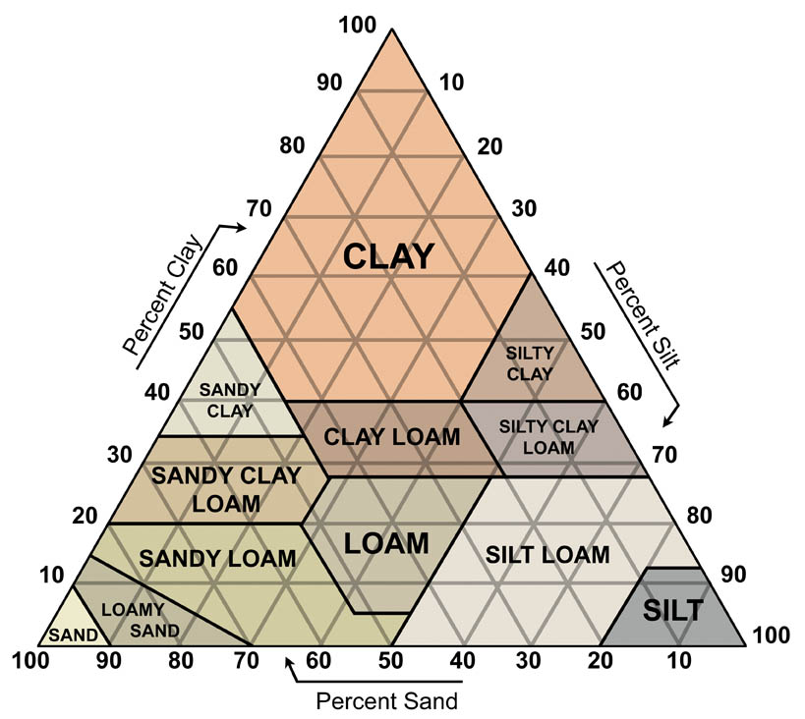19. What does texture determine? ______________________________

20. Example of how to use the texture triangle:

% Sand ____________________________________

% Silt _______________________________________

% Clay ______________________________________

Soil Texture ____________________________________________

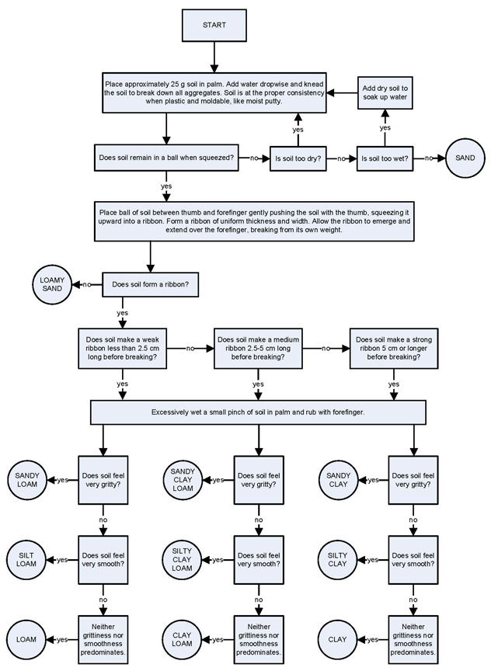**Slide 17: Soil Texture by Feel**

21. How can texture class can be

determined by: ________________________________

22. To determine texture a person MUST be

familiar with the _______________________________

23. When we are determining soil texture:

After we gather a bit of soil what do we do?

___________________________________________________

**Slide 18: Soil Particles**

24. What is soil made of? _____________________

25. What do **Particles** largely consist of? ____________________________________________________________________________________

____________________________________________________________________________________________________________________________________

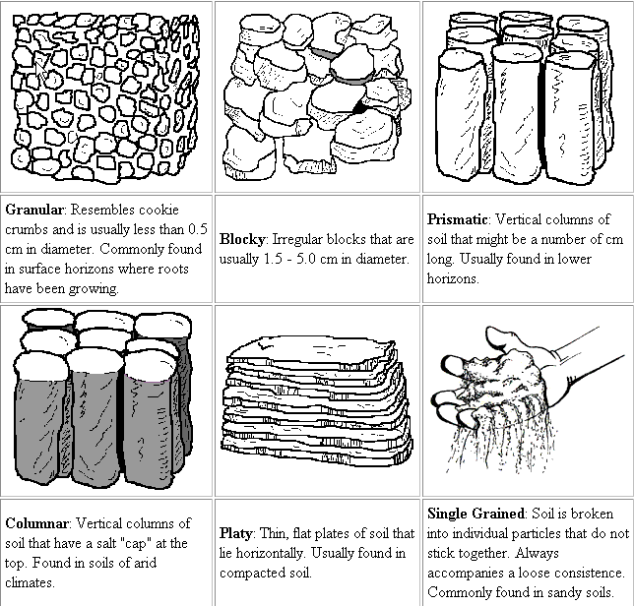

26. The space between soil particles

are called: _____________________________________

27. The **Soil Matrix:** is the arrangement of the solid particles and the

__________________________________________________

**Slide 19: Soil Structure**

28. Define **Aggregate:**

29. Please label the diagram to the right with the following terms: Granular, Single grained, platy, prismatic, blocky, columnar.

**Slide 20 and 21: Soil Color**

30. Soil color is described by comparing the color of a soil horizon with that type of chart? _____________________________

31. Dark colored horizons have _______________________________ organic matter than lighter ones.

32. What do soil colors mean? Fill in the chart below

|  |  |
| --- | --- |
| **Color** | **Meaning** |
|  | Organic Matter |
| Red |  |
|  | Well Drained |
| Grey |  |
|  | Redoximorphic concentrations and or poor drainage |

**Slide 23: Soil Horizons**

33. What are the Master Horizons called? ____________________________________________________________________________________

34. Each letter of soil is identified by a code. Please list the code:__________________________________________________________

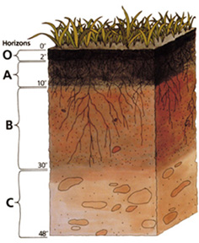

**Slide 24: Soil Profile**

35. Please describe each of the soil horizons shown to the left below:

**0: _________________________________________________________**

**A: Top Soil**

* The A horizon is a surface mineral layer where

____________________________________ accumulates

**E:** **Zone of Eluviation**

* The E horizon layer is depleted in __________________, chemicals and organic matter.
* Light colored
* Many soils _______________________ have this horizon

**B: _____________________________________**

* “Zone of accumulation:” Where chemicals leached out of the _______ horizon accumulate.
* Lower _________________________________ content than the top soil

**C: Weathered/ Aged Parent Material**

* Little touched by soil – forming ____________________
* Soft, __________________________ __________________________

**R: Hard ______________________________**

* Limestone, ________________________ or _____________________________