**Dairy Cattle Injections:** Today, more of the "beef" (i.e. meat) from dairy cattle is processed as high-value whole muscle cuts from the loin, rib, round and "flat" portions of the carcass. Injection site defects cause substantial losses to these higher-value cuts -- erasing a profit opportunity. The 1999 National Market Cow and Bull Quality Audit showed that producers lost about $70 on every cow they sold because of product defects, like injection site blemishes. These defects have a negative impact on the price that beef processors can pay for cows. Food safety and quality is a major public concern and injection site blemishes are a major concerns of retailers. Irritated and damaged tissue at the site of intramuscular injections results in unappetizing muscular scars and lesions, and increased product toughness. These defects affect consumer confidence in beef and reflect poorly on the image of the dairy industry. The following ten steps will enhance the effectiveness of the products used to maintain the health of the herd, prevent costly product losses, and build public confidence:

1. **Know the product and follow the label.** Observe purpose, preparation, route, timing safety, expiration date, withdrawal time, storage and dose. Know the product and seek documentation showing it does not cause tissue irritation.
2. **Choose the correct injection site**. Ideally, do not give injections in the hind quarters, but rather give all injections in the neck area in front of the shoulder.
3. 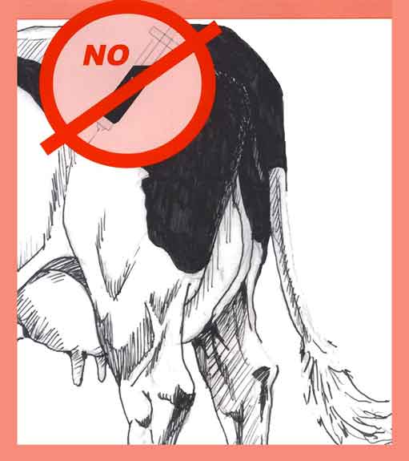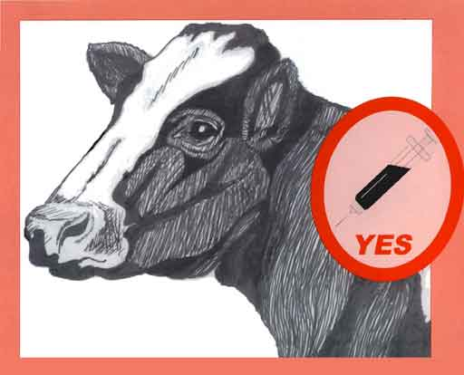**Stay away from the muscle whenever possible**. Choose products formulated and labeled for injection under the skin (subcutaneous, / Sub-Q / SC) rather than intramuscular.
4. **Use proper technique**. For example, use clean needles, insert needles at an angle just below skin surface. For subcutaneous delivery, use the two-handed "tent" technique. Clasp the animal hide between your fingers and lift, then inject the product into the "tent". Discard, burred, bent, or broken needles.
5. **Use multiple sites**. Never inject more than 10cc of a product in any one site. Keep injection sites at least 4" apart.
6. **Choose the correct needle**.
   * For Sub-Q: 16-18 gauge needle, 1/2 to 3/4 inch long;
   * For IM: 16-18 gauge needle, 1 inch long;
7. **Keep equipment clean**. Use hot water to clean equipment. Disinfectant can leave residues, which destroy vaccines and should not be used with modified live virus guns.
8. **Never combine products**. Each injectable product has specific label instructions. Do no mix "combinations." This practice causes tissue damage and will reduce or eliminate product effectiveness.
9. Mix and handle products correctly.
   * Mix large dose packages well at first and again during use;
   * Do not mix too much at once - vaccines lose effectiveness after an hour;
   * Use transfer needles;
   * Discard leftover vaccine - do not reuse;
   * Protect from extreme temperature;
10. **Keep Detailed records**. Record what was used, when, why and in which animals.

*Source: Dairy Beef Quality Assurance Centers: Northeast 717-939-7000; Midwest 952-854-6980.*

|  |  |  |  |
| --- | --- | --- | --- |
| **Keywords:** | Dairy Cattle Injections meat quality injecting quality insurance | **Doc ID:** | 581 |
| **Owner:** | Michel W. | **Group:** | Dairy Science 302 |
| **Created:** | 2008-06-15 | **Updated:** | 2010-01-27 |

# Please try to complete each of these, you must have Mrs. Weimer sign off before proceeding

# Intramuscular Injections_____________________

* Choose muscle tissue of lesser value to consumers for IM injections. In cattle, for example, IM injections where possible, are often given in the neck area instead of the hip.
* Draw air into the syringe and inject the same volume of air into the bottle as the volume you plan to take out of the bottle to equalize the pressure. Failure to do so will make it difficult to withdraw the contents of the vial or bottle.
* After filling the syringe with the product to be injected, point the syringe upwards and tap the barrel with your finger to make air bubbles move upwards into the syringe tip. Slowly and carefully push the plunger to eject the air bubbles from the syringe before injecting the product.
* Give IM injections deep into a muscle. Use a needle long enough to penetrate skin, subcutaneous tissue and fat to reach the muscle. The needle should enter the skin perpendicular to the skin surface.
* Insert the needle into the animal, and then attach the syringe to the needle. Check that the needle is not in a blood vessel by pulling back on the plunger and observing for blood flow in the tip of the syringe. If blood appears, remove the needle and put it in a different location at least one inch away from the original injection site.
  + *Lab: If done correctly, you will have to peel your chicken wing to identify the placement of the medication.*

# Subcutaneous Injections______________________

* Generally, you can choose the subcutaneous (SQ) route when given a choice of either the intramuscular (IM) or SQ on the product label.
* Give SQ injections half way up the neck in front of the shoulder, or over the ribs well behind the shoulder.
* Use a 0.5 to 1 inch long needle.
* To give SQ injections for cattle, lift a fold of skin to make a skin "tent". Insert the needle through one side of the tent at an angle of 30 to 45 degrees relative to the surface of the body. For swine, it won't be possible to make a "tent", so slide the needle under the skin at an angle of about 30 degrees from parallel to the skin surface and inject.
* *SQ injections are given under the skin into the fat layer between the skin and the muscle. Some medicines are absorbed better in the fat layer.
  + *Lab: If done correctly you will NOT be able to see a “bruise” on your chicken wing.*

# Intradermal Injections________________________

* Intradermal injections are injections given to an animal in which the goal is to empty the contents of the syringe between the layers of the skin.
* Intradermal injection is often used for conducting skin allergy tests and testing for antibody formation.
* This is a painful procedure and is used only with small amounts of solution.
* The vet should ensure that the needle is inserted into the epidermis, not subcutaneously, as absorption would be reduced.
  + *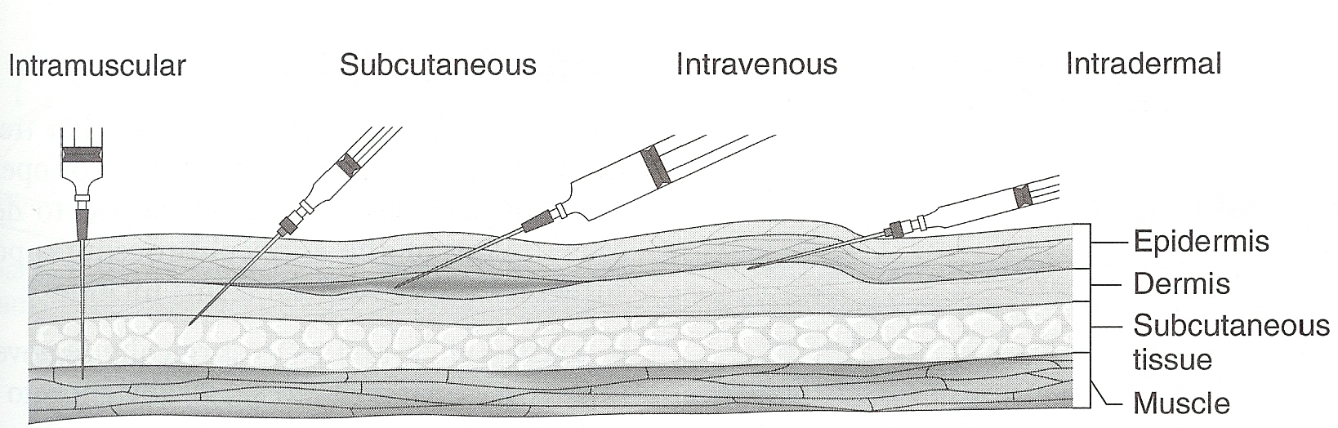Lab: If done correctly you WILL be able to see a slight “bruise” or circle of medication in your chicken wing*

Lab Questions

* 1. When giving a livestock animal an intramuscular injection, list 2 places that you would want to avoid and why would you want to avoid them.
  2. Compared to the IV injection, would the medication given in the muscle travel faster or slower-why?
  3. List 2 places on a dog that the subcutaneous injection might be given.
  4. What is the purpose of the subcutaneous injection compared to others?
  5. Which is the injection type that would give the quickest results for absorption of medication? Explain why this is. (Hint: it is one that you did not administer today!) (1)
  6. Briefly describe how and where “topical” administration of medication is given. (2)
  7. Why are sanitary conditions so vital when administering medications of any type? (1)
  8. List the 4 things you need to know about the drug that you or the vet are giving your animal. (4)
  9. What are the 2 common units of measuring dosage? (2)

10.) Assignment:

Research two types of diseases in an animal (livestock, exotic, or companion) that can be treated with medication. Determine whether intramuscular or subcutaneous would be the best way to treat the animal and WHY that would be the best way.