NAME_____________________________________________ Soil Analysis Lab-Mrs. Weimer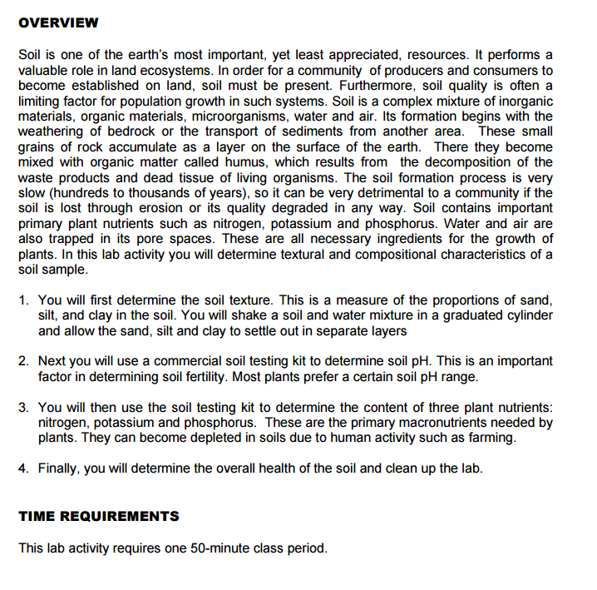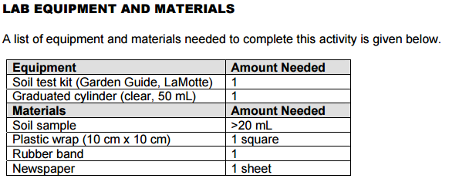

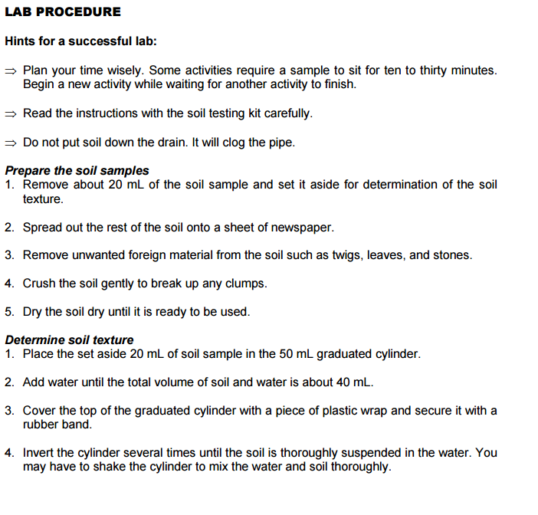

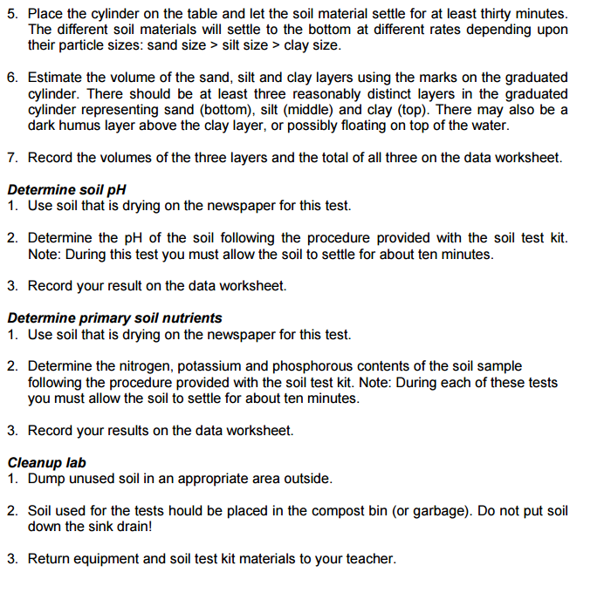

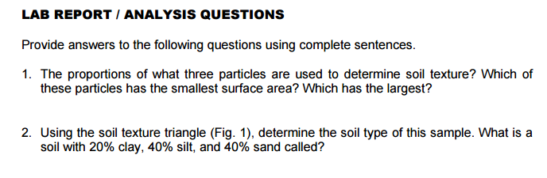

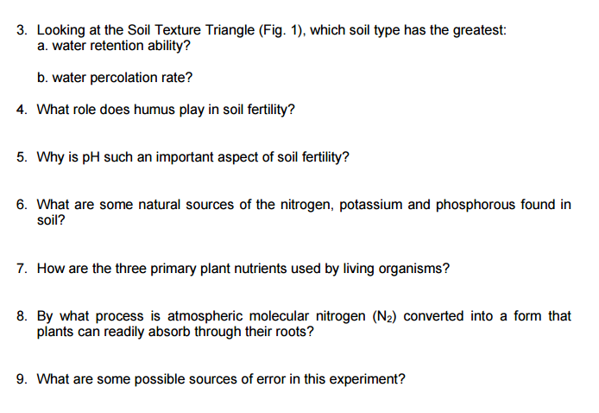

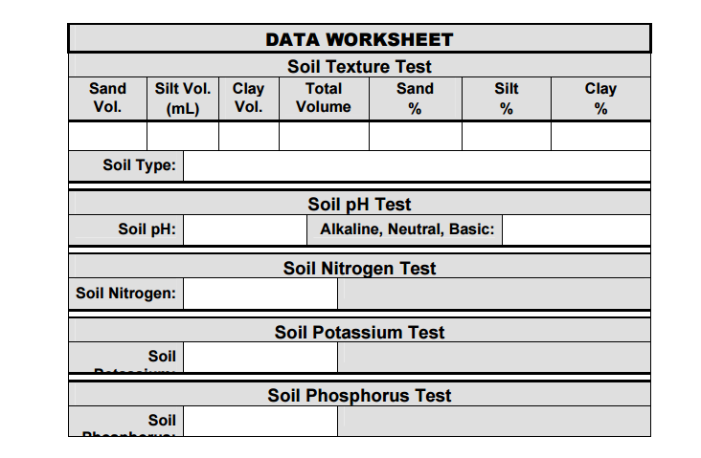

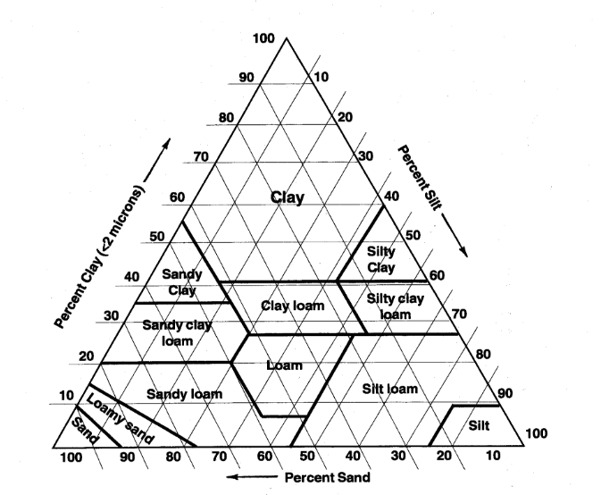

Part 2- Using what you have done with texture and using feel to determine if you were correct.

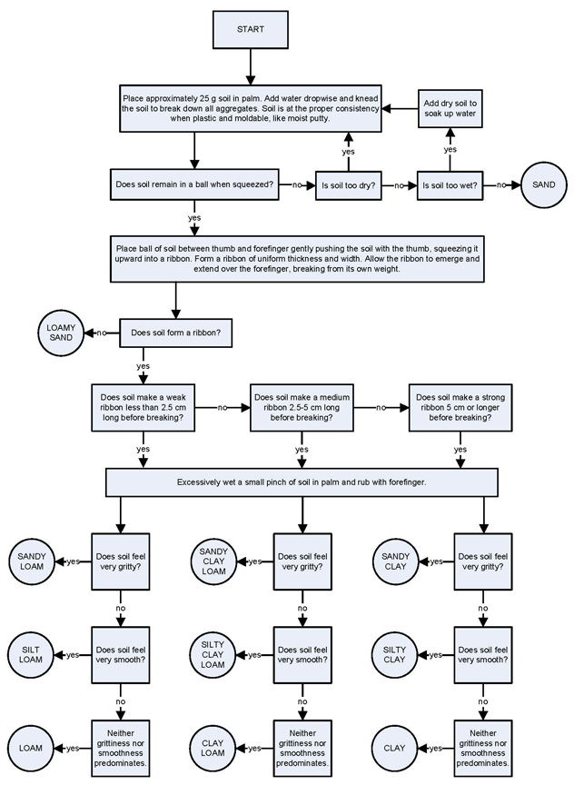

Soil Sample 1-_______________________________________________

Soil Sample 2 (borrow from a friend)-______________________________________