**Home Heating System**

**NAME #1** ___________________________

**NAME #2** ___________________________

**DATE** ______________________________

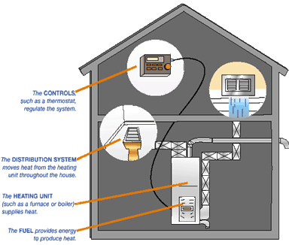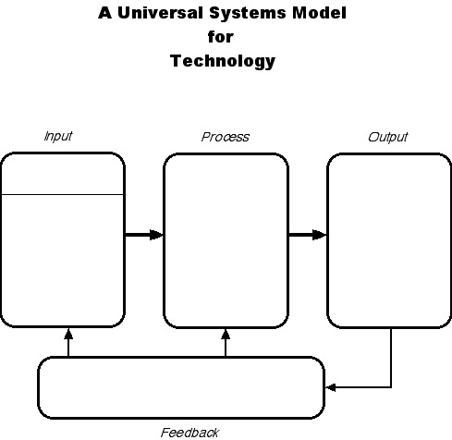**SYSTEM MODEL**

The **furnace** uses a fuel to heat the air and an electric motor to blow the heated air.

**DIRECTIONS:** Use the Systems Model Chart to identify the Inputs, Processes, Outputs, and Feedback from the home heating system diagram.

The **fuel** provides energy to produce the heat. Some common types of fuel are oil, gas, and coal.

The **floor register** sends warm air into the room from the floor.

The **thermostat** controls the temperature. This is where you can tell the system to make the house warmer or cooler. It also tells you the current temperature in the room.

**Ducts** transfer cool air in and warm air out of the furnace.

The **cold air intake** pulls cold air into the system and sends it to the furnace to be heated.

The **exhaust vent** releases the harmful exhaust fumes outside of the house**.**