Cell Organelle Project
Grade 7 Science-Mrs. Weimer
In order to understand the roles that each organelle plays in a cell we’re going to be doing a project. In this project we’ll be focusing on the functions of each organelle. The manner you display your knowledge will be up to you and your partner. Understand that you do not have an unlimited amount of time and you must be ON TASK during this process or risk losing points.

Option 1: Cell Model
Design a cell model out of real world materials that you and your partner can bring in or make a list for Mrs. Weimer to pick up. Creativity is encouraged and all models must illustrate the features, real facts (functions for each organelle) and labels for the organelles of the cell.

Option 2: Haiku
A Haiku is a Japanese poem written in 3 lines. In this class our definition of a Haiku will be: the first line has exactly 5 syllables, second line 7, and third line 5. An example is below:
It’s the control center
Called the nucleus of the cell
Contains DNA
Please write a Haiku about each organelle incorporating the function/nickname of that organelle. Then creatively display your haikus in flippable book and have them neatly decorated.

Option 3: Cell Analogy
Draw a cell diagram on a piece of paper with all of the listed organelles. Then, make an analogy (a cell city, factory, school, the Hunger Games, etc) comparing the cell and it’s organelles to something of your choice. If you are a person that does well with understanding concepts by relating them to real world things, then this may be your project . You MUST draw pointers from each of your analogies to the correct organelle on your diagram to create an analogy. Creativity is strongly encouraged but you must remember to include the real facts (functions) about the cell you choose.

Option 4: Cell Journey Story and or Brochure
Imagine you somehow ended up inside an animal cell. Use your imagination and scientific knowledge of cells to explain the journey you and your group would embark upon. Be sure to include a labeled cell diagram to clearly illustrate the path of your travels. Some possible ideas of ways to describe your travels include journal entries, a story, photo album with captions, or a fictional story. Be sure to include the listed organelles. Creativity is strongly encouraged but you must remember to include the real facts (functions) about the cell you choose.

Option 5: Cell Cartoon
If you are a visual learner and love television, consider making a goanimate video. This video must describe all the cells and their functions, but be prepared to be succinct because you have to do so in less than 10 lines OR you can make more than one video, as long as you are not in the business portion. Be creative and don’t forget punctuation, because the videos are very robotic.

Option 6: Cell RAP and Dance
Remember when we did the plate tectonics dance? If that was something that interested YOU and that you learned from, consider making a cell dance or RAP. Not only will this help you to remember the structures and functions of the cell, but it may help your classmates to remember them too. Be creative and you must have all the cell organelles and the functions of those organelles.

Option 7: Maybe you are exceptionally creative and can think of something else to show what you know, please check with Mrs. Weimer and share your idea, we will discuss logistics and see if that can function as an option-REMEMBER, this is so that YOU and YOUR PARTNER can remember the organelles, so pick something that will help you .

Cell Project Requirements
You must include the following organelles and their functions/analogies:
Animal Cell:

- Cytoplasm/Skeleton
- Golgi apparatus
- Mitochondria
- Cell membrane
- Rough endoplasmic reticulum
- Smooth endoplasmic reticulum

- Nucleus
- Ribosomes
- Lysosomes

Plant Cell: (Because there are more organelles you can receive up to 6 bonus points for using a plant cell)
- All of the animal cells organelles
- Chloroplasts
- Cell wall
- Vacuole

RUBRIC
Criteria | Basic or Below (1,0) | Proficient 2 | Advanced 3
Organelles listed (2 points for each organelle, 18 points total) |  | Student has listed all 9 organelles and they are in the appropriate places
Organelle Function (2 points for each organelle, 18 points total) |  | Student has listed the appropriate function of each of the nine organelles
Creativity |  | Creates visually exciting presentation media and includes elements in presentation that are  especially fun, lively, engaging, or powerful to the particular audience
This is an EXAM grade
Total = _____________/38 points=_________________%
BONUS ______________
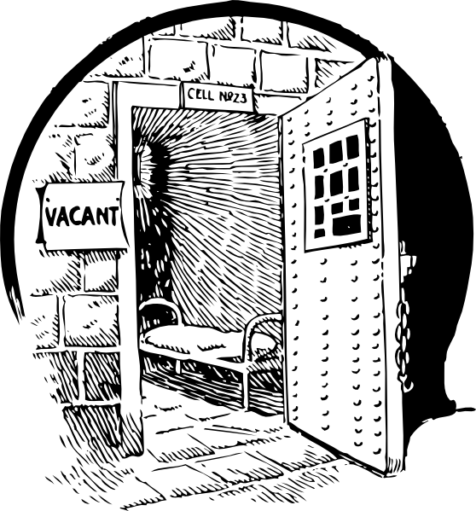

Due Date: 3/10/2015

Mrs. Weimer MAY extend the time frame based on the needs of the students and the conditions of the weather .

